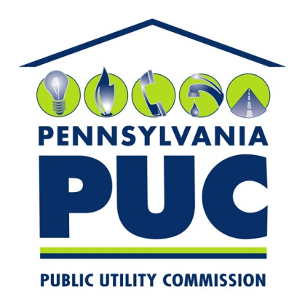

PUC User Comment Policy (for Both Facebook and Twitter)
The PA PUC welcomes your comments and hopes that conversations will be courteous. Comments posted to this page will be monitored by the PUC, and users are responsible for any postings made to this site.
Facebook and Twitter are designed to encourage ideas, discussion, debate and questions about the PUC issues. We welcome your comments and hope that our conversations here will be courteous. While we do not discriminate against any views, we reserve the right to delete any of the following in order to maintain the integrity of the page:
- Violent, obscene, profane, hateful or racist comments
- Comments that threaten or defame any person or organization
- Comments that suggest or encourage illegal activity
- Multiple successive off-topic posts by a single user
- Repetitive posts copied and pasted by multiple users
- Personal information including, but not limited to, account numbers, email addresses, telephone numbers, mailing addresses or identification numbers
- Links to sites with inappropriate content
- Sale or promotional posts/links

In the interest of ensuring our Facebook/Twitter community can participate in a safe, respectful environment, our team will remove any posts not adhering to these terms of use. There is no endorsement, implied or otherwise, by the Pennsylvania Public Utility Commission of any company selling electricity in the state or of author's posts, links or photos. Authors are fully responsible for the content they submit.
The PUC reserves the right to block access to any user who violates the PUC User Comment Policy. Please be advised that posts and comments to and from this site, in connection with the transaction or activity of the PUC, are subject to the Pennsylvania Right-to-Know Law and may be disclosed to third parties upon request.
The PUC cannot respond with specific information to questions about pending PUC proceedings.
It should be noted that communicating with the PUC through social media is not considered an official filing under the Public Utility Code. You may file an official complaint by calling 1-800-692-7380 or by following the complaint instructions on our website. Official filings in cases may be made online through the PUC’s eFiling system.

