EDEWG Change Request #153

This EDEWG Change Request can be found on the PUC website at http://www.puc.pa.gov/electric/electric_edewg_download.aspx

Requester’s Name:  Ernie Mathie | EDC/EGS Name:  FirstEnergy | Phone # :  330-384-5757
Date of Request:  07/17/19 | Affected EDI Transaction Set #(s):  814ER/814CR | E-Mail Address:  mathiee@firstenergycorp.com
Requested Priority (emergency/high/low): high | Requested Implementation Date:  To be determined once approved | Status:  Approved / Pending Redline into IGs

Brief Explanation (This will be copied into the description in the Change Control Summary Spreadsheet):
In 814ER, modify reject reason code of CAP to include scenario where enrollment request is rejected if a bill method other than rate ready or non-percent off rate is indicated. In 814CR, add a new code of CAP to indicate the same reject reason. This will be for PA only.

Detail Explanation (Exactly what change is required? To which EDEWG Standards? Why?):
Currently FirstEnergy is using the A13 rejection code when suppliers send a bill option other than rate ready or indicate a non-percent off rate code when an account is on PCAP. This will allow FirstEnergy to follow Implementation Guideline regulations. The existing reject reason code of CAP will be utilized in the 814ER when an 814E is rejected for either “Invalid Bill Type” which would cover both Duquesne Light and FirstEnergy as well as “Invalid Rate Code” which would be utilized by FirstEnergy

Since the 814C Implementation Guidelines does not have the reject reason code of CAP listed, the above reject reason code will be to add the code to the Implementation Guideline for use in the 814CR when a change request is rejected for either of these two reasons.

Example pages of the proposed changes are included below for both 814E and 814C.

For Change Control Manager Use Only:
Date of EDEWG Discussion:  8/1/2019 | Expected Implementation Date:

EDEWG Discussion and Resolution:
7/31/2019 – Brandon Siegel: reviewed request, entered tracking and assigned #153. Modified description and Gray Box to be more generic which allows use by DLC and FE, possibly other EDCs as well. Will poll rest of EDCs during EDEWG discussion to see if they will also use this code as modified by this Change Request.
8/1/2019 – Brandon Siegel: EDEWG discussed and approved EDI CC #153 without revision. CC153 will be implemented into the next annual version update to the regional IGs.

Priority Classifications

Emergency Priority | Implemented within 10 days or otherwise directed by EDEWG
High Priority | Changes / Enhancements implemented with 30 days. The next release, or as otherwise directed by EDEWG
Low Priority | Changes / Enhancements implemented no earlier than 90 days, Future Release, or as otherwise directed by EDEWG

Please submit this form via e-mail to both the PUC at jmccracken@pa.gov and lyalcin@pa.gov and to the
Change Control Manager, Brandon Siegel at brandon.siegel@intelometry.com
Your request will be evaluated and prioritized at an upcoming EDEWG meeting or conference call.

814 Enrollment
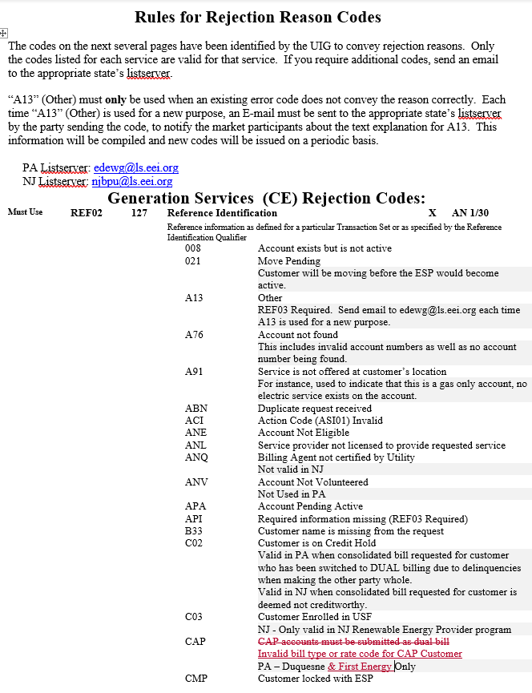
814 Change
