EDEWG Change Request #150v3

This EDEWG Change Request can be found on the PUC website at http://www.puc.pa.gov/electric/electric_edewg_download.aspx

Requester’s Name:  Ernie Mathie | EDC/EGS Name:  FirstEnergy Corp. | Phone # :  330-384-5757
Date of Request:  01/31/19 | Affected EDI Transaction Set #(s):  867MU, 867IU | E-Mail Address:  mathiee@firstenergycorp.com
Requested Priority (emergency/high/low): High | Requested Implementation Date:  August 9, 2019 | Status:  Approved / Pending redline into IGs

Brief Explanation (This will be copied into the description in the Change Control Summary Spreadsheet):
For FirstEnergy use only, add new REF*6W line to 867 transactions to account for reporting delivered and received kWh for Rider D accounts in PA per Tariff regulations. Since PA reports usage at the account level as opposed to the meter level and these accounts will only utilize one meter, reporting at the meter level is not possible. The use of this new line will allow FirstEnergy to designate the delivered and received usage using channel numbers to support the regulatory requirements.

Detail Explanation (Exactly what change is required? To which EDEWG Standards? Why?):
This Change Control is being suggested for use in Pennsylvania only for reporting net metering since Smart Meters are now making all accounts interval metered. The use of Delivered kWh for Distribution Service and Received kWh for Purchased Power (customer generation) will better align with hourly data provided PJM for settlements in lieu of providing net kWh. This will align customer usage to Utility Distribution Service and EGS Generation Service. For shopping customers on Rate Ready Billing FirstEnergy will bill its distribution service and supplier generation service based on delivered kWh (delivered kWh x EGS rate) and this will align with hourly usage provided to PJM for settlement. This means Rate Ready 810s will use delivered kWh to calculate supplier charges and any credit for received kWh will need to be provided to customers by the EGS independent of the consolidated bill. For Dual and Bill Ready billing, FirstEnergy will also bill its distribution service based on delivered kWh and report this hourly usage to PJM for settlement. Therefore, FirstEnergy will need to provide suppliers with both delivered and received kWh for supplier’s use of received kWh in the 867MU and 867IU transactions.

In order to accomplish this, FirstEnergy wishes to utilize the REF*6W line available in the 867IU Implementation Guideline under the PTD*BQ loop to report the delivered and received kWh separately in lieu of just reporting net usage when suppliers request interval usage. This would require the use of two PTD*BQ loops for kWh. Channel 1 would indicate the interval usage that follows is delivered and Channel 2 would indicate the following interval usage is received. Reporting the usage by meter number did not seem doable as these accounts would have only one meter so it was thought using the same meter number for both delivered and received usage would be confusing for the supplier. This would be an administrative Change Control adjusting the gray box area after PA Use to indicate “Used by FirstEnergy: Channel 1 = Delivered kWh and Channel 2 = Received kWh”. Changes/examples to 867IU are below on p.3-5 & p.7.

The 867MU Implementation Guidelines would require a new page for the REF*6W line. The page would basically be identical to the REF*6W page in the 867IU Implementation Guideline but would be included under the PTD*PM loop. It would be included with the other REF lines and the usage that follows would be just summary usage. Changes/examples to 867IU are below on p.9-13.

The PTD*BB loop for both 867MU and 867IU will report delivered kWh as that is the usage FirstEnergy will be using to calculate distribution dollars. The net kWh will no longer be reported in the PTD*BB loop.

The PTD*SU loop for both 867MU and 867IU will report delivered kWh and received kWh in two separate QTY segments. The net kWh will no longer be reported in the PTD*SU loop.

This Change Control will need approval by the March or April EDEWG Conference Call to allow implementation by August 9th.

For Change Control Manager Use Only:
Date of EDEWG Discussion:  2/7/2019, 3/7/2019, 4/16/2019 | Expected Implementation Date:  8/9/2019

EDEWG Discussion and Resolution:
2/1/2019 – Brandon Siegel: Received request, entered change control log, assigned #150 and placed on February 2019 EDEWG meeting agenda.
2/7/2019 – Brandon Siegel: EDEWG reviewed and found it necessary for the change to be updated with additional changes to the PA notes section as well as additional examples.
2/15/2019 – Brandon Siegel: Updated CC150 to include proposed changes to PA Notes and included examples provided by FirstEnergy. CC150 remains open pending additional EDEWG review.
3/7/2019 – Brandon Siegel: EDEWG review during March meeting – discussion added another QTY segment for Generation to the PTD*SU loop, CC150 to be updated for this addition.
3/8/2019 – Brandon Siegel: added SU loop to scope of change control & distributed to EDEWG in March meeting minutes. CC150 remains open pending additional EDEWG review and/or approval.
4/11/2019 – Brandon Siegel: EDEWG reviewed and approved EDI CC 150v2 without revision. This will be implemented into the 2020 version update to the regional implementation guidelines.
7/11/2019 – Brandon Siegel: Updated examples in CC: 1. Bill type is now Rate Ready 2. MEA readings updated for the generation loops. Saved off as CC150v3. No need for re-approval as these are only updates to correct the examples.

Priority Classifications

Emergency Priority | Implemented within 10 days or otherwise directed by EDEWG
High Priority | Changes / Enhancements implemented with 30 days. The next release, or as otherwise directed by EDEWG
Low Priority | Changes / Enhancements implemented no earlier than 90 days, Future Release, or as otherwise directed by EDEWG

Please submit this form via e-mail to both the PUC at jmccracken@pa.gov and lyalcin@pa.gov and to the
Change Control Manager, Brandon Siegel at brandon.siegel@intelometry.com
Your request will be evaluated and prioritized at an upcoming EDEWG meeting or conference call.

EDI 867 Interval Usage: Changes to the Pennsylvania Notes Section

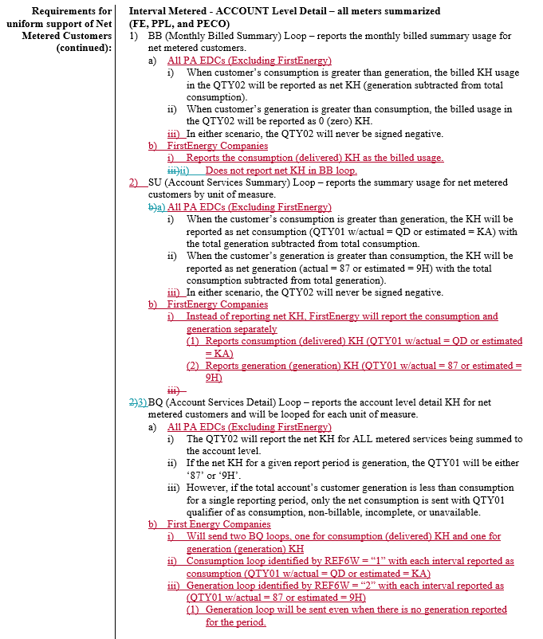

EDI 867 Interval Usage: New REF segment in PM loop(s)

Segment: REF Reference Identification (6W=Channel Number)
Position: 030
Loop: PTD
Level: Detail
Usage: Optional
Max Use: 20
Purpose: To specify identifying information
Syntax Notes: 1 At least one of REF02 or REF03 is required.
2 If either C04003 or C04004 is present, then the other is required.
3 If either C04005 or C04006 is present, then the other is required.
Semantic Notes: 1 REF04 contains data relating to the value cited in REF02.
Comments:

PA Use: |  | Used by FirstEnergy: Channel 1 = Delivered kWh and Channel 2 = Received kWh
NJ Use: |  | Used by PSEG. If only one channel is used, this will still be sent.
DE Use: |  | N/A
MD Use: |  | N/A
Example: |  | REF*6W*1

Data Element Summary
Ref. Data
Des. Element Name Attributes
Must Use | REF01 | 128 | Reference Identification Qualifier |  |  |  | M |  | ID 2/3
 |  |  | Code qualifying the Reference Identification
 |  |  |  | 6W |  | Sequence Number
 |  |  |  |  |  | Channel Number
Must Use | REF02 | 127 | Reference Identification |  |  |  | X |  | AN 1/30
 |  |  | Reference information as defined for a particular Transaction Set or as specified by the Reference Identification Qualifier
 |  |  | Channel Number

EDI 867 Interval Usage : Examples

867IU EXAMPLE 1 - CUSTOMER GENERATION (5000 KH) MORE THAN CONSUMPTION (3000 KH)

BPT*00*000450199999E*20190122*C1
N1*SJ*SUPPLIER NAME*9*123456789ABCD
N1*8S*METED-DISTRIBUTION*1*007916836
N1*8R*CUSTOMER NAME
REF*12*08012345678906547862
REF*11*123456897
REF*BLT*LDC
REF*PC*LDC
PTD*BB
DTM*150*20181219
DTM*151*20190118
QTY*D1*3000.00000*KH =====DELIVERED USAGE
QTY*QD*73.00000*K1
QTY*D1*73.00000*K1
PTD*SU
DTM*150*20181219
DTM*151*20190118
QTY*QD*3000.00000*KH =====DELIVERED USAGE
QTY*87*5000.0000000*KH =====RECEIVED USAGE
PTD*BQ
DTM*150*20181219
DTM*151*20190118
REF*MT*KH015
REF*6W*1 =====DELIVERED CHANNEL ID (INTERVAL READS TOTAL 3000 KH)
QTY*QD*67.25000000*KH
DTM*582*20181219*0015*ES
QTY*QD*73.79000000*KH
DTM*582*20181219*0030*ES
QTY*QD*54.73000000*KH
DTM*582*20181219*0045*ES
QTY*QD*96.62000000*KH
DTM*582*20181219*0100*ES
PTD*BQ
DTM*150*20181219
DTM*151*20190118
REF*MT*KH015
REF*6W*2 =====RECEIVED CHANNEL ID (INTERVAL READS TOTAL -5000 KH)
QTY*87*107.25000000*KH
DTM*582*20181219*0015*ES
QTY*87*103.79000000*KH
DTM*582*20181219*0030*ES
QTY*87*104.73000000*KH
DTM*582*20181219*0045*ES
QTY*87*106.62000000*KH
DTM*582*20181219*0100*ES

RATE READY 810 for 867 INTERVAL USAGE EXAMPLE 1
CUSTOMER GENERATION (5000 KH) MORE THAN USAGE (3000 KH)

BEFORE CHANGE (CURRENT): REPORTS NET USAGE (0 KH) FOR SUPPLIER CHARGES OF $0 (ZERO)
BIG*20190118*09530599495479***000450199999E **ME*00
REF*12*08012345678906547862
REF*11*123456897
REF*BLT*LDC
REF*PC*LDC
REF*BF*66
N1*8S*METED-DISTRIBUTION*1*007916836
N1*SJ*SUPPLIER NAME*9*123456789ABCD
N1*8R*CUSTOMER NAME
ITD******20190211
BAL*P*YB*0.00
BAL*M*J9*0.00
BAL*M*YB*0.00
IT1*1*****SV*ELECTRIC*C3*ACCOUNT
DTM*150*20181219
DTM*151*20190118
SLN*1**A
SAC*C*F950*EU*GEN004*0.00***0.0481000*KH*0.0000*****SUPPLIER BASIC CHARGES - ENERGY
TDS*0.00
CTT*1

AFTER CHANGE: REPORTS DELIVERED USAGE (3000 KH) FOR SUPPLIER CHARGES OF $144.30
BIG*20190118*09530599495479***000450199999E **ME*00
REF*12*08012345678906547862
REF*11*123456897
REF*BLT*LDC
REF*PC*LDC
REF*BF*66
N1*8S*METED-DISTRIBUTION*1*007916836
N1*SJ*SUPPLIER NAME*9*123456789ABCD
N1*8R*CUSTOMER NAME
ITD******20190211
BAL*P*YB*144.30
BAL*M*J9*0.00
BAL*M*YB*144.30
IT1*1*****SV*ELECTRIC*C3*ACCOUNT
DTM*150*20181219
DTM*151*20190118
SLN*1**A
SAC*C*F950*EU*GEN004*144.30***0.0481000*KH*3000.0000*****SUPPLIER BASIC CHARGES - ENERGY
TDS*144.30
CTT*1

867IU EXAMPLE 2 - CUSTOMER GENERATION (3000 KH) LESS THAN CONSUMPTION (5000 KH)

BPT*00*000450198591E*20190122*C1
N1*SJ*SUPPLIER NAME*9*123456789ABCD
N1*8S*METED-DISTRIBUTION*1*007916836
N1*8R*CUSTOMER NAME
REF*12*08012345678906547862
REF*11*123456897
REF*BLT*LDC
REF*PC*LDC
PTD*BB
DTM*150*20181219
DTM*151*20190118
QTY*D1*5000.00000*KH =====DELIVERED USAGE
QTY*QD*73.00000*K1
QTY*D1*73.00000*K1
PTD*SU
DTM*150*20181219
DTM*151*20190118
QTY*QD*5000.0000000*KH =====DELIVERED USAGE
QTY*87*3000.0000000*KH =====RECEIVED USAGE
PTD*BQ
DTM*150*20181219
DTM*151*20190118
REF*MT*KH015
REF*6W*1 =====DELIVERED CHANNEL ID (INTERVAL READS TOTAL 5000 KH)
QTY*QD*107.25000000*KH
DTM*582*20181219*0015*ES
QTY*QD*103.79000000*KH
DTM*582*20181219*0030*ES
QTY*QD*104.73000000*KH
DTM*582*20181219*0045*ES
QTY*QD*106.62000000*KH
DTM*582*20181219*0100*ES
PTD*BQ
DTM*150*20181219
DTM*151*20190118
REF*MT*KH015
REF*6W*2 =====RECEIVED CHANNEL ID (INTERVAL READS TOTAL -3000 KH)
QTY*87*17.25000000*KH
DTM*582*20181219*0015*ES
QTY*87*13.79000000*KH
DTM*582*20181219*0030*ES
QTY*87*14.73000000*KH
DTM*582*20181219*0045*ES
QTY*87*16.62000000*KH
DTM*582*20181219*0100*ES

RATE READY 810 for 867 INTERVAL USAGE EXAMPLE 2 ABOVE
CUSTOMER GENERATION (3000 KH) LESS THAN USAGE (5000 KH)

BEFORE CHANGE (CURRENT): REPORTS NET USAGE (2000 KH) FOR SUPPLIER CHARGES OF $96.20
BIG*20190118*09530599495479***000450198591E**ME*00
REF*12*08012345678906547862
REF*11*123456897
REF*BLT*LDC
REF*PC*LDC
REF*BF*66
N1*8S*METED-DISTRIBUTION*1*007916836
N1*SJ*SUPPLIER NAME*9*123456789ABCD
N1*8R*CUSTOMER NAME
ITD******20190211
BAL*P*YB*96.20
BAL*M*J9*0.00
BAL*M*YB*96.20
IT1*1*****SV*ELECTRIC*C3*ACCOUNT
DTM*150*20181219
DTM*151*20190118
SLN*1**A
SAC*C*F950*EU*GEN004*96.20***0.0481000*KH*2000.0000*****SUPPLIER BASIC CHARGES - ENERGY
TDS*96.20
CTT*1

AFTER CHANGE: REPORTS DELIVERED USAGE (5000 KH) FOR SUPPLIER CHARGES OF $240.50
BIG*20190118*09530599495479***000450198591E**ME*00
REF*12*08012345678906547862
REF*11*123456897
REF*BLT*LDC
REF*PC*LDC
REF*BF*66
N1*8S*METED-DISTRIBUTION*1*007916836
N1*SJ*SUPPLIER NAME*9*123456789ABCD
N1*8R*CUSTOMER NAME
ITD******20190211
BAL*P*YB*240.50
BAL*M*J9*0.00
BAL*M*YB*240.50
IT1*1*****SV*ELECTRIC*C3*ACCOUNT
DTM*150*20181219
DTM*151*20190118
SLN*1**A
SAC*C*F950*EU*GEN004*240.50***0.0481000*KH*5000.0000*****SUPPLIER BASIC CHARGES - ENERGY
TDS*240.50
CTT*1

EDI 867 Monthly Usage: New REF segment in PM loop(s)

Segment: REF Reference Identification (6W=Channel Number)
Position: 030
Loop: PTD
Level: Detail
Usage: Optional
Max Use: 20
Purpose: To specify identifying information
Syntax Notes: 1 At least one of REF02 or REF03 is required.
2 If either C04003 or C04004 is present, then the other is required.
3 If either C04005 or C04006 is present, then the other is required.
Semantic Notes: 1 REF04 contains data relating to the value cited in REF02.
Comments:

PA Use: |  | Used by FirstEnergy: Channel 1 = Delivered kWh and Channel 2 = Received kWh
NJ Use: |  | N/A
DE Use: |  | N/A
MD Use: |  | N/A
Example: |  | REF*6W*1

Data Element Summary
Ref. Data
Des. Element Name Attributes
Must Use | REF01 | 128 | Reference Identification Qualifier |  |  |  | M |  | ID 2/3
 |  |  | Code qualifying the Reference Identification
 |  |  |  | 6W |  | Sequence Number
 |  |  |  |  |  | Channel Number
Must Use | REF02 | 127 | Reference Identification |  |  |  | X |  | AN 1/30
 |  |  | Reference information as defined for a particular Transaction Set or as specified by the Reference Identification Qualifier
 |  |  | Channel Number

EDI 867 Monthly Usage: Changes to the Pennsylvania Notes Section

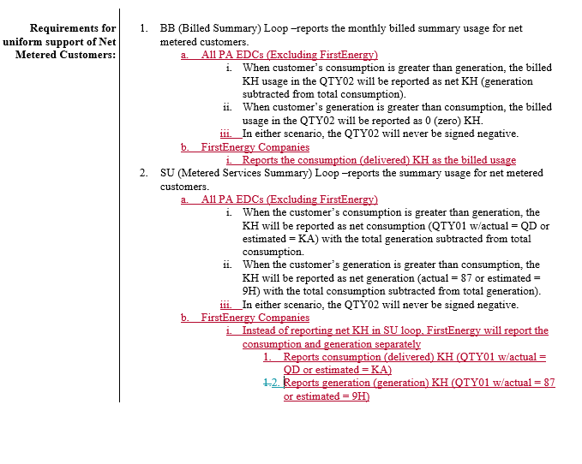
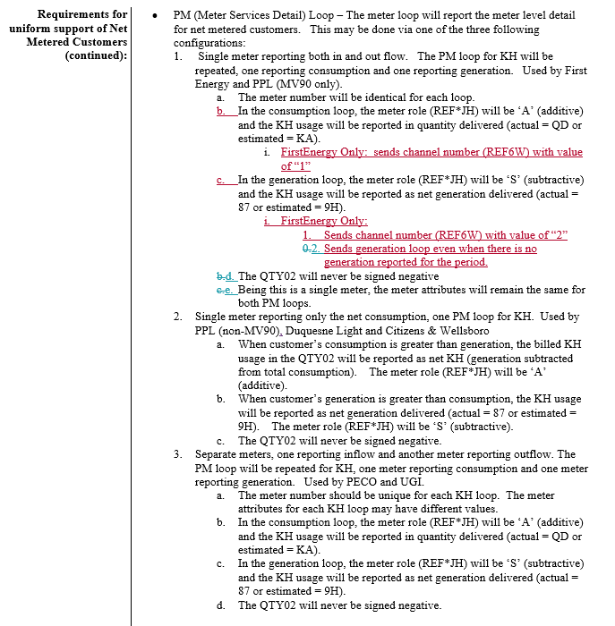
EDI 867 Monthly Usage : Examples

867MU EXAMPLE 1 - CUSTOMER GENERATION (2000) MORE THAN USAGE (1500)

BPT*00*700418133078E*20181213*DD
N1*SJ*SUPPLIER NAME*9*123456789ABCD
N1*8S*METED-DISTRIBUTION*1*007916836
N1*8R*CUSTOMER NAME
REF*12*08012234567890876543
REF*11*123654879
REF*BLT*LDC
REF*PC*LDC
PTD*BB
DTM*150*20181115
DTM*151*20181213
QTY*D1*1500.00000*KH =====DELIVERED USAGE
PTD*SU*
DTM*150*20181115
DTM*151*20181213
QTY*QD*1500.00000*KH =====DELIVERED USAGE
QTY*87*2000.00000*KH =====RECEIVED USAGE
PTD*PM
DTM*150*20181115
DTM*151*20181213
REF*MG*S317190462
REF*6W*1 =====DELIVERED CHANNEL ID
REF*NH*ME-RSD
REF*JH*A
REF*IX*5.0
QTY*QD*1500.00000*KH
MEA*EA*PRQ*1500.00000*KH*32134.00000*33634.00000*51
PTD*PM
DTM*150*20181115
DTM*151*20181213
REF*MG*S317190462
REF*6W*2 =====RECEIVED CHANNEL ID
REF*NH*ME-RSD
REF*JH*S
REF*IX*5.0
QTY*87*2000.00000*KH
MEA*EA*PRQ*2000.00000*KH*2393.00000*4393.00000*51

867MU EXAMPLE 2 - CUSTOMER GENERATION (500 KH) LESS THAN USAGE (1500 KH)

BPT*00*700418133078E*20181213*DD
N1*SJ*SUPPLIER NAME*9*123456789ABCD
N1*8S*METED-DISTRIBUTION*1*007916836
N1*8R*CUSTOMER NAME
REF*12*08012234567890876543
REF*11*123654879
REF*BLT*LDC
REF*PC*LDC
PTD*BB
DTM*150*20181115
DTM*151*20181213
QTY*D1*1500.00000*KH =====DELIVERED USAGE
PTD*SU*
DTM*150*20181115
DTM*151*20181213
QTY*QD*1500.00000*KH =====DELIVERED USAGE
QTY*87*500.00000*KH =====RECEIVED USAGE
PTD*PM
DTM*150*20181115
DTM*151*20181213
REF*MG*S317190462
REF*6W*1 =====DELIVERED CHANNEL ID
REF*NH*ME-RSD
REF*JH*A
REF*IX*5.0
QTY*QD*1500.00000*KH
MEA*EA*PRQ*1500.00000*KH*32134.00000*33634.00000*51
PTD*PM
DTM*150*20181115
DTM*151*20181213
REF*MG*S317190462
REF*6W*2 ======RECEIVED CHANNEL ID
REF*NH*ME-RSD
REF*JH*S
REF*IX*5.0
QTY*87*500.00000*KH
MEA*EA*PRQ*500.00000*KH*3393.00000*3893.00000*51

