EDEWG Change Request #164

This EDEWG Change Request can be found on the PUC website at http://www.puc.pa.gov/electric/electric_edewg_download.aspx

Requester’s Name:  Susan Scheetz | EDC/EGS Name:  PECO | Phone # :  610-737-7440
Date of Request:  1/5/2022 | Affected EDI Transaction Set #(s):  814 HU | E-Mail Address:  Susan.scheetz@exeloncorp.com
Requested Priority (emergency/high/low): LOW | Requested Implementation Date:  2022 | Status:  INCORPORATED into IG814Ev6-7.docx

Brief Explanation (This will be copied into the description in the Change Control Summary Spreadsheet):
PECO is sending a code in production on the 814 Historical Usage response transaction that is not included in the 814 E Implementation Guide for EDEWG. Note the code is showing as being used for a HI Reject Response, we also need the code added under the HU Reject Response.

Detail Explanation (Exactly what change is required? To which EDEWG Standards? Why?):

Add the IHA*INSUFFICIENT HISTORY AVAILABLE rejection response code in the 814 E Implementation Guide for a HU Reject Response.

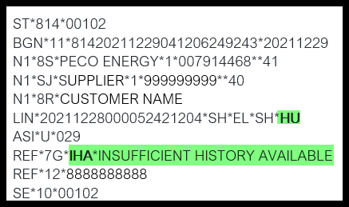

Currently available for HIU:
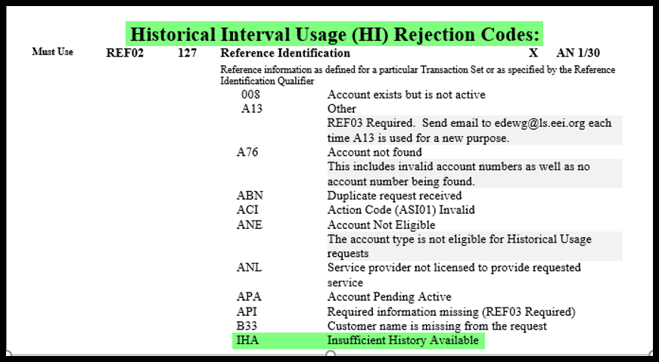

Need to have added to the HU:
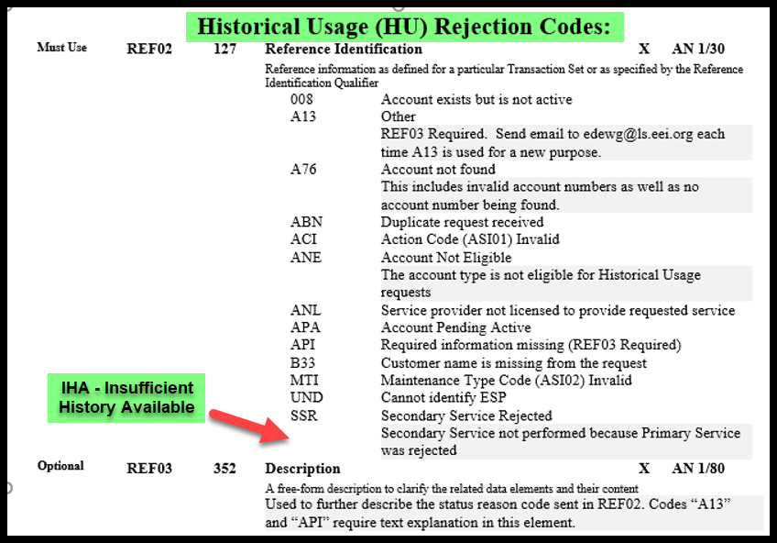

For Change Control Manager Use Only:
Date of EDEWG Discussion:  1/6/2022 | Expected Implementation Date:  TBD

EDEWG Discussion and Resolution:
1/5/2022 – Brandon Siegel: Received request, added to Change Control Log, assigned #164 and added to January 2022 meeting agenda.
1/6/2022 – Brandon Siegel: EDEWG reviewed and approved EDI CC #164 for incorporation into next IG version update.
1/27/2022 – Brandon Siegel: INCORPORATED into IG814Ev6-7.docx

Priority Classifications

Emergency Priority | Implemented within 10 days or otherwise directed by EDEWG
High Priority | Changes / Enhancements implemented with 30 days. The next release, or as otherwise directed by EDEWG
Low Priority | Changes / Enhancements implemented no earlier than 90 days, Future Release, or as otherwise directed by EDEWG

Please submit this form via e-mail to both the PUC at jmccracken@pa.gov and lyalcin@pa.gov and to the
Change Control Manager, Brandon Siegel at brandon.siegel@intelometry.com
Your request will be evaluated and prioritized at an upcoming EDEWG meeting or conference call.

