February ??, 2015

Rosemary Chiavetta, Secretary
Pennsylvania Public Utility Commission
Commonwealth Keystone Building
400 North Street
Harrisburg, Pennsylvania 17120

Dear Ms. Chiavetta:

The Electronic Data Exchange Working Group (“EDEWG”) submits the proposals of its Web Portal Working Group to the Commission herein, in response to the Commission’s Smart Meter Procurement and Installation Implementation Order issued December 5, 2012 (Docket No. M-2009-2092655.

The WPWG’s charter was to develop standards for a secure web portal solution that would permit third parties such as EGSs and CSPs to acquire both historical interval usage and billing quality interval data within 48 hours of daily meter reads. On April 17, 2014, the Commission via Secretarial Letter granted EDEWG’s request to file all proposed standards by March 1, 2015. This submittal represents that filing.

The enclosed “Solution Framework”, approved by EDEWG on February 5, includes the following:
- Consensus minimally required standards for the required secure web portals, including an associated downloadable file format in Appendix A.
- Considerations for “system-to-system” solutions (Appendix B), based upon stakeholder interest.
- Positions regarding whether the enclosed “System-to-System Considerations” are expected to be mandatory components of EDC implementation plans (Appendix C).

EDEWG Leadership respectfully requests the Commission to take the following actions:
- Review and approve the enclosed Solution Framework.
- Provide guidance to EDCs with respect to regulatory process, implementation timing, and overall expectations regarding incorporation of web portal construction into EDC smart meter implementation plans.
- Resolve non-consensus in Appendix C by addressing whether “System-to-System Considerations” must immediately be mandatory components of implementation plans.

EDEWG thanks the Commission in advance for its review and support of these standards.

Sincerely,

Christine Hughey Susan Scheetz Brandon S. Siegel
Christine Hughey Susan Scheetz Brandon S. Siegel
EDEWG EGS Co-chair EDEWG EDC Co-chair EDEWG Change Control Manager
Constellation (An Exelon Company) PPL Electric Utilities Intelometry

Before the
Pennsylvania Public Utility Commission

Pennsylvania Web Portal Working Group
Solution Framework

PUC Docket No. M-2009-2092655
Related Order Issued December 5, 2012

January 27, 2015

Table of Contents
WPWG Charter Overview 2
Secure Web Portal Standards 4
APPENDIX A: Secure Web Portal, Downloadable Usage File Format (CSV) 16
APPENDIX B: System-To-System (StS) Considerations 20
APPENDIX C: Non-Consensus on System-To-System Disposition 34

Executive Summary

This document contains the deliverables required of EDEWG’s Web Portal Working Group (WPWG) and is based on the Pennsylvania Public Utility Commission’s (PaPUC’s) December 5, 2012 Order and subsequent meetings held by the WPWG through January 2015. It captures all finalized standard implementation guidelines, including related decisions, assumptions, and open questions of the WPWG relative to said standards.

This document consists of the following:

WPWG Charter Overview – Summarizes the mandate, scope, and guiding principles that shape the proposals to follow.

Secure Web Portal Standards – Outlines related standards, decisions and assumptions regarding the required secure web portal.

APPENDIX A: Secure Web Portal, Downloadable Usage File Format (CSV) – Provides templates for the common CSV file format that all EDCs must support within their web portals as part of the web portal framework. This addresses both account-level and meter-level data.

APPENDIX B: System-to-System Considerations – Includes recommendations intended to promote commonality among any such solutions pursued, to the extent possible.

APPENDIX C: Non-Consensus on System-to-System Disposition – Details background and positions regarding one item for which WPWG could not reach consensus, specifically whether the System-To-System Considerations should be considered as mandatory or optional components of pending EDC implementation plans.

WPWG Charter Overview

NOTE: The full WPWG Charter is posted to the PUC’s EDEWG website, http://www.puc.pa.gov/utility_industry/electricity/edewg_files_for_downloading.aspx.
The PaPUC required EDEWG to develop a standardized solution for the acquisition of historical interval usage and billing quality interval usage data via a secure web-portal, as specifically directed and detailed within the Pennsylvania Public Utility Commission’s (PaPUC’s) Smart Meter Procurement and Installation Order entered December 6th 2012 at Docket M-2009-2092655. The PaPUC also required EDCs to incorporate the resulting standards within each of their respective smart meter technology and implementation plans. The PaPUC mandated completion (not implementation) of all standards by March 1, 2014 and March 1, 2015 respectively.
The Web Portal Working Group’s primary task has been to formulate, but not implement, a standardized design, format, and interface for the sharing of smart meter data. This task has included, but not been limited to, decisions on the following:

- Type of web host, including minimum security protocols
- Method(s) of access for users
- Specific customer information available
- Methods and formats for the export of information
- Potential methods and limitations on batching data for delivery to electric generation suppliers (EGSs) or authorized parties
- Methods for customer privacy protection consistent with existing Commission rules and regulations.

The web portal is intended for licensed EGSs and customer-authorized third parties. The PaPUC has not directed that this web portal usurp existing or potentially future EDC online customer communication platforms.

The WPWG leveraged appropriate national standards in the development of these standards where applicable and appropriate.

The WPWG’s intent within this Solution Framework is to define the minimal standards for the chosen portal framework required by the market participants. Any related items not specifically addressed by these standards are at the discretion of the individual EDCs.

In an effort to focus on the specific deliverables required, the WPWG initially discussed three available options for the overall request-response portal framework:

- Single User - Single Request (SU-SR). A user-based platform allowing for an authorized user to manually log into the portal, request, and receive data for one individual account at time via the portal’s user interface. The results could be rendered within the web portal interface itself or exported to the user in a predefined file format.
- Single User - Multiple Requests (SU-MR). Similar to above, except that the authorized user logging into the portal may submit and receive data for more than one account number as part of a single request.
- System-to-System (StS) – Initially conceived as a platform allowing an authorized user’s IT systems to communicate directly with the web portal system of the EDC without requiring a user to manually log into the web portal itself and leverage the user interface. (For instance, this could involve the use of File Transfer Protocol, aka “FTP”, or web services to transmit and satisfy requests.)

During initial meetings, the WPWG agreed to focus on the SU-MR framework (Option II above) as the minimum required standard on which the required deliverables should focus. During January 2014 WPWG meetings, several market participants voiced concerns regarding this approach and indicated a long-term preference for implementation of the “StS” framework (Option 3). Following attempts over the next several months to develop standards that could potentially satisfy both approaches, the WPWG agreed to re-focus the main body of this Solution Framework and the associated technical standards on the secure web portal and as such on the standards required to support the SU-MR framework (Option 2). This change was made so as to focus on the tasks necessary to meet the minimum requirements of the PaPUC order.

Please review Appendix C for an explanation of the currently opposed positions regarding the disposition of System-To-System Considerations as either mandatory or optional components within pending EDC implementation plans.

The WPWG also agreed that this document should address both of the required standards, the March 2014 standard on historical interval usage (most recent 12 months of billed data) as well as the March 2015 standard for bill quality usage available within 48 hours of the read. However, in contrast to the original WPWG charter, this deliverable will prescribe minimally required standards but NOT a single “standardized” solution. The WPWG believes that the efficiencies and avoidance of complexities realized by this course of action are justified in order to meet the overall intended goal of the PaPUC. The PaPUC approved this change in approach at the request of EDEWG Leadership via Secretarial Letter dated April 17, 2014.

Proposed changes to any of the standards contained in the pages that follow require EDEWG review and approval via pre-existing formalized EDEWG change control procedures.

Secure Web Portal Standards

The Web Portal solution standards can be broken down into the processes needing support:

- Certification, Access, and Customer Privacy
- Data Request
- Data Response
- Security and Technical
- Tracking and Reporting
- EDEWG Leadership Responsibilities

- Certification, Access, and Customer Privacy

- Determination of portal user eligibility
  - Each request will be logged into a unique Web Portal for each EDC.
  - The WPWG Charter indicates that the portal is “primarily intended for licensed EGSs and customer-authorized third parties”.
  - In subsequent WPWG discussions, the WPWG agreed on the following:
    - Entities licensed by the PUC as an EGS are eligible to access the web-portal. (Licensee status is available on the PaPUC’s website at http://www.puc.state.pa.us/consumer_info/electricity/suppliers_list.aspx. )
      - These include EGSs themselves, Conservation Service Providers (considered by PaPUC as “CSPs”), and demand response / load management providers (also known as Curtailment Service Providers, considered by PJM as “CSPs”). (Other third parties not considered PUC-licensed entities in this regard include but are not limited to researchers, public agencies with subpoenas, PaPUC-licensed Natural Gas Suppliers (NGSs), customers themselves, and other customer-authorized entities.)
      - Market participants voiced a concern on the 1/22/14 call that CSPs (in both senses) should be accommodated without having to register as licensed EGSs, on the basis that a CSP does not need or want to adhere to such requirements.
        - Consultation with the PaPUC revealed the following about Conservation Service Providers based on information provided via e-mail by Jeffrey McCracken of PaPUC staff on February 18, 2014:
          - Regarding regulations that protect customer information from being misused:
            - The PUC has the authority to penalize EGSs for fraudulent operations.
            - CSPs contracted with EDCs for Act 129 work are governed by PaPUC regulations over the EDC and the principal/agent relationship between the EDC and CSP.
            - The PaPUC does not currently require EGS licensure of CSPs. (CSPs do register with the PaPUC, and the PaPUC maintains a CSP registry.)
          - The PaPUC provides bonding reductions for brokers/marketers. It is possible that PaPUC Staff would consider an even further reduction for CSPs interested in gathering information from EDCs and consequently seek EGS licensure.
        - Based on the above, given that the PUC’s enforcement relative to customer data protection is under the umbrella of an EGS license, the WPWG recommends that CSPs (either Curtailment or Conservation) desiring to access the web portals addressed by this framework either be provided access as agents of an existing EGS OR be licensed as EGSs themselves as a prerequisite to receiving access.
    - Unlicensed subcontractors or agents of licensed EGSs, such as Electronic Data Interchange (EDI) and billing providers, are eligible to receive access to the web portal on behalf of licensees that they represent, but their use must be directly associated with those licensees under the assumption that users are only accessing the portal in support of service to a specific licensed entity. For example, a provider obtaining usage for an account on behalf of fictitious supplier “ABC Energy” must be logged in such that the “ABC Energy” licensee is associated with and held accountable for associated use of the portal by that provider on ABC Energy’s behalf. (This is covered in more detail in Section 2.5, Tracking and Reporting.)
    - The capability for other 3rd parties (entities not licensed by the PaPUC as EGSs) to access this information is outside the scope of the WPWG effort. Such entities are NOT eligible for access to the web portal and must obtain customer data via other means.
      - Alternative means of obtaining customer data include contacting the customer directly or – at the discretion of the EDC – submitting requests to the EDC accompanied by proper Letters Of Authorization, or “LOAs” (i.e. Duquesne’s current process).
      - EDCs will encourage customers to leverage separate and, in some cases, pre-existing customer-facing interfaces, many of which are self-service and designed specifically for customers.
- Access Management
  - An EGS interested in serving customers of a specific EDC must follow that EDC’s trading partner certification process. Part of certification includes verifying the licensing status of the EGS. As such, EDCs should provide access to the web portal for said EGS after verifying that the EGS is PaPUC-licensed. (Completion of EDI certification testing is not a prerequisite.)
  - 3rd parties that require Web Portal access but not full certification or treatment as an EDI-capable trading partner will have to submit a request to that EDC directly for web portal access. (The EDC must verify that the party is PaPUC-licensed as an EGS or broker/marketer prior to granting access.)
  - The minimal requirement is for individual-level credentials, meaning one unique user ID per individual per PaPUC-licensed EGS entity.
    - Each use of the portal is directly associated with exactly one PaPUC-licensed entity.
    - EDCs will associate a unique user ID with an entity’s name and DUNS+4 number(s). (The user ID cannot be the user’s e-mail address.)
NOTE: The WPWG previously accepted such an implementation based on the current workings of PPL Electric Utilities’ pre-existing supplier portal. However, WPWG members have expressed a preference for EDCs to implement user IDs at the organizational level where possible, meaning one user ID per user regardless of the number of DUNS+4 entities associated with that user. EDCs other than PPL must therefore evaluate the feasibility and cost-effectiveness of this option when designing their portals but may elect not to implement in this manner based on the results of said evaluation.
    - Each user ID must be associated with a non-public e-mail address directly associated with either the licensed entity itself or the associated subcontractor/agent. (Examples of forbidden public e-mail addresses include but are not limited to Gmail, Yahoo, Hotmail, and AOL.)
    - Users within unlicensed subcontractor/agent organizations that support multiple PaPUC-licensed EGS entities are subject to the following:
      - Each user must receive unique user IDs for each PaPUC-licensed DUNS+4 numbers supported, as deemed appropriate by the associated entities themselves on a case-by-case basis.
      - For each use, the user is responsible for accessing the portal with the user ID associated with the licensed DUNS+4 numbers that their portal usage supports. All activity under that user ID must be in support of the associated licensed entity’s DUNS+4 number, since the PaPUC will hold the licensed entity responsible for the user’s actions.
- The EDC cannot and therefore will not attempt to detect whether an individual user is accessing the portal with the appropriate user ID.
- The EDC must publish and communicate availability of a user guide for all portal users which covers the following:
- Functional use of the solution
- Any EDC-specific administrative or security conditions more stringent than the standards published in this document
- The EDC must maintain, re-publish, and re-communicate the availability of the user guide as changes occur
- The EDC will designate at least two “administrators” for each PaPUC-licensed entity’s DUNS+4 number as specified by that entity. (If applicable, the same administrators may be responsible for administration on all of that entity’s DUNS+4 numbers.) The administrators are responsible for the following:
- Authorizing and communicating requests for the EDC grant portal access to users (includes both new users and previously terminated users). The EDC may only honor requests sent directly by an administrator.
- Promoting awareness and review of the EDC user guide to all authorized users within their organizations.
- Maintaining attributes of existing portal credentials.
- Terminating/revoking access of existing portal credentials.
- On a quarterly basis, reviewing and attesting to appropriateness of access for all users associated with that specific licensed entity. (In the absence of timely attestation, the EDC has the right to revoke access for all users associated with a specific entity, including administrators.)
- The EDC is responsible for the following:
- Upon request from ONLY the entity’s identified administrators, granting access to new users as well as to users whose access was terminated/revoked – assuming that the e-mail address associated with the user is a non-public address,.
- Driving the quarterly review process required of licensed entities via reminder communications.
- Revoking access for all users associated with a particular entity if the administrators for that entity fail to complete the quarterly review(s) in a timely manner.
- Performing and attesting to completion of its own quarterly review with regard to EDC user access.
- The PaPUC will audit and if necessary pursue licensee organizations, not individuals.

- Customer Privacy
  - Prior PaPUC regulatory mandates require that the EDC make this data available to EGSs and place the burden of customer authorization on licensed EGSs and their agents, who are subject to PUC audit for the same.
  - The Web Portal will adhere to the privacy standards mandated by the PaPUC regardless of the customer’s preference for release of information on file with the EDC.

- Data Request

Once an EDC has granted a requestor access to the Web Portal, the requestor will be able to initiate requests for the available data via an online, user-driven process.

For the initial phase of implementation, each EDC will minimally provide data at the ACCOUNT level. Given the PaPUC requirements in the Order for meter-level data, each EDC will work toward providing data at the METER level in a subsequent phase of implementation after the initial phase of its solution matures.

- At a minimum, the EDC must satisfy requests for usage data at the ACCOUNT level. (Providing METER-level data is optional.)
- The same eligibility rules leveraged in providing historical usage in response to EDI-based requests apply when providing usage via the portal. (Example: PECO does not honor EDI-based historical usage requests on finalled accounts.)
- An EGS may request account-level information for at least ten (10) customer accounts at a given time.
- An EGS may request meter-level information for one (1) customer account at a given time.
- The EDC web portal must be able to accommodate such a request by providing the requested usage data simultaneously in the required format.
- Above the minimal standard of 10 accounts, EDCs reserve the right to cap the maximum number of account numbers requested simultaneously at their discretion.
- The web portal will require the EGS to provide only the EDC account number in the request.
- The EDC web portal may either permit EGSs to either directly enter the account number(s) into the portal, allow the EGS to upload an Excel spreadsheet listing the account numbers for which information is requested, or both.
- Each EDC will have the ability to design its own User Interface (UI) for the web portal.
- This solution will not support a ‘subscription service’.

2.3 Data Response

Upon receipt of a Request, each EDC will respond with the associated data for each account number requested.

- The Response process begins once a valid Request has been submitted.
- The EDC may reject all or part of a request (meaning all or only selected account numbers) and must provide a descriptive rejection reason.
  - The EDC may reject individual account numbers within a given request based on errors unique to the specific account numbers requested (for instance, invalid or ineligible account numbers, not an interval-metered account, interval data unavailable/missing, etc.).
  - The minimum standard will be to replicate the EDI reject reason. Follow-up questions on reject reasons will be supported by pre-existing EDC supplier support processes.
- For each account number requested at the account level where the EDC has data available, the EDC must render the following information online for each account:
  - EDC account number
  - Start and end dates for each billing period listed.
  - A minimum of the 12 most recent billed periods of account-level monthly summary usage, aka consumption or kWh. (NOTE: 12 moths may not be available, in which case the portal will return data for the available number of months.)
  - A minimum of the 12 most recent billed periods of account-level monthly demand, aka kW (both measured/registered and calculated/billed; Also, see note above regarding 12 months not necessarily being available – also applies here)
  - Quantity Qualifiers for both summary usage and registered demand (designates actual vs. estimate and load vs. generation)
  - All account-level or rate-level (varies by EDC) data elements provided in the Scheduling Determinant (FG) loop of the EDC’s EDI historical usage transactions. This includes but may not be limited to Peak Load Contribution (current and future if known), Network Service Peak Load (current and future if known), bill group/cycle, rate class, rate subclass, and load profile.
- For each account number requested at the meter level where the EDC has data available, the EDC must render the following information online for each meter:
  - EDC account number
  - Meter number
  - A minimum of the 12 most recent billed periods of meter-level monthly summary usage, aka consumption or kWh (NOTE: 12 moths may not be available, in which case the portal will return data for the available number of months.)
  - A minimum of the 12 most recent billed periods of meter-level monthly demand, aka kW (both measured/registered and calculated/billed; Also, see note above regarding 12 months not necessarily being available – also applies here)
  - Start and end dates for each billing period listed.
- The EDC must provide the capability for the portal user to download the required data elements for each of the requested account numbers in the common comma-delimited CSV format included in Appendix A of this document.
  - For account-level requests, the portal must provide the capability for the user to download one file per account requested.
  - For meter-level requests, the portal must provide the capability for the user to download one file per meter on a requested account..
- Historical summary and interval usage data shared that pertains to the standard originally required by March of 2014 must be billed data, defined as data from a billing cycle for which the EDC has already billed the customer.
  - This data is subject to change in the event that the EDC cancels and rebills those periods.
  - Only the most recent version of billed data will be available in the portal.
- Data within 48 hours of the read must be “bill-quality”, defined as “data that is sourced from an EDC’s meter data management system that has completed the process of being verified, estimated, and edited” as cited from Page 16 of the PaPUC Final Order. This means that the EDC has not necessarily billed the associated period yet.
- Only the most recent version of usage data will be available in the portal.
- All timestamps presented in the portal should be presented in 24-hour Eastern Time.
- All intervals must be presented in hour-ending format.
NOTE: The solution assumes that all EDCs bill a 24-hour period of usage on a midnight-to-midnight basis.
- Each element listed is defined identically to the manner in which it is defined in the Pennsylvania Electronic Data Exchange Working Group (EDEWG) EDI Implementation Guides. Considering the PUC Order states that Meter Level should be provided, the EDCs proposed that the first implementation will delivery Account level, and each EDC will work toward providing Meter level as the market matures.
- Data elements available to users in the downloadable file format for accepted account-level requests must include the following:
  - Customer identifier (varies by EDC; Account number is an example)
  - Customer name
  - Report title (Account-Level Usage or Meter-Level Usage)
  - EDC name
  - Usage start and end dates (encompass all data provided in report)
  - Peak Load Contribution, kWh (PLC, also known as “capacity obligation) – Current and, if known, future
  - Network Service Peak Load, kWh (NSPL, also known as “transmission obligation”) – Current and, if known, future
  - Rate Class
  - Rate Subclass (if applicable for EDC; Otherwise, leave blank)
  - Bill Cycle
  - Load Profile
  - Special Meter Configuration (currently indicates net metered status)
  - A minimum of the 12 most recent billed periods of account-level monthly summary usage, aka consumption or kWh, with the most recent data first (NOTE: 12 months may not be available, in which case the portal will return data for the available number of months)
  - A minimum of the 12 most recent billed periods of account-level monthly demand, aka kW, with the most recent data first (both measured/registered and calculated/; Also see note above regarding 12 months not necessarily being available – also applies here)
  - Detailed account-level interval usage data, aka consumption or kWh, with the most recent data first, spanning the 12 most recent billed periods as well as bill-quality interval data available within 48 hours of the read that the EDC has not yet billed (See note above regarding 12 months of billed data not necessarily being available – also applies here)
  - Quantity Qualifiers for summary usage, summary registered demand, and detailed interval usage (designates actual vs. estimate and load vs. generation as well as unavailability of a specific interval)
  - Quality Indicator (populated with “VEE” if the EDC has not yet billed this data)
- Data elements available to users in the downloadable file format for accepted meter-level requests must include the following:
  - Customer identifier (varies by EDC; Account number is an example)
  - Customer name
  - Report title (Account-Level Usage or Meter-Level Usage)
  - EDC name
  - Premise (corresponds to a specific physical location)
  - Service Point (corresponds to a specific electric service)
  - Meter Number
  - Meter Manufacturer (name)
  - Meter Multiplier
  - Usage start and end dates (encompass all data provided in report)
  - Peak Load Contribution, kWh (PLC, also known as “capacity obligation) – Current and, if known, future
  - Network Service Peak Load, kWh (NSPL, also known as “transmission obligation”) – Current and, if known, future
  - Rate Class
  - Rate Subclass (if applicable for EDC; Otherwise, leave blank)
  - Bill Cycle
  - Load Profile
  - Special Meter Configuration (currently indicates net metered status)
  - A minimum of the 12 most recent billed periods of meter-level monthly summary usage, aka consumption or kWh, with the most recent data first (NOTE: 12 months may not be available, in which case the portal will return data for the available number of months)
  - A minimum of the 12 most recent billed periods of meter-level monthly demand, aka kW, with the most recent data first (both measured/registered and calculated/; Also see note above regarding 12 months not necessarily being available – also applies here)
  - Detailed meter-level interval usage data, aka consumption or kWh, with the most recent data first, spanning the 12 most recent billed periods as well as bill-quality interval data available within 48 hours of the read that the EDC has not yet billed (See note above regarding 12 months of billed data not necessarily being available – also applies here)
  - Quantity Qualifiers for summary usage, summary registered demand, and detailed interval usage (designates actual vs. estimate and load vs. generation as well as unavailability of a specific interval)
  - Quality Indicator (populated with “VEE” if the EDC has not yet billed this data)
- The downloadable files must accommodate Fall Daylight Savings Time data via adding data between hour-ending intervals 3 and 4 on the appropriate date.
- The downloadable files must accommodate Spring Daylight Savings Time in hour-ending interval 3 via blank values on the appropriate date.
- Precision of usage values will be dictated by the degree of precision available from each EDC’s AMI network. This solution will not dictate usage precision standards.
- On-peak and off-peak characteristics of usage and demand are not necessary to include in the web portal, as these elements are typically tied to EDC tariffs. EGSs may calculate such components at their own discretion.
- The EDC will respond to each request in “near real time”.

2.4 Security and Technical

Customer data must be delivered with the highest integrity and privacy. The Security standards cover the standards, tools, and policies that will be considered for the exchange of this data.

Several of these standards are varied adaptations of the Guidelines for Smart Grid Cybersecurity published by the National Institute of Standards and Technology, or NIST. (NIST also refers to these guidelines as Interagency Report 7628, or NISTIR 7628.)

NOTE: EDC policies and procedures, including but not limited to those governing information security and configuration management, may be more stringent than the standards identified in this section. In the event of contradictions between these standards and EDC policies and procedures, the more restrictive of the two shall govern.

- No data governed within the scope of these standards will be publicly accessible.
  - Valid user login to an EDC’s secure web portal is required to access all related data.
  - All other access must be denied.
  - The user must log on each and every time they access the portal. (Any capability designed to “remember” the user should not preclude user logon.)
- At a minimum, EDC portal solutions must be compatible with the two most recent major versions of Microsoft’s Internet Explorer web browser.
- Each EDC’s portal solution requires the use of a non-self-signed SSL certificate issued by a Microsoft-trusted authority for governance of secure user connections via HTTPS, both before and after user authentication at logon.
- When a user attempts to log into the web portal, the portal must mask the user’s password as the user enters it.
- Immediately following successful user authentication and login, the portal must provide the following to the user:
  - Details of user’s last login (date/time)
  - Applicable EDC’s legal disclaimers, terms, and conditions as applicable (scope of which is based on EDC information security policies and PaPUC privacy regulations)
  - Capability for user logged on to affirmatively agree to EDC terms and conditions presented, as a prerequisite to accessing usage data
- The web portal will limit users to one concurrent session per credential.
- The portal will lock out a user’s portal credential and prevent access if that user fails to successfully login with the same credential five times within a 30-minute period.
- The portal will enforce a session timeout and lock a user’s portal session when that user has been inactive for 30 consecutive minutes. The user must be required to re-login to the portal to continue.
- Regarding the practice of “screen-scraping”:
  - Portal users must not scrape billed usage data from portal screens. This data is available to licensed EGSs via Pennsylvania’s approved statewide standard of EDI.
  - EDCs must not implement measures specifically designed to prevent screen-scraping. However, as a mitigating practice if necessary to limit the impact of screen scraping on portal performance, EDCs have the right to implement a daily cap (maximum) number of account numbers for which usage is requested per user ID.
- The EDC must notify portal users of any planned changes no later than two weeks prior to the planned implementation of those changes. (NOTE: This does not apply to implementation of added functionality that would have no impact on existing portal functions.)
- If an EDC’s secure web portal experiences either technical problems or a cybersecurity incident (as defined by EDC information security procedures) which substantially disrupt portal operations OR increase the risk of compromising portal information (inadvertently allowing unauthorized users access to either customer usage data or user credentials), then the EDC must immediately perform the following:
  - Deny all new attempts to access the portal by default, gracefully indicating to users attempting to log on that the portal is temporarily unavailable.
  - Immediately terminate all active user sessions such that users already logged in can no longer access the data without re-logging into the portal.
  - Communicate status to portal users and stakeholders as appropriate given the nature of the issue or incident.
    - Avoid disclosing restricted details that could aid cybersecurity attackers.
    - Consider EDEWG Leadership and PaPUC liaisons to EDEWG as impacted stakeholders.
  - Leave the above restrictions in place until deeming that the issue has been resolved and that any associated risk has been sufficiently mitigated. (This will vary based on several factors, potentially including but not limited to identification of the source of the issue and the degree to which any collateral damage has been contained.)
  - This standard does not supersede pre-existing EDC cybersecurity incident response plans. EDCs will always execute their own plans and rely on their own definitions with regard to cybersecurity incidents.
- Error handling within the portal for all technical / internal system errors encountered (as opposed to rejected usage requests for an account) must not reveal more to the portal user than a simple error code and a “graceful” error message indicating next steps.
- EDC portal solutions may only leverage Javascript-based active content (embedded software components triggering actions automatically) and mobile code (code that a web browser must process, typically triggered by active content). EDCs should refrain from using other similar technologies including but not limited to ActiveX controls, Flash, and VBScript within their portal solutions.

2.5 Tracking and Reporting

NOTE: The PA WPWG is not aware of any specific PaPUC reporting requirements relative to portal use and therefore assumes that the following standards would support any necessary ad hoc reporting for either EDCs or market participants on portal use and administration.

- The EDC must track the following portal-related event information on a per-user basis:
  - User changes (user ID, associated entity, last updated date/time, add/update/terminate)
  - User login attempts (user ID entered, login attempt date/time, successful/failed)
  - Accounts queried (user ID, associated entity, EDC account number requested, date/time, yes/no for data provided, account-level/meter-level if “yes”, reason for rejection if “no”)
  - Quarterly review status of licensed entities (user ID, attestation date/time)
- The portal must perform all logging on the server-side.
- The portal may only leverage cookies on the client-side if cookies are necessary for the purposes of session management and/or personalization.
- The portal must retain all of the above portal-related event information for a period of at least three years.
- Each EDC’s portal must provide the capability for users associated with each licensed entity to query and download any of the above portal-related event information within a specified date range for one or more users associated with that specific entity (but no others).
- The EDC must have the capability to query and download any of the above portal-related event information for one or more users and/or licensed entities.
- The portal must not allow any user, including EDC users, to directly edit the above log data.

2.6 EDEWG Leadership Responsibilities

- Leadership will facilitate periodic reviews of these standards in parallel with other EDEWG governance and standards documentation.
- Leadership will facilitate dispute resolution between market participants with regard to interpretation of these standards and escalate disputes to PaPUC Commission Staff as warranted when unable to achieve resolution within EDEWG.
- Leadership will manage changes to these standards using pre-established EDEWG change control processes, similarly to those used for modifications to Electronic Data Interchange (EDI) standards. This includes incorporation of changes into these standards annually as well as associated republication of updated standards to EDEWG.
- Leadership will maintain an ongoing awareness of changes in the Smart Grid Cybersecurity Standards published by the National Institute for Standards and Technology (aka NISTIR-7628) and any other national standards for which changes would impact or otherwise necessitate changes to the WPWG standard.

APPENDIX A: Secure Web Portal, Downloadable Usage File Format (CSV)

Account-Level Usage (after delimiting via commas)

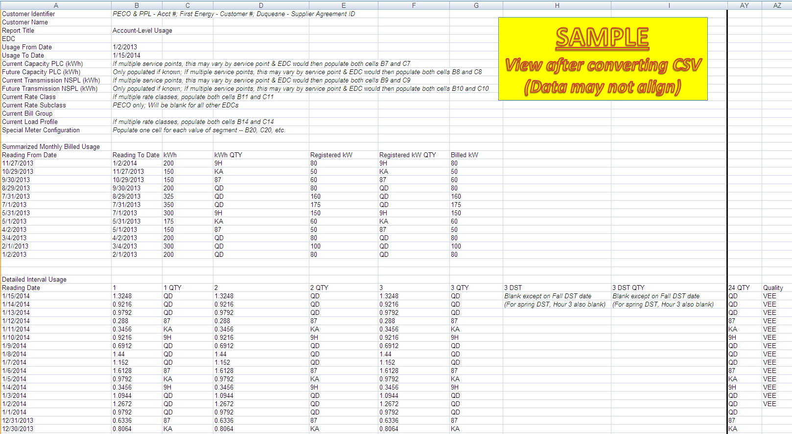

Account-Level Usage (CSV Draft)

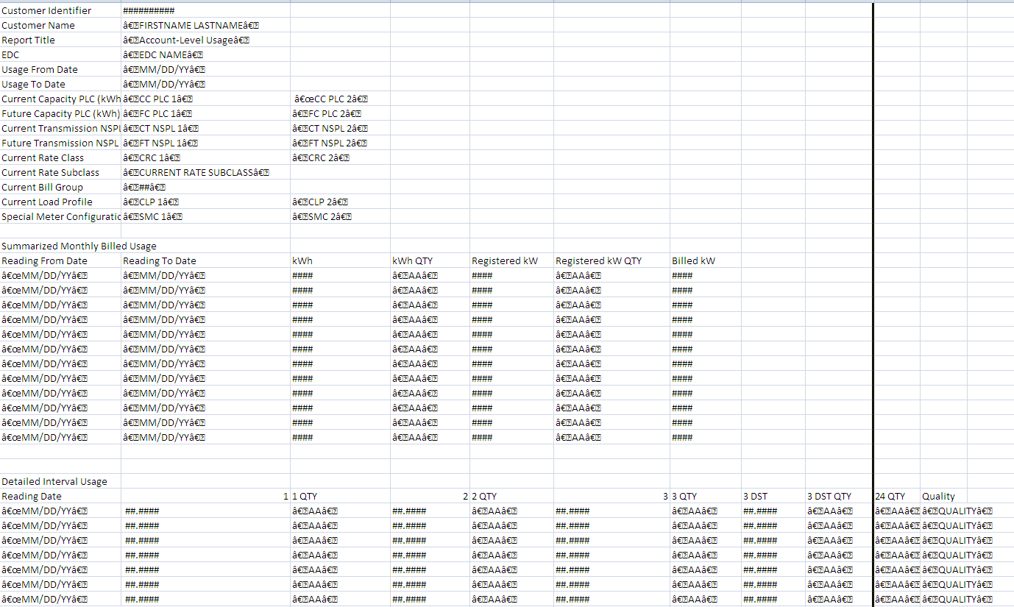

Meter-Level Usage (after delimiting via commas)

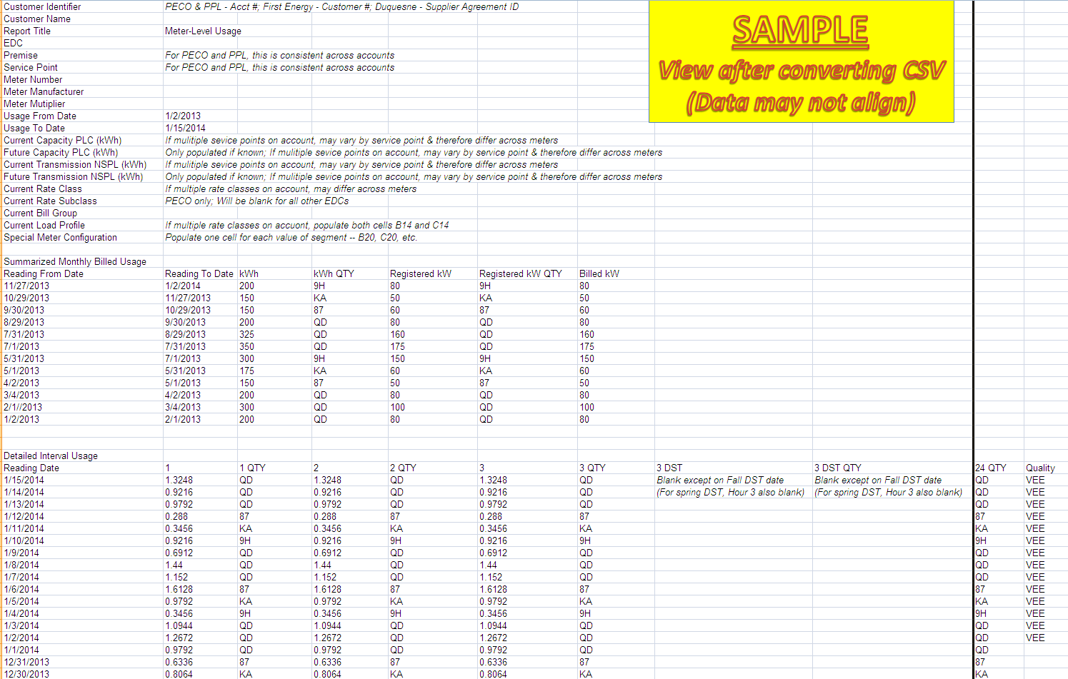

Meter-Level Usage (CSV Draft)

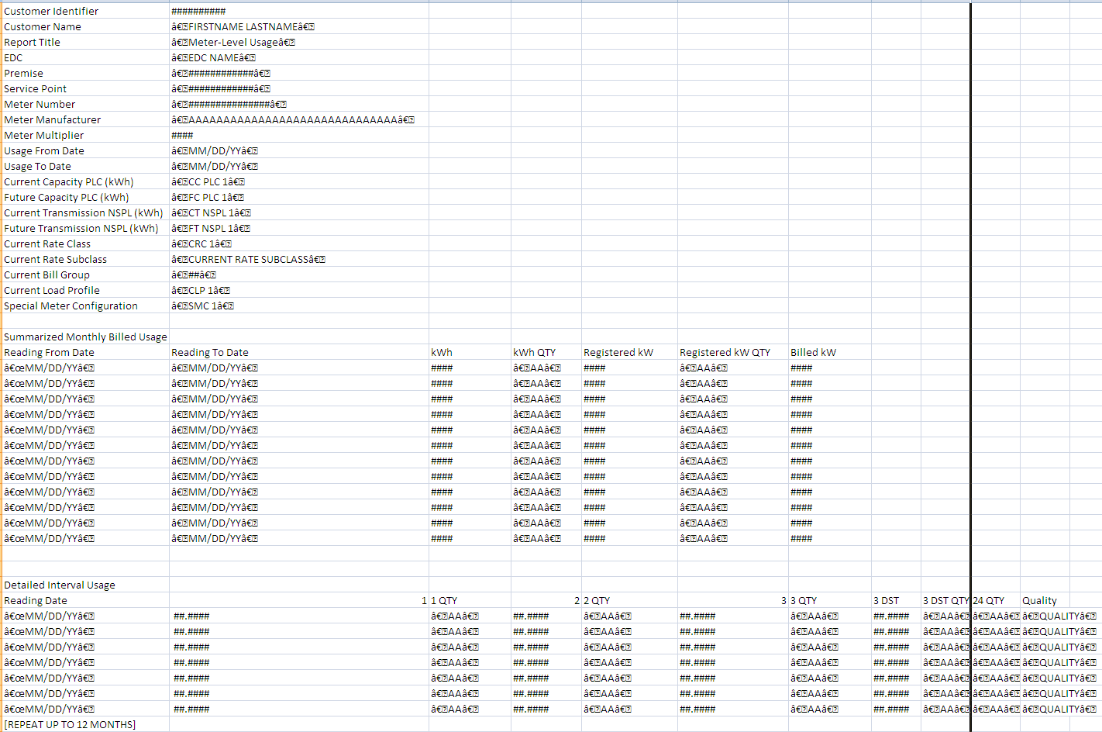

APPENDIX B: System-To-System (StS) Considerations

Purpose

WPWG representatives expressed a long-term preference for EDC implementation of a System-To-System (StS) approach for accessing interval usage data that allows an authorized user’s IT systems to communicate directly with the secure web portal system of the EDC. Electronic Data Interchange (EDI) is the current Pennsylvania system-to-system standard for data exchange of historical interval usage but does not address usage data available within 48 hours of the read.

While the WPWG asserts that standards for a system-to-system approach are not expressly required by the associated PaPUC order, the WPWG recognizes the importance of outlining considerations that all market participants – and particularly EDCs that may eventually need or want to build an associated solution – must consider. This appendix outlines those considerations.

Use Cases

Stakeholders identified the following as potentially applicable uses of data provided in this manner:

- Improving performance of daily forecasting via comparison with detailed intervals.
- Coordinating responses to EDCs and RTOs following a curtailment / demand response event within the required time limit.
- Driving changes in customer behavior by looking for and alerting customers to outliers in usage patterns on a regular basis.
- Independently performing Peak Load Contribution calculations for comparison and forecasting.

The above use cases primarily leverage account-level data. Stakeholders acknowledged the possibility of additional use cases over the longer-term that would be likely to require meter-level data (for handling of net metering and other varied types of electric service requiring multiple meters).

Guiding Principles

- Focus on a simple solution with time-to-market as a higher priority than available capabilities.
- Deliver detailed interval usage data only, accounting for data “within 48 hours of the read”.
- Provide bill-quality data per terms of PUC order for secure web portal.
- Account for existing Pennsylvania regulations regarding data privacy and associated customer authorization.
- Propose bulk interval data transfer services providing data in a standardized format, both account-level and meter-level.
- Augment (do not replace) existing EDI and secure web portal data exchange standards.
- Remain consistent with the current PUC-approved decentralized model of electronic data exchange in Pennsylvania, similarly to the secure web portal standards above.

Stakeholders participating in detailed discussions of the above initially indicated a strong preference for EDCs to take a “provide and park” approach using a standard data format, in contrast to a true system-to-system approach leveraging more direct point-to-point communication between IT systems/machines. Subsequent discussions resulted in a re-emergence of a truer system-to-system option. The two sets of considerations below address both methods.

Positions on Applicability of Regional and National Standards

The PA PUC has encouraged the Web Portal Working Group to consider and if possible to adopt national standards to the largest extent possible. To that end, stakeholders considered the applicability of various such standards to a system-to-system approach. Positions on each NAESB standard considered follow below.

NAESB REQ.22 – Data Privacy Standards

These standards address data access and privacy issues related to smart grid technologies in general. As of this writing, various industry stakeholders are finalizing a related certification program potentially integrated within the Smart Meter Texas framework which is based on these standards.

WPWG stakeholders cite no direct applicability between the practices within these standards and the above system-to-system considerations. As with the above secure web portal standards, any system-to-system solution would adhere to the privacy standards mandated by the PaPUC regardless of the customer’s preference for release of information on file with the EDC.

NAESB Electronic Transport (ET) and Electronic Delivery Mechanisms (EDM) v1.6

NAESB EDM standards are primarily applicable in situations where transactional data is delivered directly into receiving systems of trading partners. In Pennsylvania’s case, PUC-approved standards governed by EDEWG have been specifically tailored for the testing and implementation of EDI protocols.

With this in mind, the spirit of various selected aspects of NAESB EDM v1.6 standards and practices (though not all) are applicable to system-to-system considerations, including:

- Encryption of all information transmitted across the Internet.
  - SSL encryption via secure HTTP connections, referenced in the secure web portal standards, would be similarly applicable to the above proposals.
  - Use of PGP is considered outside of scope for this effort.
- Use of Eastern Prevailing Time ‘EPT’ (Eastern Standard Time ‘EST’ using Daylight Saving Time ‘DST’) as the default time zone for EDEWG transactions
- EDC communication of server maintenance schedules to users

NAESB PKI WEQ-012 Standards

These standards represent a set of criteria for creation of digital certificates governing machine-to-machine authentication. They were designed to help parties avoid having to acquire and manage multiple credentials from various sources when transmitting market-based information, originally within the context of transmission information.

WPWG stakeholders have determined that existing security protocols defined both above and in the secure web portal considerations are sufficient and as such that the additional layer of machine-to-machine authentication in this manner is not necessary to incorporate into these considerations, given the “provide and park” approach on which these are based.

Green Button “Connect My Data”

Some Pennsylvania EDCs have publicly supported adoption of the national Green Button initiative from a customer perspective, providing self-service “Download My Data” options online for customers to download their usage information in a standard Green Button format. When considering system-to-system proposals, WPWG stakeholders acknowledged the need to evaluate potential use of the Green Button “Connect My Data” standard in a similar manner for 3rd parties.

Green Button “Connect My Data” could prove to be valuable over time as it matures and is adopted by additional markets. At the time of this writing, however, its use is limited to specific EDCs in California and framed as being in the “beta” (trial) stages of use. WPWG stakeholders active in the competitive marketplace in other states cited no reliance on or preference for adopting the Green Button standard over and above a more simplified approach that focuses solely on the vital usage data sought via these considerations.

Therefore, the WPWG recommends that EDEWG Leadership consider reintroducing this format into future discussions at a later date based upon its maturity and adoption rate and will proceed with recommending more simplified proposals relative to these considerations.

NAESB REQ.21 – Energy Services Provider Interface (ESPI)

In concert with the above, WPWG stakeholders also reviewed the NAESB standard on which the Green Button initiative is based. The primary purpose of the ESPI standard is to provide a consistent interface enabling customers to authorize energy usage information from “Data Custodians” to “Third Parties”. Green Button practices based on this standard include the ability for customers to permit and revoke access to usage information by third parties.

As previously noted within the secure web portal standards, the intended users of WPWG system-to-system solutions for energy usage information are entities licensed by the PUC as an EGS (which can also include Conservation Service Providers and Curtailment Service Providers. The capability for other 3rd parties (entities not licensed by the PaPUC as EGSs) to access this information is outside the scope of the WPWG effort, including customers. EDCs will encourage customers to leverage separate and, in some cases, pre-existing customer-facing interfaces, many of which are self-service and designed specifically for customers. Additionally, as mentioned previously, PaPUC regulations currently prohibit the EDC from being actively involved in the customer authorization process and delegates responsibility for obtaining customer authorization to EGSs and third parties.

REQ.21 also cites the Energy Usage Information Model outlined in REQ.18 as the basis for the Green Button XML format. At least one EDC stakeholder commented that individual review by market participants of this model against the energy usage information in their own systems could be valuable if and when use of Green Button “Connect My Data” is considered at a later date, but all agree that this is not a necessary prerequisite to WPWG finalizing standards or system-to-system considerations at this time.

Given the above, WPWG found no synergies with ESPI from a system-to-system perspective.

Bulk Interval Data Transfer Proposal 1: “Active EGS” Rolling 10-Day (Batch CSV Files)

NOTE: Sample request and response XML formats, in the form of WSDL (Web Service Descriptive Language), are available at the conclusion of this section.

This proposal takes a “provide-and-park” approach, as opposed to a true system-to-system interface. EDCs would make this service available only to EGSs actively serving accounts within a particular EDC’s territory upon request from an EGS for a specific DUNS(+4) number under which that EGS is serving accounts. An EGS with more than one DUNS(+4) number serving customers must specify the DUNS number(s) for which it requests this service, as the EDC would publish separate files for each DUNS(+4) number.

EDCs must track relationship status and associated effective dates associated with the customer-supplier relationship, but EDCs may not have similar methods in place with regard to account-level relationships with Curtailment Service Providers, Conservation Service Providers, or other types of third parties. As such, the WPWG must assume that this solution can only be universally applied to EGSs (as opposed to all eligible third parties).

On a daily basis (processing days only), the EDC would publish all available detailed bill-quality account-level interval usage in hour-ending format for the set of accounts served by a particular DUNS(+4) number on a specific usage delivery date. Publication would occur over a rolling 10 day period with the EDC making best efforts to publish data for a given date as close to 48 hours following the last interval on that date as technically possible. The EDC would remove older data in favor of more recent data as the rolling 10-day period renews itself over time.

EDCs would publish each file as a compressed, comma-delimited file (zipped CSV) based on the interval usage increments provided. For instance, an EDC with a portion of meters capturing 60-minute increments and another set of meters capturing 15-minute increments will publish the associated interval usage in a minimum two separate files, one presenting accounts for which 60-minute intervals are available and another presenting accounts for which 15-minute intervals are available.

Each file published will have a unique filename adhering to the following standard:

[EDC DUNS(+4)]_[EGS DUNS(+4)]_P[Publication Date]_IU[Usage Date]_[Interval Increment]_[File #].zip

For instance, the first PECO 60-minite file for usage delivery date of 9/2/2014 that corresponds to EGS DUNS “123-45-6789-0123”, if published on 9/8/2014, would be named as follows:

007914468_1234567890123_P20140908_IU20140902_60_01.zip

Each file will contain only the EDC account numbers, usage delivery date (identical for all records), and multiplied hour-ending account-level interval usage values. EDCs will sign net metered (generation) values as negative.

The EDC will handle Daylight Savings Time as follows:
- Spring DST – Null interval usage values will be included for hour-ending 0300.
- Fall DST – For the long DST usage delivery date only, additional interval usage values will be populated in the columns at the end of each record as a second set of data for hour-ending 0200, labeled 0200D (0115D, 0130D, 0145D). These columns will include null values for all other usage delivery days.

EDC would publish each file to a specified FTP site within its secure web portal, allowing only web portal users registered under that specific DUNS(+4) to have access to that particular set of usage data.

EDCs would reserve the right to publish multiple data sets with predefined volumes (i.e. X accounts per file) based upon their existing infrastructures and would be required to communicate these parameters to EGSs as applicable.

Given the volume of data to be published, EDCs would reserve the right to periodically verify with EGSs whether this service should continue and, consequently, the right to discontinue that service if no response to this verification request is received from the EGS within a reasonable timeframe.

In accordance with the guiding principle of simplicity and time-to-market taking priority over available capabilities, and considering use cases requiring the best quality data in the minimal amount of time possible, republishing data for a given usage delivery date for any reason is considered outside the scope of these considerations and is left solely to EDC discretion.

The WPWG recommends that EDCs pursue this proposal either before or during implementation of Proposal 2 that follows.

“Active EGS” Rolling 10-Day CSV File Format (60-minute)

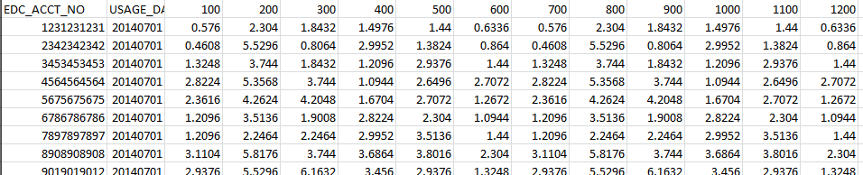

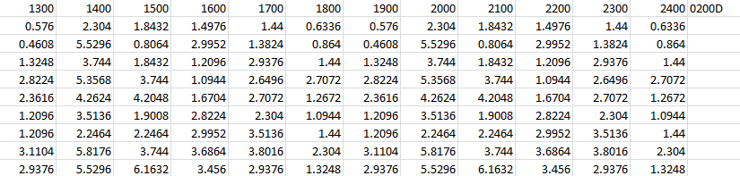

Active EGS Rolling 10-Day CSV File Format (15-minute)

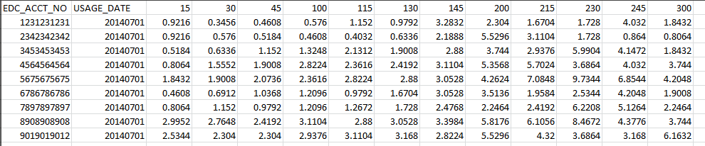

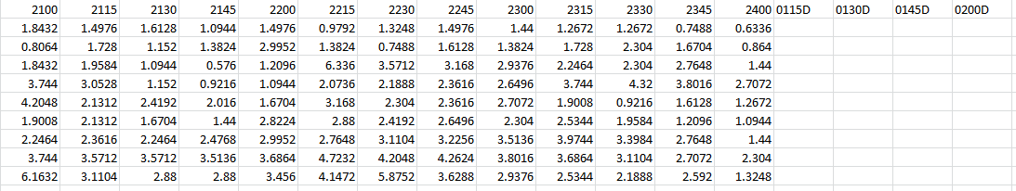

Bulk Interval Data Transfer Proposal 2: “By Request” (SOAP Web Service)

NOTE: A draft describing the XML data structure that the SOAP service would support is available at the conclusion of this section. This draft is not a fully-published technical specification, for which EDEWG ultimately must further establish if and when EDCs begin to design their detailed solutions.

This proposal outlines a system-to-system interface for exchange of both account-level and meter-level detailed interval usage leveraging a SOAP (Simple Object Access Protocol) web service.

A SOAP web service connects to the EDC’s meter data management system or similar usage data storage repository and leverages XML transactions for data exchange. Individual EDCs would each host and maintain their own web service. Each EDC will secure use of the service via username and password, assigning each authorized client (based upon DUNS+4 and eligibility as described in the above web portal standards) exactly one unique username and password.

Requestors intending to use the service must develop and maintain the code necessary for their clients to call it. In this case, a requestor would transmit its request directly to the EDC’s web service URL, at which point the EDC would be responsible for verifying authorization, generating an appropriate response in near-real-time, and logging the request internally. The EDC would then transmit the response generated directly to the authorized requestor’s response URL, and the requestor’s client would be responsible for handling the response appropriately upon receipt.

Each request, or call, of the web service call must include the following request parameters:
- Authorized username and password (in the header)
- EDC Account Number (exactly one per call)
- Usage Dates (“From” and “To”)
  - If omitted or blank, EDC would return all available data up to a maximum no smaller than the most recent twelve months (assuming that at least twelve months is available)
  - EDC reserves the right to set a maximum on the time horizon over which usage can be returned and may reject requests for date ranges exceeding this maximum range. (Per PUC, EDC maximum must be no less than the most recent 12 months).
- Account-Level or Meter-Level (but not both in the same call)

High request volume (both number of requests and volume of data requested) may impact the performance of the EDC’s service. For both security and performance reasons, EDCs would reserve the right to set rate limits (number of calls per IP address within a specific time window) on the use of the web service, at their discretion.
Upon receipt, the EDC would create and transmit a response containing either the associated usage information or an associated rejection. All responses regardless of acceptance or rejection must include a status code and a status message. For accepted requests, the code would simply be set to “0” and the message to “Successful. More information on this for rejected requests is below.

For accepted requests, the EDC’s response would include the detailed interval usage kwh values (hour-ending, multiplied) at the appropriate increment. For each kwh interval, the EDC will include a Quantity Qualifier – analogous to the QTY01 segment in the EDI 867 Historical Interval Usage Transaction. Codes for this qualifier include but are not limited to the following:

- QD – Actual Quantity Delivered (net consumption)
- KA – Estimated Quantity Delivered (net consumption)
- 87 – Actual Quantity Received (net generation)
  - Usage values signed positive
- 9H – Estimated Quantity Received (net generation)
  - Usage values signed positive

Please refer to the existing Pennsylvania EDEWG 867 Historical Interval Usage Implementation Guideline for a complete listing, specifically the Quantity Qualifier (QTY01) codes associated with the interval detail in the BQ loop of the transaction.

Meter-level response transactions will also include the associated meter numbers and meter multipliers.

For rejected requests, standard HTTP rejection codes would apply as status codes and messages for rejection scenarios including but not limited to the following:

- HTTP 401 – Unauthorized or missing credentials
- HTTP 429 – Too many requests (may apply if EDC sets rate limits)
- HTTP 500 – Service unavailable (For instance, during maintenance windows)

Similarly to the secure web portal standards above, EDCs could also reject authorized and properly structured requests based on business logic unique to the specific account numbers requested. In such cases, standard rejection reason codes applicable to REF*7G segments returned in rejection responses for EDI 814 Historical Interval Usage transactions would apply as status codes and messages. These include but are not limited to the following:

- 008 – Account Exists But Is Not Active
- A76 – Account Not Found
- NIA – Not Interval Account
- API – Required Information Missing – for instance, account vs. meter level parameter is not included in request

Please refer to the existing Pennsylvania EDEWG 814 Enrollment Request/Response Implementation Guideline for a complete listing, specifically the Historical Interval Usage (HI) Rejection Reason Codes associated with the REF*7G segment.

The EDC will handle Daylight Savings Time in responses as follows:
- Spring DST – No interval usage values will be included for hour-ending 0300.
- Fall DST – Additional interval usage values will be provided on the long Fall DST day only to accommodate a second set of data for hour-ending 0200, labeled 0200D (0115D, 0130D, 0145D).

The EDC and EGS must complete and document a pre-production connectivity test, during which the EGS calls the EDC web service for at least one account number specified by the EDC and receives a successful response from the EDC.
  - The EDC reserves the right to require EGSs to conduct more comprehensive testing and to require use of both test URLs and test credentials as part of that testing.

The EDC would log all calls to its service. Data logged would at a minimum include all request parameters – Username, EDC account number, usage dates, and the level of data requested (account-level vs meter-level) – as well as the response (success/failure and associated return code). EDCs reserve the right to log additional information at their discretion, including the requester’s IP address.

From a security perspective, similarly to the web portal standards above, each EDC’s solution requires the use of a non-self-signed SSL certificate issued by a Microsoft-trusted authority for governance of secure user connections via HTTPS. Both requestors and EDCs would be responsible for transmitting all data – both calls and responses – using SSL encryption.

If any component of an EDC’s service experiences either a technical problem or cybersecurity incident (as defined by EDC information security procedures) which either substantially disrupts its operations OR increases the risk of compromising portal information (inadvertently allowing unauthorized users access to either customer usage data or user credentials), then the EDC must immediately:

- Deny all new attempts to access the service by default, gracefully indicating to new callers that the service is temporarily unavailable via appropriate HTTP rejection codes.
- Immediately terminate all active processing and reject calls for which processing is already in progress.
- Communicate status to stakeholders as appropriate given the nature of the issue or incident.
  - Avoid disclosing restricted details that could aid cybersecurity attackers.
  - Consider EDEWG Leadership and PaPUC liaisons to EDEWG as impacted stakeholders.
- Leave the above restrictions in place until deeming that the issue has been resolved and that any associated risk has been sufficiently mitigated. (This will vary based on several factors, potentially including but not limited to identification of the source of the issue and the degree to which any collateral damage has been contained.)
- This standard does not supersede pre-existing EDC cybersecurity incident response plans. EDCs will always execute their own plans and rely on their own definitions with regard to cybersecurity incidents.

NOTE: EDC policies and procedures, including but not limited to those governing information security and configuration management, may be more stringent than the standards identified in this section. In the event of contradictions between these standards and EDC policies and procedures, the more restrictive of the two shall govern.

Draft XML/WSDL Data Structure for Proposal 2:

THIS IS NOT A FULLY PUBLISHED TECHNICAL SPECIFICATION. IT IS INTENDED TO DESCRIBE THE DATA PROVIDED. A FULLY PUBLISHED WSDL WOULD INCLUDE POST, SOAPAction, AND OTHER STANDARD PARAMETERS.

SOAP/WSDL Request (inclusion of a header with credentials is implied):
<soap:Envelope>
<soap:Body>
<EDC_ACCT_NO>
<decimal>1111111111</decimal>
</EDC_ACCT_NO>
<USAGE_DATES>
<FROM>20140101</FROM>
<TO>20140102</TO>
</USAGE_DATES>
<IURequestLevel>
<char>Account OR Meter</char>
</IURequestLevel>
</soap:Body>
</soap:Envelope>

** Comment -- If usage dates are not present in request, EDC will provide all available IU data up to a maximum equal to or greater than the 12 most recent calendar months)

SOAP/WSDL Successful Account-Level IU Response:
<soap:Envelope>
<soap:Body>
<STATUS_CODE>
<char>0</char>
</STATUS_CODE>
<STATUS_MESSAGE>
<char>Successful</char>
</STATUS_MESSAGE>
<IUAccountLevelResponse>
<arr:IU_ACCT>
<IU_ACCT>
<EDC_ACCT_NO>
<decimal>1111111111</decimal>
</EDC_ACCT_NO>
<USAGE_DATE>20140101/>
<60MinuteIU>
<IU_0100>0.917</IU_0100>
<QTY_0100>QD</QTY_0100>
----------------
<IU_2400>0.947</IU_2400>
<QTY_2400>KA</QTY_2400>
</60MinuteIU>
</IU_ACCT>
<IU_ACCT>
<EDC_ACCT_NO>
<decimal>1111111111</decimal>
</EDC_ACCT_NO>
<USAGE_DATE>20140102/>
<60MinuteIU>
<IU_0100>0.738</IU_0100>
<QTY_0100>87</QTY_0100>
----------------
<IU_2400>0.821</IU_2400>
<QTY_2400>QD</QTY_2400>
</60MinuteIU>
</IU_ACCT>
</arr:IU_ACCT>
</IUAccountLevelResponse>
</soap:Body>
</soap:Envelope>

** Comment -- Increments can vary - 60MinuteIU, 30MinuteIU, 15MinuteIU - by EDC.
** Comment -- On Long DST Day only, will include <IU_0200D> interval
** Comment -- On Short DST Day only, will omit <IU_0300> interval

SOAP/WSDL Successful Meter-Level IU Response:
<soap:Envelope>
<soap:Body>
<STATUS_CODE>
<char>0</char>
</STATUS_CODE>
<STATUS_MESSAGE>
<char>Successful</char>
</STATUS_MESSAGE>
<IUMeterLevelResponse>
<EDC_ACCT_NO>
<decimal>1111111111</decimal>
</EDC_ACCT_NO>
<arr:IU_METER>
<IU_METER>
<METER_NO>12345</METER_NO>
<METER_MULTIPLIER>1</METER_MULTIPLIER>
<USAGE_DATE>20140101/>
<60MinuteIU>
<IU_0100>0.917</IU_0100>
<QTY_0100>QD</QTY_0100>
----------------
<IU_2400>0.947</IU_2400>
<QTY_2400>KA</QTY_2400>
</60MinuteIU>
</IU_METER>
<IU_METER>
<METER_NO>12345</METER_NO>
<METER_MULTIPLIER>1</METER_MULTIPLIER>
<USAGE_DATE>20140102/>
<60MinuteIU>
<IU_0100>0.738</IU_0100>
<QTY_0100>KA</QTY_0100>
----------------
<IU_2400>0.821</IU_2400>
<QTY_2400>QD</QTY_2400>
</60MinuteIU>
</IU_METER>
----------------
<IU_METER>
<METER_NO>54321</METER_NO>
<METER_MULTIPLIER>1</METER_MULTIPLIER>
<USAGE_DATE>20140101/>
<60MinuteIU>
<IU_0100>0.3</IU_0100>
<QTY_0100>87</QTY_0100>
----------------
<IU_2400>0.152</IU_2400>
<QTY_2400>9H</QTY_2400>
</60MinuteIU>
</IU_METER>
<IU_METER>
<METER_NO>54321</METER_NO>
<METER_MULTIPLIER>1</METER_MULTIPLIER>
<USAGE_DATE>20140102/>
<60MinuteIU>
<IU_0100>0.738</IU_0100>
<QTY_0100>87</QTY_0100>
----------------
<IU_2400>0.821</IU_2400>
<QTY_2400>87</QTY_2400>
</60MinuteIU>
</IU_METER>
</arr:IU_METER>
</IUMeterLevelResponse>
</soap:Body>
</soap:Envelope>

** Comment -- Increments can vary - 60MinuteIU, 30MinuteIU, 15MinuteIU - by EDC.
** Comment -- On Long DST Day only, will include <IU_0200D> interval
** Comment -- On Short DST Day only, will omit <IU_0300> interval

SOAP/WSDL Rejected IU Response: Only status code and message are returned.
<soap:Envelope>
<soap:Body>
<STATUS_CODE>
<char> ... </char>
</STATUS_CODE>
<STATUS_MESSAGE>
<char> ... </char>
</STATUS_MESSAGE>
</soap:Body>
</soap:Envelope>

** The body of a response indicating rejection of a request will contain either a standard HTTP status code & message, or an existing EDI HI rejection code and associated message.

APPENDIX C: Non-Consensus on System-To-System Disposition

The Commission stated the following in its Order (12/5/2012, Docket Number M-2009-209265):

“We direct that the EDEWG to initiate a web-portal working group of all EDCs covered by the smart meter mandate and any other interested stakeholders to develop a standardized solution for acquisition of interval usage data via a secure web-portal. The Commission expects the shorter-term solution will be a system that offers 12-months of HIU data via a secure web platform. The Commission expects the longer-term solution will be a system that provides billing quality interval data within 24 to 48 hours of daily meter reads.” (13-14)
Toward the conclusion of that same Order, the Commission reiterated this by ordering the following:

“That the Electronic Data Exchange Working Group shall convene a web-portal working group including all electric distribution companies required to submit smart meter technology and implementation plans and other interested stakeholders to develop a standardized solution for the acquisition of historical interval usage and billing quality interval usage data via a secure web-portal, as specifically detailed within this Order, for incorporation within each electric distribution company’s smart meter technology and implementation plan.” (29)

The WPWG began discussions of System-to-System Considerations after arriving at consensus on the standards for the secure web portal itself. Feedback addressed in the latter phases of these discussions revealed that members possessed different interpretations of the Commission’s intent and as such varying assumptions on whether such considerations are to be mandatory or optional components of EDC implementation plans.

As such, the WPWG respectfully asks the Commission to clarify its expectations regarding the System-to-System Considerations proposed in this document. The following summarizes the two conflicting positions for Commission review and response.

Position 1: System-to-System, Optional

WPWG members supporting this position believe that System-to-System Considerations should be limited to an optional component of related EDC implementation plans. They base this on interpretation of the PUC Order as written and on related prior WPWG consensus accepted by all WPWG members until January of 2015.

In the aforementioned PUC Order, the PUC asserted that its preferred solution is a secure web portal:

“Concerning post-smart meter implementation, we have determined that the use of a standardized, secure web-based portal will enable interactions among all parties for communicating 12-months of historical interval data on the meter and account level and provide meter or account level data as requested by the customer or the customer’s third-party representative.” (13)

In May of 2013, the WPWG agreed on its charter based directly upon the PUC’s assertion. This charter, available on the PUC’s EDEWG website, articulates the scope of the working group in language that mirrors the PUC’s own language in the Order. Those supporting this position believe that the Order contains no mandate, implied or otherwise, for standards addressing solutions above and beyond development of a secure web portal.

The WPWG discussed the possibility of developing System-To-System standards in greater detail at its meeting on January 8, 2014. The recap of this meeting, also available on the PUC’s EDEWG website, notes discussions of web portal standards as minimum requirements and indicates that System-To-system Solutions would be an optional component of its deliverables to EDEWG, as opposed to a requirement. This decision was consistent with the language in both the PUC Order and the associated WPWG charter.

Based upon that agreement, the WPWG delayed discussion of said proposals until after achieving consensus on the web portal standards themselves – consensus which the WPWG achieved in early July of 2014. The WPWG also immediately began labeling these proposals as “Considerations”, both within discussions and in all drafts of this document. The intent of labeling in this manner was to commit EDCs electing to implement those proposals as part of their solution would be obligated to consider the consensus decisions of the WPWG if and when electing to do so.

WPWG subsequently completed development and review of System-To-System Considerations in late December and solicited all members for final feedback on the overall product by early January. Portions of the feedback represented the first time that any WPWG member formally indicated non-consensus with the prior decision that System-To-System Considerations be considered optional.

Supporters of this position have no intent to stifle innovation in Pennsylvania’s marketplace. The development of System-To-System Considerations in and of itself represents the WPWG’s acknowledgement that such solutions are both of interest and potentially of value to market participants. However, expectations throughout the WPWG’s tenure, and potentially related long-term planning and cost recovery assumptions by the EDCs up to this point, have focused solely on the eventual implementation of a secure web portal as mandated based upon the assumptions and consensus points described above.

Adding System-to-System solution implementation as a mandatory need at this time would therefore represent an increase in scope to both the PUC mandate and the related WPWG charter, extending both schedule and resource requirements needed by the EDCs to meet the PUC’s mandate as quickly and effectively as possible.

Therefore, supporters of this position recommend that the PUC clarify its expectations regarding the System-to-System Considerations proposed in this document as follows:

- State the PUC’s position and intent with regard to System-To-System solutions. This could include:

  - Implementation priority relative to the secure web portal

  - Applicability of the same cost recovery mechanisms for EDCs electing to build such solutions

  - An appeal to market participants such as EGSs to provide additional context for the market need behind such solutions, specifically how the uniqueness of such solutions impacts the deployment of specific types of new products and services.

- Reiterate the previously-ordered required scope of the implementation plans to be filed by EDCs, specifically requiring those plans to focus solely on development of a secure web portal per the associated standards provided herein.

- Clarify that EDCs may consider System-To-System proposals as optional components of these implementation plans and encourage EDEWG to revisit said proposals following implementation of EDCs’ respective secure web portals. (Note that timing will vary based on the respective states of EDC smart meter deployments and associated EDC web portal implementations.)

Position 2: System-to-System, Mandatory

In its December 5, 2012 Order, the Commission states that it “recognizes that the smart meter technology required by Act 129 provides more information about a customer’s electricity use than previous technology,” and that, “this information is intended to empower electricity customers. . .” (2)

The system-to-system solution is critical to enabling retail suppliers to deliver the innovative product and service offerings that, as the Commission rightly recognizes, will “empower electricity customers,” and must be implemented at the same time as the manual API solution. Retail suppliers’ ability to deliver product innovations that empower consumers hinges on timely access to their customers’ interval usage data. The API solution simply does not meet this key requirement. The System-to-System solution must be mandatory.

Retail suppliers need access to all of their customers’ interval usage data every day. With the API solution, a supplier will be required to request each customer’s usage data one customer at a time, every day. Even if this single account request is automated – as API would be – a large supplier serving hundreds – or even tens – of thousands of customers would be forced to wait hours, if not an entire day, every day, before beginning the task of analyzing, parsing and converting the data retrieved from the utility system into useful information for its customers. API simply cannot handle the volume of data necessary for a retail supplier to effectively deploy a large scale retail product offer that is entirely dependent on the timely access to its customers’ interval usage data.

In contrast, the System-to-System solution involves the utilities providing a single flat file to a supplier via their existing secure supplier portals. The file contains all of the interval usage data for all of that supplier’s customers. In the same way that suppliers currently retrieve the Eligible Customer Lists from the utility web portals, a supplier would log into the existing supplier portal using an assigned username and password, download the data file, and begin the work necessary to translate that data into useful information for its customers.

As noted above, the Commission directed the work group to “develop a standardized solution for acquisition of interval usage data via a secure web-portal.” Nothing in the Commission’s Order suggests a preference for a manual versus System-to-System approach to data acquisition. The retail suppliers believe that it is the Commission’s intent to enable delivery of innovative product offers that empower electricity customers to take control of their electricity usage on a large scale. Until suppliers have sufficient access to their customers’ smart meter data, they simply cannot develop or deliver the solutions that the Commission anticipates.

It is also critical to understand that developing these product solutions will take time (i.e., up to a year or maybe more) to bring to the market. Retail suppliers need access to this data as soon as possible so that they can (1) become familiar with and analyze the data, (2) design and program the systems needed to capture, store and analyze that data in real time, and (3) develop, test, market and deliver new products that utilize that data to customers. The longer retail suppliers must wait to gain access to this data, the longer it will be before the innovative solutions that the Commission anticipates will be available to customers.

Additional Considerations:

- The System-to-System solution is simple and would be the same for all utilities; there are no technical hurdles to overcome to provide the data;
- The System-to-System solution provides a flat file to suppliers with their customers’ interval meter data but does not provide historical interval usage (HIU) data. However, HIU data is currently available to licensed retail suppliers through EDI, so they do not need a need a new data retrieval system to obtain it.
- The System-to-System solution will only provide account level data, rather than meter level data. However, meter level data, while useful, is not necessary to develop product offers for mass market customers who typically only have a single meter and thus a single account. The System-to-System solution meets the data needs of retail suppliers who aim to deliver innovative solutions to residential and small commercial customers.
- Both API and the System-to-System solutions are secure. Each solution is username and password protected and the utility will be able to determine when data is retrieved and by which company. The System-to-System solution would only be available to retail suppliers licensed by the PUC. It does not provide third parties with access to customer data. However, retail suppliers do not object to the API solution which would provide both interval usage and historical interval usage data to those third parties whom the PUC deems should have access to it, such as conservation and load management services providers (CSP).
- The API solution inevitably will encounter problems that will delay retrieval of data; data retrieval programs are prone to problems; they will take time to investigate and correct; and each utility will have its own API system, forcing retail suppliers to work with multiple systems that work differently.
Supporters of this position request that the PUC direct that the system-to-system solution be mandatory and implemented at the same time as the API solution.

