 | COMMONWEALTH OF PENNSYLVANIA  PENNSYLVANIA PUBLIC UTILITY COMMISSION  P.O. BOX 3265, HARRISBURG, PA 17105-3265 | IN REPLY PLEASE REFER TO OUR FILE  M-2010-2210316
April 10, 2012

Ms. Melanie J. Elatieh
UGI Corporation
460 North Gulph Road
King of Prussia, PA 19406

Re: Compliance Filing – Docket No. M-2010-2210316- Petition of UGI Utilities, Inc. - Electric Division for Approval of its Energy Efficiency and Conservation Plan

Dear Ms. Elatieh:

On March 23, 2012, UGI Utilities, Inc. - Electric Division (“Company”) filed a revised blacklined copy of its Energy Efficiency & Conservation Plan pursuant to the Pennsylvania Public Utility Commission’s (“Commission”) Opinion and Order entered on March 16, 2012 at Docket No. M-2010-2210316. Specifically, the Company modified pages 5 and 61.

In Ordering Paragraph No. 2 of the March 16, 2012 Opinion and Order, the Commission stated:

“That UGI Utilities, Inc.- Electric Division shall file a revised blacklined copy of its Energy Efficiency and Conservation Plan that requires that appliances eligible for fuel switching incentive payments must carry an EPA ENERGY STAR performance rating, where available, to be eligible for an incentive. The revised blacklined copy of the Energy Efficiency and Conservation Plan shall be filed with the Commission and served on all Parties of record in this proceeding within thirty days of the entry date of this Opinion and Order.”

Commission staff in the Bureau of Technical Utility Services reviewed the Company’s filing and found that it is in compliance with Ordering Paragraph No. 2 of the March 16, 2012 Opinion and Order.

Thus, based on Ordering Paragraph No. 3 of the March 16, 2012 Opinion and Order, UGI Utilities, Inc. - Electric Division shall begin to implement its Energy Efficiency and Conservation Plan within three months of receipt of this letter.

If you have any questions in this matter, please contact Darren Gill, Bureau of Technical Utility Services, at 717-783-5244 or dgill@pa.gov .

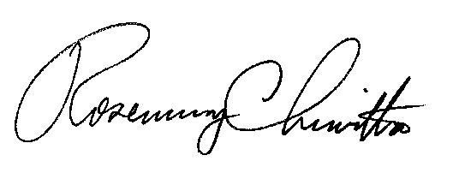
Sincerely

Rosemary Chiavetta,
Secretary

cc: Darren Gill, Bureau of Technical Utility Services
Greg Shawley, Bureau of Technical Utility Services
Chuck Covage, Bureau of Technical Utility Services

