 | COMMONWEALTH OF PENNSYLVANIA  PENNSYLVANIA PUBLIC UTILITY COMMISSION  P.O. BOX 3265, HARRISBURG, PA 17105-3265
July 11, 2012
Docket No. A-110056
JOSSI FRITZ-MAUER
THE ENERGY COOPERATIVE ASSOCIATION OF PENNSYLVANIA
1528 WALNUT ST STE 2100
PHILADELPHIA PA 19102

Re: Electric Generation Supplier License A-110056

Dear Ms. Fritz-Mauer:

On January 14, 1999, the Commission issued a permanent license at Docket No. A-110056, authorizing the Energy Cooperative Association of Pennsylvania the right to begin to offer, render, furnish, or supply electric generation supplier services to residential, commercial governmental customers in the service territory of PECO Energy, within the Commonwealth of Pennsylvania.
On May 10, 2012, the Energy Cooperative Association of Pennsylvania filed a request that the Commission change the name on its license to provide electric generation supplier services to the Energy Cooperative Association of Pennsylvania d/b/a The Energy Co-op.
The Energy Cooperative Association of Pennsylvania has provided the proper Pennsylvania Department of State documentation and a bond or other approved security as required by this Commission.
Therefore, the Commission approves, by this Secretarial Letter, the change of the Energy Cooperative Association of Pennsylvania’s name on its license for the provision of electric generation supplier services to residential, commercial and governmental customers in the service territory of PECO Energy Company, within the Commonwealth of Pennsylvania, at Docket No. A-110056, to the Energy Cooperative Association of Pennsylvania d/b/a The Energy Co-op. The Secretary’s Bureau will issue a new license with the name change.
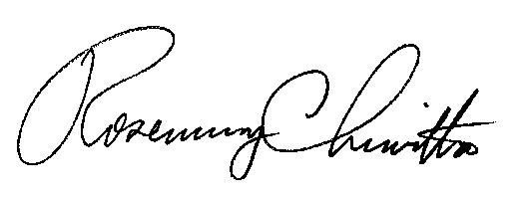
If you have any questions in this matter, please contact James Shurskis of the Bureau of Technical Utility Services, 717-787-8763, or email jshurskis@state.pa.gov.
Sincerely,

Rosemary Chiavetta
Secretary

LICENSE ENCLOSED

Cc: Kathy Aunkst, Secretary’s Bureau

