 | COMMONWEALTH OF PENNSYLVANIA  PENNSYLVANIA PUBLIC UTILITY COMMISSION  P.O. BOX 3265, HARRISBURG, PA 17105-3265 | IN REPLY PLEASE REFER TO OUR FILE
September 19, 2012
Docket No. P-2008-2062739

BRIAN D CROWE
PECO ENERGY COMPANY
2301 MARKET ST 15th FL
PHILADELPHIA PA 19103

Re: PECO Energy Company
Results of Fall 2012 Request for Proposals Process

Dear Mr. Crowe:

On September 18, 2012, PECO Energy Company (“PECO” or “the Company”) filed the results of its Request for Proposals (“RFP”) Process and Rules for the Fall 2012 Solicitation for provider of last resort service. The filing includes proposed bid results for a Block Energy RFP for Residential customers who receive default service from PECO during the period December 1, 2012 through December 31, 2014.

This filing was submitted in accordance with the RFP Process and Rules as set forth in the Joint Petition for Settlement approved by the Commission in its Order entered June 2, 2009, at Docket No. P-2008-2062739. The Joint Petition for Settlement resolved all issues in connection with PECO’s Petition, filed on September 10, 2008, requesting that the Commission approve the Company’s Default Service Program and Rate Mitigation Plan to establish rates, terms and conditions for the provision of default service for the period January 1, 2011 through May 31, 2014.

PECO requests that the Commission approve the bid results of the Fall 2012 Solicitation on or before September 19, 2012.

Further investigation does not appear to be warranted at this time, since the results of the Fall 2012 Solicitation appear to have been conducted in accordance with the RFP Process and Rules as approved by the Commission. Therefore, we approve the bid results submitted for the Fall 2012 Block Energy RFP process for the Residential class.

In addition, we direct PECO to disclose the results of this Fall 2012 Solicitation in accordance with the Commission’s Secretarial Letter in Re: Disclosure of Default Service Solicitation Results and Creation of a Default Service Rate Calculation Model, issued October 12, 2010 at Docket No. M-2009-20082042.

Please direct any questions to Anthony Rametta, Energy Division Supervisor, Bureau of Technical Utility Services, at (717) 787-2359.
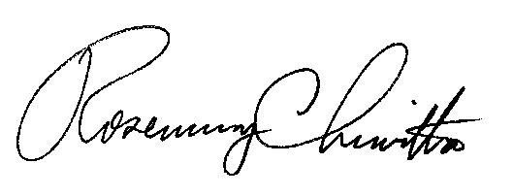
Sincerely,

Rosemary Chiavetta
Secretary

Cc: All Parties of Record

