PENNSYLVANIA
PUBLIC UTILITY COMMISSION
Harrisburg, PA 17105-3265

 | Public Meeting held October 11, 2012
Commissioners Present:

Robert F. Powelson, Chairman
John F. Coleman, Jr., Vice Chairman
Wayne E. Gardner
James H. Cawley
Pamela A. Witmer

Application of Peregrine Keystone Gas Pipeline, LLC for Approval on a Non-Exclusive Basis to Begin to Offer, Render, Furnish, or Supply Natural Gas Gathering, Compression, Dehydration, and Transportation or Conveying Service by Pipeline to the Public in All Municipalities Located in Greene and Fayette Counties and in East Bethlehem Township in Washington County, Pennsylvania | A-2010-2200201
OPINION AND ORDER

BY THE COMMISSION:

Before the Pennsylvania Public Utility Commission (Commission) for consideration and disposition is the Petition for Reconsideration (Petition), filed by the Pennsylvania Independent Oil and Gas Association (PIOGA) on September 28, 2012, seeking reconsideration of the Opinion and Order entered on September 13, 2012, relative to the above-captioned proceeding.
Pursuant to Rule 1701 of the Pennsylvania Rules of Appellate Procedure, Pa. R.A.P. Rule 1701, the Commission must act to grant a petition for reconsideration within thirty days of the date of entry of the order for which reconsideration is sought, or otherwise lose jurisdiction to do so if a petition for review is timely filed. The thirty-day period within which the Commission must act upon this Petition for Reconsideration in order to preserve jurisdiction ends on October 15, 2012. Accordingly, we shall grant reconsideration, within the meaning of Pa. R.A.P. Rule 1701(b)(3), pending review of, and consideration on, the merits of the Petition; THEREFORE,

IT IS ORDERED: That the Petition for Reconsideration filed on September 28, 2012, by the Pennsylvania Independent Oil and Gas Association is hereby granted, pending further review of, and consideration on, the merits.
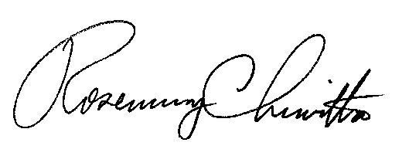
BY THE COMMISSION,

Rosemary Chiavetta
Secretary

(SEAL)

ORDER ADOPTED: October 11, 2012

ORDER ENTERED: October 11, 2012

