PENNSYLVANIA
PUBLIC UTILITY COMMISSION
Harrisburg, PA 17105-3265

 | Public Meeting September 12, 2013
Commissioners Present:

Robert F. Powelson, Chairman
John F. Coleman, Jr., Vice Chairman
Wayne E. Gardner
James H. Cawley
Pamela A. Witmer

PPL Electric Utilities Corp. Proposed Transmission Service Charge (TSC) Reconciliation for the 12 Months Ended November 30, 2010 | M-2010-2213754
PPL Electric Utilities Corp. Transmission Service Charge | M-2011-2239805

OPINION AND ORDER

BY THE COMMISSION:

Before the Commission for consideration and disposition are two petitions relative to the Commission’s August 15, 2013 Order in the captioned proceedings. In addition to making several determinations, that order referred certain matters to the Office of Administration Law Judge (OALJ) for hearings and preparation of a recommended decision.

The first petition is a Petition for Reconsideration and/or Clarification (PPL Petition), filed by PPL Electric Utilities (PPL), on August 30, 2013, seeking reconsideration and/or clarification of the Commission’s August 15, 2013 Order. The second is a Petition for Clarification and/or Reconsideration (PPLA Petition), filed by PP&L Industrial Customer Group (PPLICA), on August 30, 2013, seeking clarification and/or reconsideration of the Commission August 15, 2013 Order.

Pursuant to Rule 1701 of the Pennsylvania Rules of Appellate Procedure, Pa. R.A.P. Rule 1701, the Commission must act to grant a petition for reconsideration within thirty days of the date of entry of the order for which reconsideration is sought, or otherwise lose jurisdiction to do so if a petition for review is timely filed. The thirty-day period within which the Commission must act upon this Petition for Reconsideration in order to preserve jurisdiction ends on September 16, 2013. Accordingly, we shall grant reconsideration and clarification, within the meaning of Pa. R.A.P. Rule 1701(b)(3), pending review of, and consideration on, the merits of the Petitions, and predicated upon a recommended decision from the OALJ; THEREFORE,

IT IS ORDERED:

1. That the Petition for Reconsideration filed on August 30, 2013, by PPL Electric Utilities, and the Petition for Reconsideration filed on August 30, 2013, by PP&L Industrial Customer Group, are hereby granted, pending further review of, and consideration on, the merits.

2. That granting the Petitions for Reconsideration does not stay PPL Electric Utilities’ obligation to file the refund plan, with the supporting documentation, nor does it stay the referral of this matter to the Office of Administrative Law Judge, which shall proceed, as directed in the August 15, 2013 Commission Order.

3. That PPL Electric Utilities provide its refund plan and supporting spreadsheets, schedules, and documentation electronically in Word®-compatible format to Louise Fink Smith, finksmith@pa.gov, and Shaun Sparks, shsparks@pa.gov, in the Commission’s Law Bureau, Anthony Rametta, arametta@pa.gov, in the Commission’s Bureau of Technical Services, and Lori Burger, lburger@pa.gov, in the Commission’s Bureau of Audits, as well as to the Administrative Law Judge assigned to the proceeding.

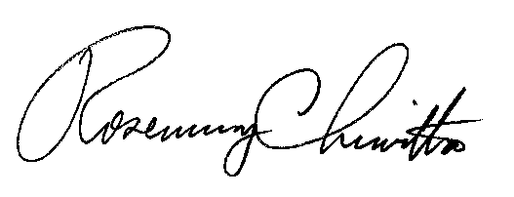
BY THE COMMISSION,

Rosemary Chiavetta
Secretary

(SEAL)

ORDER ADOPTED: September 12, 2013

ORDER ENTERED: September 12, 2013

