Petition of PPL Electric Utilities Corporation for a Waiver of the
Distribution System Improvement Charge Cap of 5% of Billed Revenues

P-2015-2474714. Petition of PPL Electric Utilities Corporation (“PPL Electric”) requesting (i) waiver of the Distribution System Improvement Charge (“DSIC”) cap of 5% of billed revenues and (ii) approval to increase the maximum allowable DSIC from 5% to 7.5% of billed revenue for service rendered on or after January 1, 2016. Act 11 of 2012 authorized public utilities to use a DSIC mechanism to facilitate the recovery of reasonable and prudent capital costs incurred to repair, improve or replace certain eligible distribution property that is part of the electric distribution companies’ distribution systems. PPL Electric’s DSIC recovery at P-2012-2325034 is currently capped at 5% of billed distribution revenues between rate cases. PPL Electric proposes to increase the maximum DSIC rate by 2.5%.
The current monthly cost of the DSIC at the maximum surcharge rate of 5% for an average residential customer is approximately $2.47 per month. Increasing the maximum DISC rate to 7.5% is expected to result in an estimated customer cost of approximately $3.70 per month at the cap. However, because the DSIC rate increases gradually each quarter, the average increase per quarter likely would be less than this amount.
Formal protests and petitions to intervene must be filed in accordance with 52 Pa. Code (relating to public utilities). Filings must be made with the Secretary of the Pennsylvania Public Utility Commission, 400 North Street, Harrisburg, PA 17120 on or before April 27, 2015. The documents filed in support of the Petitions are available for inspection in the Secretary’s Bureau from 8 a.m. to 4:30 p.m. (EST), Monday through Friday, and at the Pennsylvania Public Utility Commission's (Commission) web site at www.puc.pa.gov, and at the applicant's business address.
Applicant: PPL Electric Utilities Corporation
Through and By Counsel:
David B. MacGregor and Christopher T. Wright
Post & Schell, PC, 17 North Second Street, 12th Floor, Harrisburg, PA 17101-1601
Paul E. Russell, and Kimberly A Klock,
PPL Services Corporation, Two North Ninth Street, Allentown, PA 18106

BY THE COMMISSION
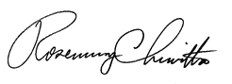
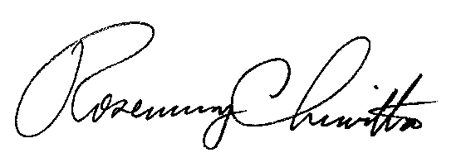
Rosemary Chiavetta
Secretary

