**PENNSYLVANIA**

**PUBLIC UTILITY COMMISSION**

**Harrisburg, PA 17105-3265**

Public Meeting held February 11, 2016

Commissioners Present:

Gladys M. Brown, Chairman

Andrew G. Place, Vice Chairman

Pamela A. Witmer

John F. Coleman, Jr.

Robert F. Powelson

|  |  |
| --- | --- |
| Petition of Metropolitan Edison Company for Approval  of their Long-Term Infrastructure Improvement Plan | P-2015-2508942 |
| Petition of Pennsylvania Electric Company for Approval  of their Long-Term Infrastructure Improvement Plan | P-2015-2508936 |
| Petition of West Penn Power Company for Approval of their Long-Term Infrastructure Improvement Plan | P-2015-2508948 |
| Petition of Pennsylvania Power Company for Approval of their Long-Term Infrastructure Improvement Plan | P-2015-2508931 |

**OPINION AND ORDER**

**BY THE COMMISSION:**

Before the Commission for consideration are the Petitions of Metropolitan Edison Company (Met-Ed), Pennsylvania Electric Company (Penelec), Pennsylvania Power Company (Penn Power), and West Penn Power Company (West Penn) (collectively, FirstEnergy, or FirstEnergy Companies) for approval of their Long-Term Infrastructure Improvement Plans (LTIIPs) The Petitions were filed on October 19, 2015. Copies of the Petitions were served on the statutory advocates.

FirstEnergy is a corporation organized and existing under the laws of the Commonwealth of Pennsylvania with its principal office in Akron, Ohio. FirstEnergy provides electric service to approximately 2 million customers located throughout a 33,000 square-mile area. FirstEnergy furnishes electric service within its authorized service territory through-out the commonwealth. FirstEnergy operates and maintains over 3000 distribution circuits.

Each of the FirstEnergy Companies are considered a “public utility” within the meaning of Section 102 of the Public Utility Code, 66 Pa. C.S. §§ 102, and, with respect to their provision of electric service, an “electric distribution company,” as defined in 66 Pa. C.S. § 2201 and are subject to the regulatory jurisdiction of the Commission.

On November 5, 2015, the Office of Small Business Advocate (OSBA) filed an Answer, Notice of Intervention, Public Statement, and Verification. In their Answer, the OSBA requested the Petitions be sent to the Office of Administrative Law Judge (ALJ) for hearings and preparation of an initial decision. The Commission’s LTIIP review procedures require LTIIPs to be referred to the ALJ if comments “raise material factual issues”. 52 Pa. Code § 121.4(c). The only section of each of the FirstEnergy Companies’ LTIIP Petitions that was denied by the OSBA was F-18. The OSBA averred there was insufficient information or knowledge to form a belief as to the truth of the Petitions’ claims in this section. This alone does not raise material factual issues. However, the Commission did agree the Petitions did not provide enough information in section F-18. Therefore, among other additional information, the Commission requested more detail on section F-18 in each of the FirstEnergy Companies’ LTIIP Petitions.

On November 18, 2015, the Office of Consumer Advocate (OCA) filed comments on the FirstEnergy Companies’ LTIIPs. The OCA did not request hearings, but suggested that the FirstEnergy Companies provide additional information to the Commission to ensure the FirstEnergy Companies’ LTIIPs accelerated infrastructure repair and replacement in a cost effective manner as required by Act 11. Specifically, OCA noted that the FirstEnergy Companies did not provide historical baseline data to compare against the proposed LTIIPs. The OCA further recommended the commission review/evaluate the FirstEnergy Companies’ biennial Inspection and Maintenance Plans to determine if the LTIIPs meet the acceleration requirements in Act 11. The OCA also suggested that previous service/reliability commitments as part of previous settlements should not be considered as accelerated infrastructure improvements and that the FirstEnergy Companies’ LTIIPs may not meet the required acceleration standard for LTIIPs.

On November 18, 2015, the Met-Ed Industrial Users Group (MEIUG) filed comments indicating they do not oppose Met-Ed’s LTIIP at this time, and that they reserve their right to raise and address cost recovery and allocation issues during any forthcoming Met-Ed distribution system improvement charge (DSIC) proceeding. In general, MEIUG expressed its concern that the Commission should ensure the overall cost effectiveness of the LTIIP and that the LTIIP projects only include eligible property categories.

On November 18, 2015, the Penelec Industrial Customer Alliance (PICA) filed comments indicating they do not oppose Penelec’ s LTIIP at this time, and that they reserve their right to raise and address cost recovery and allocation issues during any forthcoming Penelec DSIC proceeding. In general, PICA expressed its concern that the Commission should ensure the overall cost effectiveness of the LTIIP and that the LTIIP projects only include eligible property categories.

On November 18, 2015, the West Penn Power Industrial Intervenors (WPPII) filed comments to the commission indicating they do not oppose West Penn’s LTIIP at this time, and that they reserve their right to raise and address cost recovery and allocation issues during any forthcoming West Penn DSIC proceeding. In general, WPPII expressed its concern that the Commission should ensure the overall cost effectiveness of the LTIIP and that the LTIIP projects only include eligible property categories.

On December 4, 2015, the FirstEnergy Companies filed reply comments to the OCA Comments taking exception to the comment that LTIIP acceleration of utility infrastructure improvement should not be allowed for existing commitments from previous settlements.

On December 11, 2015, the Commission issued a Secretarial Letter to the FirstEnergy Companies requesting more details regarding their LTIIPs. Specifically, the request centered on the need for baseline historical expenditures related to the identified LTIIP initiatives as well as more information in regards to ensuring cost effectiveness. The Commission also sought more detail on each of the FirstEnergy Companies’ LTIIP section F-18, as noted above.

On January 8, 2016, FirstEnergy Companies filed a response to the Secretarial Letter.

**BACKGROUND**

On February 14, 2012,Governor Thomas Wingett Corbett signed into lawAct 11 of 2012 (Act 11),[1] which amends Chapters 3, 13 and 33 of Title 66. Act 11, *inter alia*, provides utilities with the ability to implement a Distribution System Improvement Charge (DSIC) to recover reasonable and prudent costs incurred to repair improve or replace certain eligible distribution property that is part of the utility’s distribution system. The eligible property for the utilities is defined in 66 Pa. C.S. §1351. Act 11 states that as a precondition to the implementation of a DSIC, a utility must file an LTIIP with the Commission that is consistent with 66 Pa. C.S. §1352. The Commission’s LTIIP Regulations are codified at 52 Pa. Code Chapter 121.

On April 5, 2012, the Commission held a working group meeting for discussion and feedback from stakeholders regarding its implementation of Act 11. On May 10, 2012, the Commission issued a Tentative Implementation Order addressing and incorporating input from the stakeholder meeting. Stakeholders filed comments to the Tentative Implementation Order on June 6, 2012. On August 2, 2012, the Commission issued the Final Implementation Order, at Docket No. M‑2012‑2293611, establishing procedures and guidelines necessary to implement Act 11.

The Final Implementation Order adopts the requirements established in 66 Pa. C.S. § 1352, provides additional standards that each LTIIP must meet, and gives guidance to utilities for meeting the Commission’s standards. The Final Implementation Order of Act 11 requires the inclusion of eight elements in the LTIIP.

**FIRSTENERGY COMPANIES’ LTIIP PETITIONS**

**FirstEnergy Companies’ Petitions**

Each of the FirstEnergy Companies’ LTIIPs are five year plans, spanning the years 2016-2020. The LTIIPs detail accelerated infrastructure improvements in order to enhance system resiliency and reliability on an aging infrastructure. In general, the FirstEnergy Companies’ reliability performance metrics for System Average Interruption Duration Index (SAIDI), System Average Interruption Frequency Index (SAIFI), and Customer Average Interruption Duration Index (CAIDI) have indicated an increasing trend in the number of equipment and line failures due to an aging infrastructure.[2] Below is a summary of the FirstEnergy Companies’ total expected LTIIP expenditures.

* Met-Ed has outlined 18 initiatives totaling $43.44 million
* Penelec has outlined 17 initiatives totaling $56.74 million
* West Penn has outlined 15 initiatives totaling $88.34 million
* Penn Power has outlined 6 initiatives totaling $56.35 million

**Met-Ed**

Met-Ed’s LTIIP allocates $16.02 million for projects and programs in response to a Pennsylvania Management Audit Order on March 30, 2015,[3] and $22.37 million in additional reliability plan improvements. These accelerated expenditures will replace obsolete or aging infrastructure and will construct new infrastructure designed to split large circuits and provide additional feeds to circuits during outage events. Met-Ed’s plan is to achieve benchmark-level performance for SAIFI, SAIDI, and CAIDI by 2018. Met-Ed also allocated $5.05 million for unreimbursed costs of required highway relocation projects.

**Penelec**

Penelec’s LTIIP allocates $29.19 million for projects and programs in response to a Pennsylvania Management Audit Order on March 30, 2015,[4] and $20.74 million in additional reliability plan improvements. These accelerated expenditures will replace obsolete or aging infrastructure and will construct new infrastructure designed to split large circuits and provide additional feeds to circuits during outage events. Penelec’s plan is to achieve benchmark-level performance for SAIFI, SAIDI, and CAIDI by 2018. Penelec also allocated $6.81 million for unreimbursed costs of required highway relocation projects.

**Penn Power**

Penn Power’s LTIIP allocates $29.65 million for projects and programs in response to a Pennsylvania Management Audit Order on March 30, 2015,[5] and $20.65 million in additional reliability plan improvements. These accelerated expenditures will replace obsolete or aging infrastructure and will construct new infrastructure designed to split large circuits and provide additional feeds to circuits during outage events. Penn Power’s plan is to achieve benchmark-level performance for SAIFI, SAIDI, and SAIDI by 2018. Penn Power also allocated $6.05 million for unreimbursed costs of required highway relocation projects.

**West Penn**

West Penn’s LTIIP allocates $33 million for projects and programs in response to a Pennsylvania Management Audit Order on March 30, 2015,[6] and $48.14 million in additional reliability plan improvements. These accelerated expenditures will replace obsolete or aging infrastructure, accelerate rehabilitation of Worst Performing Circuits, and accelerate system modernization and automation to enhance distribution system sectionalizing designed to reduce the impact of outages. West Penn’s plan is to achieve benchmark-level performance for SAIFI, SAIDI, and CAIDI by 2018. West Penn also allocated $7.2 million for unreimbursed costs of required highway relocation projects.

The FirstEnergy Companies in their individual petitions addressed the eight LTIIP elements required in the Final Implementation order of Act 11 as discussed below:

**(1) TYPES AND AGE OF ELIGIBLE PROPERTY**

**FirstEnergy Position**

Tables 1 through 4, below, describe the types and ages of eligible property for each of the initiatives outlined in the individual FirstEnergy Companies’ LTIIPs

**Table 1 – Met-Ed Types and Age of Eligible Property**



**Table 2 – Penelec Types and Age of Eligible Property**



**Table 3 – Penn Power Types and Age of Eligible Property**

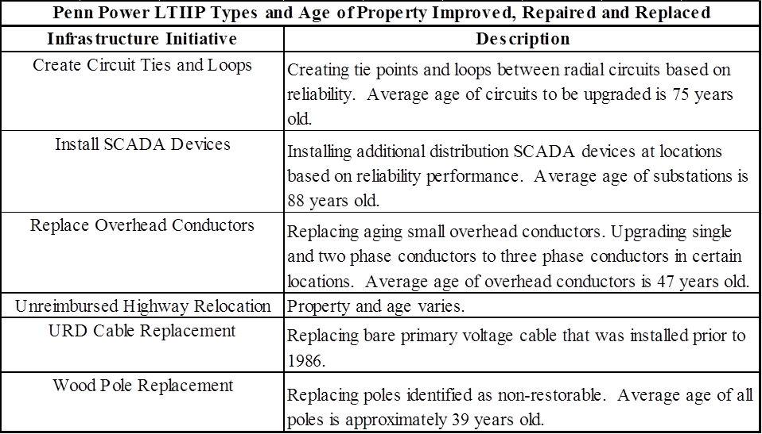

**Table 4 - West Penn Types and Age of Eligible Property**



**Comments**

No comments were received regarding the types and ages of eligible property.

**Resolution**

Upon review of FirstEnergy Companies’ LTIIPs and all supplemental information filed, the Commission finds the types and ages of eligible property requirements of element one of the Final Implementation Order have been fulfilled. The Commission acknowledges the level of detail contained within the LTIIP for item one conforms to Commission requirements and is presented in a manner that allows for complete and efficient review of, and reference to, these materials.

**(2) SCHEDULE FOR PLANNED REPAIR AND REPLACEMENT OF ELIGIBLE PROPERTY**

**FirstEnergy Position**

Tables 5 through 8, below, provide the schedule for planned projects for each of the FirstEnergy Companies’ initiatives for 2016 thru 2020 and the accelerated repair and replacement of eligible property based on the LTIIP project categories. The information in the tables is based on the FirstEnergy Companies LTIIPs and supplemental information filed with the Commission’s Bureau of Technical Utility Services.

**Table 5 – Met-Ed LTIIP Project Schedule**



**Table 6 – Penelec LTIIP Project Schedule**



**Table 7 – Penn Power LTIIP Project Schedule**

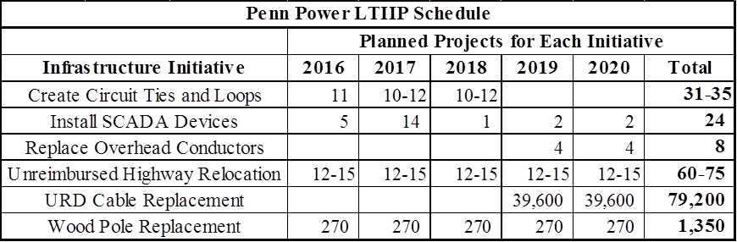

**Table 8 – West Penn LTIIP Project Schedule**



**Comments**

No comments were received regarding the types and ages of eligible property.

**Resolution**

Upon review of FirstEnergy’s LTIIPs and all supplemental information filed, the Commission finds the schedule for planned repair and replacement of eligible property requirements of the Final Implementation Order has been fulfilled. The Commission acknowledges the level of detail contained within the LTIIPs conforms to Commission requirements and is presented in a manner that allows for complete and efficient review of, and reference to, these materials.

**(3) LOCATION OF THE ELIGIBLE PROPERTY**

**FirstEnergy Position**

The FirstEnergy Companies aver that total eligible property as outlined in the LTIIPs is located throughout the individual FirstEnergy Companies’ territory. Tables 9 through 12, below, provide information on the expected locations of the LTIIP projects for each of the FirstEnergy Companies. The locations provided are the Operations Centers for each of the companies. These Operations Centers cover a general geographic area surrounding the center. While the exact locations of the projects depend on various factors (customer impact, reliability impact, identification of targeted infrastructure, etc.), FirstEnergy has outlined the expected number of projects in each LTIIP initiative for each of the Operations Center areas.

**Table 9 – Met-Ed LTIIP Project Locations**



**Table 10 – Penelec LTIIP Project Locations**



**Table 11 – Penn Power LTIIP Project Locations**

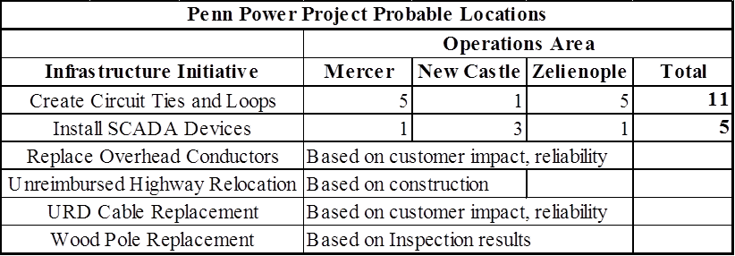

**Table 12 – West Penn LTIIP Project Locations**



**Comments**

No comments were received regarding the locations of the eligible property.

**Resolution**

Upon review of the FirstEnergy Companies LTIIPs and all supplemental information filed, the Commission finds the location of eligible property requirements of the Final Implementation Order has been fulfilled. The Commission acknowledges the level of detail contained within the LTIIPs conforms to Commission requirements and is presented in a manner that allows for complete and efficient review of, and reference to, these materials.

**(4) REASONABLE ESTIMATES OF THE QUANTITY OF PROPERTY TO BE IMPROVED**

**And,**

**(5) PROJECTED ANNUAL EXPENDITURES AND MEASURES TO ENSURE THE PLAN IS COST EFFECTIVE**

**FirstEnergy Position**

The FirstEnergy Companies provided information on the expected annual expenditures for each project initiative category in their respective LTIIPs. The LTIIP expenditures represent an incremental increase over the expected normal spending in those categories. The FirstEnergy Companies also provided baseline expenditures from the previous five years (for the same categories as the LTIIP initiatives). The baseline and projected expenditure information is attached as Appendix A. The number and types of LTIIP projects are detailed in Tables 1 through 8, above. FirstEnergy proposes to increase overall spending on maintaining and improving reliability by $450 million over the next 5 years. Table 13, below, details the historic and projected reliability spending of the FirstEnergy Companies. This is inclusive of the projected LTIIP expenditures (with the exception of the unreimbursed highway relocation expenditures).

**Table 13 – FirstEnergy Reliability Expenditures**



In addition to the expenditure information, FirstEnergy provided information on measures to ensure cost effectiveness. These measures include ensuring projects are completed by qualified and trained FirstEnergy personnel, or selected Contractors of Choice (COCs). COCs are employed for those projects that would be competitively bid. Those projects are determined by evaluating the expected construction hours needed to complete the projects versus the amount of internal labor hours available. Table 14, below, provides the estimated percentage of projects that will be competitively bid for each of the companies for 2016. FirstEnergy is not able to provide an estimate for the years 2017 through 2020 as the labor hour evaluations are only projected the year prior to implementation.

**Table 14 – Percentage of Competitively Bid Work**

|  |  |
| --- | --- |
| **Company** | **2016 percentage of outsourced work** |
| Met-Ed | 0% |
| Penelec | 68% |
| Penn Power | 60% |
| West Penn | 87% |

FirstEnergy evaluates the COCs using a contractor review survey scorecard. This scorecard evaluates the COCs performance related to safety, quality, timeliness, cost and other factors. Poor performing COCs are held accountable and may be held to a performance improvement plan, if necessary. FirstEnergy provided a sample scorecard for review. FirstEnergy selects COCs for projects through the COC guidelines, which include issuing a competitively bid request for proposal (RFP). FirstEnergy provided a sample RFP for review. RFP responses are evaluated by FirstEnergy’s engineering, project management, and supply chain groups. COCs are then selected based on the ability of the COC to provide: qualified personnel; equipment resources; understanding of the project scope; constructability; management and safety oversight; and pricing.

FirstEnergy avers that they ensure materials are procured in a cost effective manner through their formalized sourcing procedure. FirstEnergy notes this process allows the company to be assured of receiving the best evaluated supplies and components. Pricing is also evaluated as part of the process. FirstEnergy provided a copy of their procedures for sourcing materials and services. FirstEnergy also monitors that disposal and salvage of materials is completed in a safe and environmentally sensitive manner. This process also ensures any credit for salvage is recognized as an offset to the cost of removal.

The FirstEnergy Companies plan to analyze the cost effectiveness of the individual LTIIP initiatives through the projected improvements in their SAIDI and SAIFI metrics. It is expected these improvements will allow the FirstEnergy Companies to achieve benchmark performance in 2018 and beyond. FirstEnergy provided a table, attached as Appendix B, that details the estimated improvements in SAIDI and SAIFI from 2016 through 2018. FirstEnergy noted that forecasting direct reliability impacts beyond 2018 is difficult and would not be of benefit as the calculations used for the estimates utilize reliability performance from the previous three years. FirstEnergy stated the SAIDI and SAIFI impacts represented the potential avoidance of outages and were based on historic reliability information from 2012 through 2014. In general, FirstEnergy noted the LTIIP expenditures are considered cost effective because the infrastructure that will be replaced and/or upgraded will have a direct impact on customer service and increase reliability.

FirstEnergy outlined a two-part methodology to evaluate the benefits and cost-effectiveness of the LTIIPs based on the reliability improvements. First, FirstEnergy plans to calculate the realized reliability benefits by using actual circuit specific outage and reliability data over a certain time period after an LTIIP project is completed. FirstEnergy provided the time period example of three years, which is consistent with their methodology for the expected SAIDI and SAIFI benefits mentioned, above.

The second part of the methodology proposed by FirstEnergy related to evaluating outage cost trends. FirstEnergy proposed to calculate costs by using categories such as unscheduled repair of overhead and underground facilities, line failure follow up orders, and funds allocated towards storm repairs (not including Major Event outages as defined in 52 Pa. Code § 57.192). FirstEnergy will then evaluate those costs over a time period such as five years and then compare the costs to historical outage costs. In summary, FirstEnergy will evaluate the realized SAIDI and SAIFI benefits versus the expected benefits as well as determine any cost savings related to avoided outages.

**Comments**

The OCA, MEIUG, PICA, and WPPII all commented generally that the Commission should thoroughly examine the FirstEnergy Companies’ LTIIPs to ensure cost effectiveness. The OCA specifically noted that the FirstEnergy Companies should provide more detail to the Commission on how cost effectiveness would be calculated. The OSBA in its Answer averred there was insufficient information or knowledge to form a belief as to the truth of the Petitions’ claims in sections related to determining cost effectiveness.

**Resolution**

Upon review of FirstEnergy Companies’ LTIIPs and supplemental information filed, the Commission finds the reasonable estimates of the quantity of property to be improved and the projected annual expenditures and measures to ensure that the plan is cost effective, requirements of elements of the Final Implementation Order of Act 11 have been fulfilled. The Commission acknowledges the level of detail contained within the LTIIP, and the supplemental information filed, conform to Commission requirements and are presented in a manner that allows for complete and efficient review of, and reference to, these materials.

The concerns of the OCA, OSBA, MEIUG, PICA, and WPPII have been addressed by the FirstEnergy Companies’ LTIIPs and supplemental information filed, including FirstEnergy’s detailed explanation of the COC and procurement processes, as well as their methodology of how cost effectiveness would be determined. However, we agree that it is important to continue to fully evaluate the cost effectiveness of the LTIIPs. Although the Commission receives an annual report on the progress of the LTIIPs through the required Annual Asset Optimization Plans, as explained by FirstEnergy, the realization of the benefits and cost savings will take a period of time after the LTIIP projects have been completed. Therefore, we shall require FirstEnergy to provide the Commission a report, within 120 days after the LTIIP period ends, that evaluates the cost effectiveness of the LTIIP initiatives for each of the operating companies. The Commission may also seek subsequent updates on cost effectiveness evaluations as the reliability benefits are realized.

**(6) ACCELERATED REPLACEMENT AND MAINTAINING SAFE AND RELIABLE SERVICE**

**FirstEnergy Position**

The FirstEnergy Companies aver that the LTIIP projects are an acceleration of past and current projects and will enhance safe and reliable service. FirstEnergy provided information regarding the historical spending in the eligible property categories outlined in the LTIIP project areas. This information is summarized in Appendix A. FirstEnergy noted that the projected expenditures in Appendix A for 2016 to 2020 represent the incremental increase over and above the normally planned expenditures in those categories. As shown in Table 13, above, FirstEnergy plans to increase spending on reliability improvements, including the incremental increases represented by the expenditures in the LTIIPs. FirstEnergy also provided information on the expected reliability improvements as summarized in Appendix B.

**Comments and Reply Comments**

The OCA noted that the FirstEnergy Companies’ LTIIPs may not meet the standard for the required acceleration component because FirstEnergy did not provide sufficient background information on how it will accelerate infrastructure repair and replacement. The OCA also noted that FirstEnergy may not be meeting the acceleration standard because many of the LTIIP initiatives relate to previous commitments made by the companies to improve infrastructure and reliability (OCA Comments at 4-7). The OCA summited that should a DSIC be implemented at some point for the FirstEnergy Companies, the expenditures should be for accelerated infrastructure improvements and not for previous commitments made by the companies without additional DSIC surcharges (Comments at 8) .

FirstEnergy, in its Reply Comments, noted that the OCA’s suggestion that an LTIIP must accelerate infrastructure improvements beyond a utility’s existing commitments is not supported by the Code, regulations, or previous LTIIP approval Orders (FirstEnergy Reply Comments at 2). FirstEnergy submitted that the Commission’s regulations recognized that the acceleration of infrastructure improvements may have preceded the filling of an LTIIP and that the Commission reviews each LTIIP to determine whether it “[s]pecifies the manner in which it accelerates or maintains an accelerated rate of infrastructure repair, improvement or replacement.” 52 Pa. Code § 121.4(e)(2). FirstEnergy further noted that the Commission had already approved an LTIIP where certain of the accelerated infrastructure improvements were part of commitments made in an earlier Settlement (Reply Comments at 2).[7] FirstEnergy submitted that the Commission should reject the OCA’s assertion that an LTIIP must accelerate the pace of infrastructure improvements beyond existing commitments.

**Resolution**

FirstEnergy is correct in noting that we have previously approved an LTIIP where certain of the accelerated infrastructure improvements were part of commitments prior to the filing of the LTIIP. Moreover, we have approved an LTIIP that maintained an already accelerated rate of infrastructure improvement.[8] The fact that many of the LTIIP projects outlined by FirstEnergy relate to previous commitments for improvement is irrelevant. FirstEnergy has demonstrated that the LTIIP expenditures are an acceleration of historical spending in the eligible property categories outlined in the LTIIP projects areas. Therefore, we disagree with the OCA. Upon review of the FirstEnergy Companies’ LTIIPs and supplemental information, the Commission finds the manner in which replacement of aging infrastructure will be accelerated and how repair, improvement or replacement will maintain safe and reliable service requirements of the Final Implementation Order have been fulfilled. The FirstEnergy Companies are clearly planning to accelerate their infrastructure replacement over the timeframe of the LTIIPs and have demonstrated that completion of the planned projects of the LTIIPs will maintain safe and reliable service.

**(7) WORKFORCE MANAGEMENT AND TRAINING PROGRAM**

**FirstEnergy Position**

The Final Implementation Order requires utilities to include within its LTIIP a workforce management and training plan designed to ensure the utility will have access to a qualified workforce to perform work in a cost-effective, safe and reliable manner.

The FirstEnergy Companies created a Power Systems Institute (PSI) which is a two-year associate degree program that would allow graduates the opportunity for entry level positions based on the companies’ standard hiring process. FirstEnergy averred that this ensures new hires are familiar with the FirstEnergy processes, safety programs, and system.

FirstEnergy also provides ongoing internal formal training through the Workforce Development (WFD) team. The WFD team develops, conducts, and evaluates knowledge and skills training for apprentices and incumbents. The FirstEnergy Companies adhere to the following, but not inclusive, applicable regulations that are incorporated into the FirstEnergy Companies’ work practices, procedures, construction standards, and Accident Prevention Handbook:

* Occupational Safety and Health Administration Regulations for Electrical Power Generation, Transmission, and Distribution Standard
* American National Standards Institute
* American Society for Testing Materials
* Institute of Electrical and Electronics Engineers Standards

The FirstEnergy Companies size the workforce to accommodate steady state workload that includes day-to-day activity and a reasonable level of storm response as projected from historical averages. Any additional qualified manpower needed to complete LTIIP projects will be acquired in accordance with the FirstEnergy Companies’ Contractor of Choice (COC) Program that was described, above. This ensures contractors are selected based on available manpower and equipment resources, understanding of project scope, constructability, management and safety oversight and pricing.

**Comments**

No comments were received regarding the workforce management and training program.

**Resolution**

Upon review of FirstEnergy Companies’ LTIIPs and supplemental information, the Commission finds the workforce management and training program requirements of the Final Implementation Order have been fulfilled.

1. **A description of a utility’s outreach and coordination activities with other utilities, PennDOT and local governments on planned maintenance/construction projects**

**FirstEnergy Position**

FirstEnergy noted that most of the work being performed under their LTIIPs will likely have minimal impact on other entities’ work schedules. Therefore, FirstEnergy noted that they do not have any LTIIP-specific outreach plans developed. However, the FirstEnergy Companies will continue their regular communication and coordination with the Pennsylvania Department of Transportation (PennDOT), local governments, local municipalities, and other utilities that would be impacted by any LTIIP activities. Examples of coordination efforts include press releases, public meetings, and communication with customers that may experience a planned outage as a result of LTIIP project work.

**Comments**

No comments were received regarding the coordination activities.

**Resolution**

Upon review of the FirstEnergy Companies’ LTIIPs, the Commission finds the coordination activities requirements of the Final Implementation Order have been fulfilled.

**LTIIP SUMMARY**

The Commission reviewed the eight required elements for each FirstEnergy Company Petition for Approval of their LTIIPs and any resulting Petition comments. The FirstEnergy Companies’ proposed LTIIPs appear to demonstrate their associated expenditures are reasonable, cost effective, and designed to ensure and maintain efficient, safe, adequate, reliable, and reasonable service to their customers.

**CONCLUSION**

The Commission finds that the FirstEnergy Companies’ Long-Term Infrastructure Improvement Plans and the manner in which they were filed conform to the requirements of Act 11 and our Final Implementation Order. The plans, as approved herein, are designed to maintain safe, adequate and reliable service and, as such, the FirstEnergy Companies shall be required to comply with the infrastructure replacement schedule and elements of each plan. **THEREFORE,**

**IT IS ORDERED:**

1. That the Petition for Approval of Long-Term Infrastructure Improvement Plan (LTIIP) filed by Metropolitan Edison Company is approved, consistent with this Order.

2. That the Petition for Approval of Long-Term Infrastructure Improvement Plan (LTIIP) filed by Pennsylvania Electric Company is approved, consistent with this Order.

3. That the Petition for Approval of Long-Term Infrastructure Improvement Plan (LTIIP) filed by Pennsylvania Power Company is approved, consistent with this Order.

4. That the Petition for Approval of Long-Term Infrastructure Improvement Plan (LTIIP) filed by West Penn Power Company is approved, consistent with this Order.

5. That FirstEnergy shall file a report with the Commission, within 120 days after the LTIIP period ends, that evaluates the cost effectiveness of the LTIIP initiatives for each of the operating companies and that a copy of the report shall be filed with the Reliability and Emergency Preparedness Section of the Bureau of Technical Utility Services.

**BY THE COMMISSION,**

Rosemary Chiavetta

Secretary

(SEAL)

ORDER ADOPTED: February 11, 2016

ORDER ENTERED: February 11, 2016

**Appendix A – FirstEnergy Companies’ Baseline and Accelerated LTIIP Expenditures**



**Appendix B – FirstEnergy Companies’ Projected SAIFI and SAIDI Improvement 2016-2018**



1. <http://www.legis.state.pa.us/WU01/LI/LI/US/HTM/2012/0/0011..HTM>
2. SAIDI measures the average outage duration time (in minutes) for every customer served during the year. SAIFI measures the average frequency of power interruptions for every customer served during the year. CAIDI measures the average power restoration time (in minutes) for every customer who lost power during the year.
3. *See* Docket No. D-2013-2365991.
4. *Id*.
5. *Id*.
6. *Id*.
7. *See* Docket No. P-2013-2398833, *Petition of UGI Utilities, Inc. for Approval of its Long Term Infrastructure Improvement Plan*, Order entered July 31, 2014
8. See Docket No. P-2012-2325034, *Petition of PPL Electric Utilities Corporation for Approval of its Long Term Infrastructure Improvement Plan*, Order entered January 10, 2013.