BEFORE THE
PENNSYLVANIA PUBLIC UTILITY COMMISSION

Notice of En Banc Hearing on Alternative : Docket No. M-2015-2518883
Rate Making Methodologies :

TESTIMONY

OF

DAVID F. CIARLONE, PE

OF

ALCOA INC.

ON BEHALF OF

INDUSTRIAL ENERGY CONSUMERS OF PA

FEBRUARY 25, 2016
Good afternoon Chairman Brown, Vice Chairman Place and Commissioners Powelson, Coleman and Witmer. My name is David Ciarlone, and I am the Senior Manager for Energy and Carbon at Alcoa Inc. Alcoa operates a variety of energy-intensive processes associated with the production and use of aluminum and other lightweight metals at five production and research facilities in Pennsylvania and over one hundred-sixty other locations across the United States and around the world.
Today, I represent the Industrial Energy Consumers of Pennsylvania (IECPA). We are a trade organization formed in 1982 by large energy-intensive customers with one or more facilities in Pennsylvania. Our 18 members spend more than $1 billion annually on natural gas and electricity and provide more than 41,000 good paying jobs in the Commonwealth.
IECPA commends the Commission for initiating a constructive dialogue on these important and timely topics, and we are eager to play our part. That said, I am advised that it would probably not be possible to implement many of the ideas we are discussing today without first making certain changes to the governing statutes in the Commonwealth, and I further understand that there are no cases presently being considered that directly touch upon any of the issues we are discussing today. Hence, rather than litigating hardened positions, you have provided the opportunity for us to engage on these issues on the level of values, principles and expectations. It is in this way that I share IECPA's views on these issues.
At the core of these discussions are the three questions posed by the Commission in the hearing notice:

- Whether revenue decoupling and similar rate mechanisms encourage energy utilities to better implement energy efficiency and conservation programs;

- Whether these rate mechanisms are just and reasonable and in the public interest; and,

- Whether the benefits of implementing such rate mechanisms outweigh any costs associated with implementing the rate mechanisms.

In each case, our answer is a firm, but respectful, no.

Later in this testimony we revisit each question individually and explain the basis for our position. However, before doing so, it is constructive to first explain something about our situation, our guiding principles and our expectations on ratemaking in order to help those who will use this record to more fully appreciate our perspectives on rate design and energy efficiency.

IECPA and Manufacturing Commitment to Energy Efficiency and Pennsylvania
Again, we are pleased that in inviting our testimony, the Commission recognizes manufacturing's crucial role in Pennsylvania's economy. Statistics recently compiled by the National Association of Manufacturers (NAM) highlight the value of manufacturing Pennsylvania.
- Manufacturing provides over 565,200 jobs within Pennsylvania, which is over 9.7% of the state's workforce.
- The average annual compensation for each of these jobs is $69,203, which is 39% higher than non-manufacturing jobs.
- The average annual contribution to Gross State Product for each of these jobs is $136,890.
- Manufacturing accounts for 91% of Pennsylvania's exports.
Many of our IECPA members, and in fact many of the manufacturers across the Commonwealth, are what have become known as Energy-Intensive, Trade-Exposed (EITE) businesses. This term explains much of our perspective and behavior. "Energy-Intensive" means even small increases in energy prices translate into large increases in energy costs that, because energy is one of the largest variable costs of production, further translate into significant decreases in profitability. "Trade-Exposed" means that these manufacturers serve customers who are able to fill their needs from competing suppliers around the globe. A "Trade-Exposed" manufacturer operating in Pennsylvania that passes cost increases on to a customer risks losing that business to a global competitor. These businesses must proactively manage all of their costs, and they need to squeeze every bit of productivity from what they spend on land, buildings, raw materials, people and energy. If these businesses relax their control on any of these costs, they surrender their competitive advantage, and they soon perish.
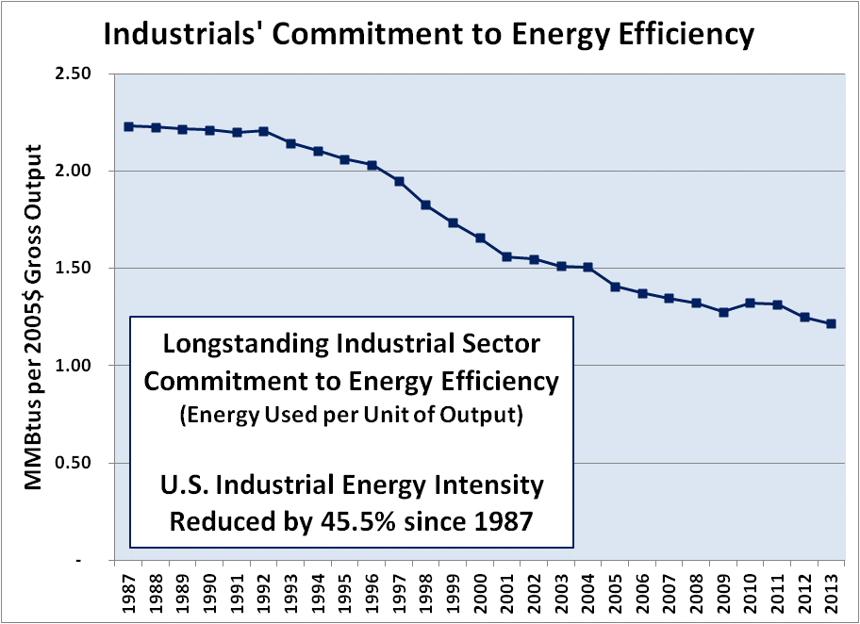
Taking note that Pennsylvania's manufacturers are typical of US manufacturing, Figure 1 clearly demonstrates a consistent commitment to energy efficiency in the US industrial sector. The data shows that persistent efforts have cut energy intensity by over 45% since at least 1987. This data proves the assertion that energy efficiency is both a matter of survival and a fact of everyday life for EITE manufacturers. We practice energy efficiency every day. We practice energy efficiency with or without rebates, and whether or not anyone is watching. We live energy efficiency every day because of the competition we face.
Figure 1

Clearly, IECPA and the balance of Pennsylvania's industrial end users appreciate the value of energy efficiency. But we assert that it is of at least equal value for the Commonwealth to hold a sharp focus on making and keeping Pennsylvania an attractive place for EITE industrials and manufacturers of all kinds to locate and grow their operations. Energy efficiency and conservation are important tools, but the real goal is economic growth and the hundreds of thousands of family sustaining jobs it brings.

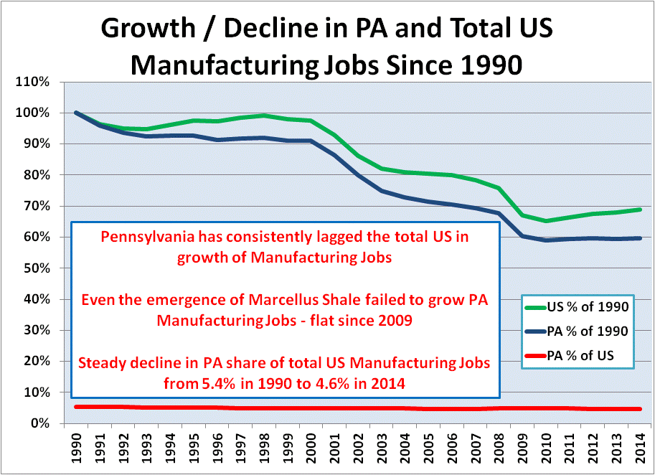
It is also important to recall, as we consider alternative ratemaking methodologies, that these are challenging times for American manufacturing. US manufacturing faces global competition that does not always share the same commitment to fair labor, safety and environmental compliance that US manufacturers have and pay for. Quite often, US manufacturers face competitors that are benefiting from manipulated currencies. The situation is even more acute in Pennsylvania. Figure 2 shows the degree to which Pennsylvania has lagged the nation in manufacturing jobs. This underscores the care that the Commonwealth must take in designing how we allocate energy costs to this sector of our economy, particularly to our EITE businesses.
Figure 2

Despite these challenges, large, energy intensive manufacturers have continued to invest their capital in Pennsylvania. Thirteen IECPA member businesses have added over $2 billion to the state's economy for various facility upgrades since 2010. That is, these thirteen companies alone made capital investments that exceed all of the capital expenditures made statewide under the PA Act 129 Programs to-date.

Five Guiding Principles
IECPA's views on Alternative Ratemaking Methodologies, as with energy policy in general, are shaped by applying our Five Guiding Principles: Affordability; Reliability; Stability; Predictability and Sustainability.

Affordability is the measure by which our energy price compares favorably to the costs paid by our competition and sister facilities in other states. This is not limited to a simple comparison of energy costs. It includes consideration of the degree to which energy costs contribute to a competitive advantage in total cost of production.

Reliability is important in three dimensions. First is our ability to maintain production schedules and customer retention by keeping our promises to our customers on delivery dates. Second is our ability to maintain our production facilities free of damage due to unscheduled disruptions in operations. Finally, and most important, is our ability to maintain a safe work place. Sudden, unplanned stoppages to operating equipment is extremely hazardous.

Stability is important because our stakeholders demand financial results that do not vary wildly month to month. Energy prices that are not stable discourage investment in future projects.

Predictability is important because our stakeholders need to trust that we can write long-term business plans on which we can reliably deliver. Unpredictable energy costs undermine the confidence in our long-term business plans, which also discourages investment in future projects.

Sustainability has two dimensions. The first is our responsibility to be good stewards of the environment, while the second is our responsibility to the long-term success of our business and that of our suppliers. Maintaining focus on both of these dimensions require a focus and a commitment to the long-term.

Key Expectations on Ratemaking
Application of our Guiding Principles lead us into a few expectations on ratemaking:

- Cost-of-Service: Utility revenues should be sufficient to sustain its operations over the long-term and should consist of the recovery of all prudently incurred expenses, plus an opportunity to earn a fair return on all used and useful capital investment, and not one dollar more.

- Cost Causation: Rates should be designed to achieve a single purpose: to collect the appropriate revenues from customers in a manner that corresponds to the costs that each customer imposes upon the utility's system.

- Maintenance and Reliability: Certain expenses and investments required to ensure adequate system reliability should be included in rates, and utilities should exercise a degree of diligence and care in the planning and maintenance of their facilities so that expenses and investments can be predicted and planned. Trackers, because they introduce sudden and unpredicted changes in energy costs, should be avoided in all but the most extreme cases.

- Appropriate Oversight: Periodic, comprehensive review of rates is the best way to ensure that both utilities and customers enjoy reliable service and the collection of revenues that are appropriate and fairly allocated – i.e., just and reasonable rates.

- Focus on Purpose: Using utility rates to encourage outcomes unrelated to the fair allocation of revenues appropriate to ensure reliable service, no matter how worthy, will almost invariably violate one or more of our Guiding Principles and open the door to unintended consequences and perverse incentives.

The Main Issues Identified by the Commission
In announcing this hearing, the Commission identified three specific issues, which we address in turn from our own perspective.

At the core of the Commission's examination of alternative ratemaking methodologies is interest, by some, in revenue decoupling. The term "decoupling" itself presents a challenge. It is so overused that it has lost precise definition. Any new discussion of alternative ratemaking mechanisms in Pennsylvania must begin by establishing accepted definitions.

As we understand it, revenue decoupling, regardless of its form, essentially disconnects an electric utility's profits from the amount of electricity it distributes to end users. Proponents of decoupling present it as a means for a utility to encourage its customers to reduce energy use without reducing the utility's own revenue. The goal is to remove the natural incentive a utility has to increase energy sales.

Decoupling begins with essentially the same process as traditional ratemaking: a rate case. Based on a test time period, the rate case determines what the utility's profits should be. With a decoupled methodology, however, utility rates are regularly adjusted (either across the board or on a per-class basis) to ensure that the utility generates its allotted revenue. These adjustments are made frequently and are based upon some predetermined formula. Thus, in times of generally low electricity usage, rates, or assigned cost per kilowatt-hour will tend to rise as a fixed revenue is being recovered over fewer units of energy. Similarly, in times of generally high usage, rates, or assigned cost per kilowatt-hour would purportedly fall. In theory, this would provide a "correcting mechanism" to ensure that utilities' profits remain relatively constant.

Though decoupled ratemaking methodologies differ in details, they all still generally involve charging consumers for all of the utility's costs based upon the usage. The difference is that the rate, or assigned cost per kilowatt-hour, varies based on the consumption of the utility's broader customer base.

- Whether revenue decoupling and similar rate mechanisms encourage energy utilities to better implement energy efficiency and conservation programs;

No. Starting with the assumption and the basic social contract that the Commission will ensure that the utility earns an appropriate amount of total revenues (recovery of costs and return on invested capital, as described above), the various rate mechanisms utilized to produce that total revenue should be a matter of indifference to the utility and therefore should not encourage one type of behavior over another.

However, from the perspective of the customer, the answer is still "no," but for different reasons. In IECPA's view, decoupling and similar alternative ratemaking mechanisms are counterproductive because they remove customers' incentive to reduce energy consumption for cost savings.

It is constructive to underscore that for both the large, energy-intensive customer and the utility alike, decoupling creates the ultimate of perverse incentive: it eliminates the most efficient positive reinforcement for positive action. For the large, energy-intensive customer, decoupling eliminates the incentive to make incremental investment in energy efficiency. Why should a business undertake a large investment in new equipment, facilities, training, permits, etc., to reduce its energy intensity if it will not be able to earn a return on that investment through lower energy costs? For the utility, decoupling eliminates a significant incentive to rapid restoration of service after a storm-related outage. Without the direct link between revenue recovery and system reliability, is there sufficient motivation for a utility to incur overtime costs and expose its trouble crews to the hazards of system restoration work during severe weather in the dark?

As we have stated in the past, IECPA believes that utility rates that are designed and allocated in accordance with cost-of-service principles are a better method to encourage the full range of desired behaviors on the part of customers and utilities alike.

- Whether these rate mechanisms are just and reasonable and in the public interest;

No. These mechanisms, to the extent we understand what is meant by the general term, involve collecting fixed costs as if they were dependent upon consumption. This is a departure from the principle of cost-causation, and causes high load factor customers, who make the most complete and most efficient use of the infrastructure maintained by the utility, to subsidize low load factor customers who create the need for the underutilized facilities.

Revenue decoupling can result in frequent and irregular rate increases between rate cases. As described above, rates can go either down or up (depending on system-wide electricity consumption). However, because the goal of decoupling is energy conservation, the more successful those efforts are, the more large electricity users will see their rates increase, even with continued attention to improving energy efficiency and conservation initiatives at their facilities.

Decoupling shifts risk from utilities to consumers, and can result in intra-class and inter-class cost shifting. While individual electricity consumers are still charged based on their own usage, the rate per kilowatt-hour is determined by the total amount of electricity delivered by that utility to a broader group of customers, and no longer related to the utility's cost to serve that customer. For example, if the decoupling mechanism is structured as a surcharge, that surcharge could require a Large C&I customer to restore revenues lost by the utility through usage reductions by customers on different rate schedules or even those in different customer classes. While individual consumers still control how much electricity they use, they can no longer expect the rate they pay to remain stable or predictable between rate cases under this scenario. For Large C&I users who are already maximizing their efforts to reduce energy intensity, decoupling will not help them reduce energy use; rather, it will simply make their rates subject to fluctuations of other companies' or customer classes' energy use.

The artificial and arbitrary incentives embodied in decoupling or other alternative ratemaking methodologies open the door to subjective criteria that are unpredictable case to case. In such a situation, the Commission could find itself forced to make one subjective judgement after another while chasing a fix to the fix.

Clear in the discussion of all of these concerns is the fact that decoupling, of whatever form, would result in the violation of at least two or our Guiding Principles: Stability and Predictability. "Decoupled" utility rates would introduce a degree of arbitrary and subjective decision making criteria that would create uncertainty and be harmful to the ratemaking process, especially for Large C&I customers. For example, it would be very difficult to distinguish between sales and revenue reductions that occur due to the implementation of energy efficiency versus those resulting from other causes (such as weather, the loss of major customers or storm outages). This would be particularly true for advanced manufacturers using competitively sensitive and proprietary production processes. The introduction of factors like weather and the shifting tides of businesses in other industries into the mix of rate making elements would render such rate changes to be random, and hence not 'just and reasonable and in the public interest'.

- Whether the benefits of implementing such rate mechanisms outweigh any costs associated with implementing the rate mechanisms.

No. By decoupling the cost of using something from what it costs to make it, we introduce artificial and arbitrary incentives that almost inevitably lead to unintended consequences and perverse incentives.

Decoupling has caused problems that have resulted in some states investigating or completely abandoning their decoupled rate programs. For example, Maine, which pioneered a decoupled rate design in the early 1990s, soon faced a recession, resulting in reduced electricity usage in the state. This caused the decoupling mechanism to kick in, automatically raising rates at the same time consumers were least able to pay them. While a traditional rate case would have eventually made corrections, the burden was shifted suddenly and with little warning to electricity consumers. This resulted in decoupling being viewed by the public as a method of shifting risk from utilities to consumers. By 1993, Maine abandoned decoupling.

Other Concerns and Observations
In addition to the three issues stated in its announcement, the Commission invited views on other topics, and attached a list of suggestions. Following are discussions of some concerns important to us.

For EITE businesses, energy efficiency is an essential tool, but it is not a goal. EITE businesses with a long-term outlook implement energy efficiency projects and practices to the maximum extent that is cost effective, but also utilize additional tools for organizational sustainability and competitive longevity. In addition to energy efficiency, we use tools like innovative product design, precise logistics, supply chain management, and customer intimacy to drive our businesses forward. IECPA's concern is that some would re-engineer ratemaking policy as if energy efficiency itself was a policy goal.

On the other hand, sustainable economic growth is an important public policy goal. It should be a goal to create and sustain an economic climate in Pennsylvania capable of supporting a people with access to prosperity in food, housing, healthcare, education and a clean environment. IECPA cites the NAM statistics included above as evidence that Pennsylvania presently relies upon well over a half million family-sustaining, manufacturing jobs to support that kind of growth. We believe that manufacturing is and must remain the foundation for sustainable economic growth in Pennsylvania today, as well as the launching pad for continued growth for years to come. We believe that ratemaking policies serve this goal best when customer rates reflect their cost-of-service and when costs are allocated according to the principle of cost causation. Adhering to these principles, while resisting the impulse to introduce the type of fluid and subjective criteria associated with decoupling, is the best way to keep Pennsylvania an attractive place for all kinds of EITE industrials and manufacturers to locate and grow their operations.

As we have shared, IECPA does not believe that decoupling is appropriate. However, if the Commission elects to implement decoupling despite all of the concerns that we have shared, we believe that the Commission should exclude Large C&I customers from these ratemaking mechanisms and the adverse impacts they would have on our businesses and the Commonwealth.

Conclusions and Recommendations
Following is a quick list of IECPA's conclusion and recommendations:

- Manufacturing is critical to the Commonwealth's present and future prosperity and policies should support the retention and growth of sustainable energy-intensive, trade-exposed (EITE) industries.

- EITE industrials, including IECPA members, rely upon energy efficiency as an important tool in their businesses and implement energy efficiency projects and practices to the maximum extent that is cost beneficial.

- The implementation of decoupling or similar alternative ratemaking mechanisms would first require changes to state law.

- Decoupling does not encourage either utilities or Large C&I customers to better implement energy efficiency and conservation programs.

- Decoupling produces rates that are not 'just and reasonable and in the public interest'.

- Decoupling could, in fact, hurt EITE's businesses by making them pay costs that they did not cause or benefit from under rates that are neither stable nor predictable.

- The best way to encourage energy efficiency, as well as other desired behaviors is to ensure that rates reflect the actual cost of service and that they are allocated to those customers who caused or benefit from them.

- If the Commonwealth elects to use decoupling or similar alternative ratemaking mechanisms to encourage energy efficiency, the measures should not include Large C&I customers.

We appreciate your patience with our presentation this afternoon, and we look forward to your questions today and to our further participation in these important and timely discussions.

The National Association of Manufacturers, Pennsylvania Data Sheet, updated February 2015 http://www.nam.org/Data-and-Reports/State-Manufacturing-Data/2014-State-Manufacturing-Data/Manufacturing-Facts--Pennsylvania/.
U.S. Energy Information Administration www.eia.gov and U.S. Bureau of Economic Analysis www.bea.gov.
Figure based upon data from U.S. Department of Labor, Bureau of Labor Statistics www.bls.gov
Act 129 Programs to-date ~$1.574 Billion ($803 million Phase I and projected $774 million in Phase II).
This expectation also encompasses our concern with Distribution System Improvement Charges (DSIC). We are pleased to pay the rates required to ensure reliable service, including the recovery over time of significant system investments planned to repair and/or replace aging infrastructure. We also encourage utilities to regularly submit their costs and rates to comprehensive Commission scrutiny in order for them to eliminate any question of their revenues being in excess of just and reasonable rates.
Pennsylvania Public Utility Commission, American Recovery and Reinvestment Act Investigation Working Group Final Report, Docket No. I-2009-2099881 (Jan. 24, 2011).
"Energy intensity" is a common metric for energy efficiency used by industrials. It allows measurement of energy used per unit of production independent of how much energy is being used.
IECPA has also shared in other discussions in the Commonwealth our believe that there is more energy efficiency yield available in public policies focused on Residential and Commercial customers than on Large C&I customers.

