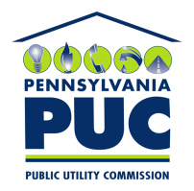 | COMMONWEALTH OF PENNSYLVANIA  PENNSYLVANIA PUBLIC UTILITY COMMISSION  P.O. BOX 3265, HARRISBURG, PA 17105-3265 | IN REPLY PLEASE REFER TO OUR FILE
Date Served: April 25, 2016

VIA CERTIFIED MAIL

RANDY LARKIN
T/A LARKIN TRUCKING & TRANSPORT
PO BOX 58
CALLENSBURG PA 16213

RE: RANDY LARKIN t/a Larkin Trucking & Transport
C-2015-2474850

TO WHOM IT MAY CONCERN:

Please know we are returning the enclosed check(s) because the Commission cannot accept either personal or checks drawn from a corporate account. This will not affect the timeliness of your filing or in answering a complaint.

You may void the check(s) to avoid incurring any cancellation fees from your bank. Please send us a replacement check for the amount of the fee or civil penalty in the form of a CERTIFIED CHECK OR MONEY ORDER MADE PAYABLE TO THE “COMMONWEALTH OF PENNSYLVANIA.”

Sincerely,
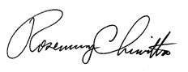
Rosemary Chiavetta
Secretary of the Commission

Enclosure Check # 2620

