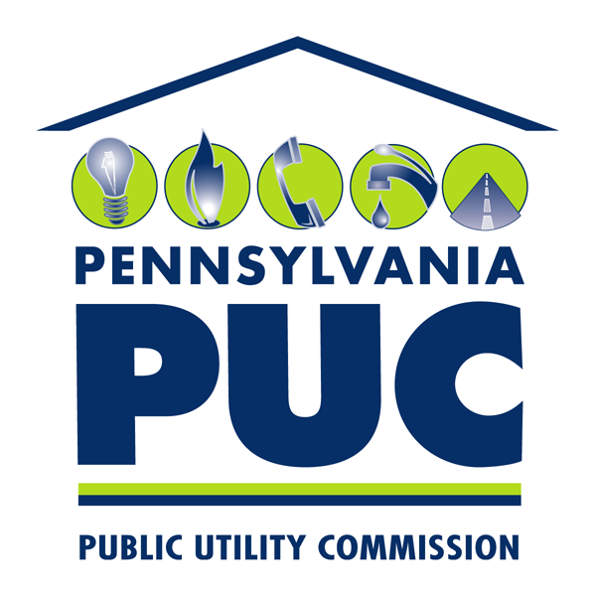 | COMMONWEALTH OF PENNSYLVANIA  PENNSYLVANIA PUBLIC UTILITY COMMISSION  P.O. BOX 3265, HARRISBURG, PA 17105-3265 | IN REPLY PLEASE REFER TO OUR FILE  M-2015-2514767  M-2015-2514768  M-2015-2514769  M-2015-2514772

May 19, 2016

John L. Munsch, Esquire
FirstEnergy
800 Cabin Hill Drive
Greensburg, PA 15601

Re: Metropolitan Edison Company, Pennsylvania Electric Company, Pennsylvania Power Company and West Penn Power Company CSP Contract with Enertouch, Inc. d/b/a Good Cents Solutions
(PO # 55121987)
Docket Nos. M-2015-2514767; M-2015-2514768;
M-2015-2514769; M-2015-2514772

Dear Mr. Munsch:

This letter acknowledges that Commission staff has reviewed the FirstEnergy Companies, Metropolitan Edison Company, Pennsylvania Electric Company, Pennsylvania Power Company and West Penn Power Company proposed Conservation Service Provider (CSP) contract with Enertouch, Inc. d/b/a Good Cents Solutions (PO # 55121987), filed with the Commission on April 14, 2016 for the provision of the Phase III Residential Energy Incentives In-Home Audit Program.

The Implementation Order, inter alia, required all Electric Distribution Companies (EDCs) subject to Act 129 to submit, for Commission review, all proposed contracts with CSPs. The Commission may order modification of these proposed contracts. 66 Pa. C.S. § 2806.1(a)(8). The Commission, in its Energy Efficiency and Conservation Program Implementation Order at Docket No. M-2008-2069887 (entered January 16, 2009), delegated its authority to review and approve CSP contracts to Commission Staff.

FirstEnergy Companies are advised that the proposed CSP contract with Enertouch, Inc. d/b/a Good Cents Solutions (PO # 55121987), filed on April 14, 2016 is approved. Furthermore, we note that approval of this filing does not constitute a determination that such filing is consistent with the public interest and that the associated costs or expenses are reasonable or prudent for the purposes of cost recovery. These issues will be addressed by the Commission in any appropriate plan approval and cost recovery proceedings.

Please direct any questions to Joseph Sherrick, Bureau of Technical Utility Services, at (717) 787-2359 or Patricia T. Wiedt, Assistant Counsel, Law Bureau, at (717) 787-5755.

Sincerely,

Rosemary Chiavetta
Secretary

cc: Darren Gill, Deputy Director, TUS
Joseph Sherrick, TUS
Charles Covage, TUS
Kriss Brown, Law Bureau
Patricia T. Wiedt, Law Bureau
Kathy Aunkst, Secretary’s Bureau
Tanya J. McCloskey, Esquire, OCA
John R. Evans, OSBA

