**PENNSYLVANIA PUBLIC UTILITY COMMISSION**

###### Public Meeting held May 19, 2016

Docket Number: M-2016-2543615

**BUREAU OF TECHNICAL UTILITY SERVICES**

**REPORT ON THE QUARTERLY EARNINGS**

**OF JURISDICTIONAL UTILITIES**

**FOR THE YEAR ENDED**

**December 31, 2015**

|  |
| --- |
| Gladys M. Brown, Chairman |
| Andrew G. Place, Vice Chairman |
| John F. Coleman, Jr., Commissioner |
| Robert F. Powelson, Commissioner |
|  | |

#### TABLE OF CONTENTS

**Page No.**

**Introduction**..................................................................................................... 4

UGI Utilities, Inc. – Gas Division has a pending rate filing at Docket No. R-2015-2518438, and filed a letter with the Secretary in place of a report in accordance with 52 Pa. Code § 71.4.

**Attachment A – Summary of Equity Returns**……………………………… 5

**Attachment B – Summary of Returns** 12

This chart depicts the overall and equity returns (actual and adjusted) for the filing utilities for the current quarter. The last authorized equity return and the year authorized is also shown.

**Attachment C – Allowed Rates of Return on Common Equity** 14

This is a historical chart that shows the most recent fully litigated rate cases for select companies in electric, gas, and water. A docket number followed by their final return on equity and year is also given.

**Attachment D – Distribution System Improvement Charge Return on Equity** 15

Compares utility adjusted return on equity to Commission authorized return on equity for utilities with a Distribution System Improvement Charge.

**Attachment E – Explanation of Return on Equity Methods** 16

Criteria for determining the industry barometer groups used in ROE calculations. Also provides details of the Discounted Cash Flow equation and Capital Asset Pricing Model equation.

**Attachment F – Market Based Returns on Equity – Electric** 18

The market indicated common equity cost rate range consists of data used from the electric barometer groups and is based on a series of calculations to average the DCF methods. Also indicates Distribution System Improvement Charge Return.

**Attachment F – Historic DCF and CAPM – Electric** 19

Historic barometer group DCF and CAPM average ROEs, including a linear trend line graph.

**Attachment F – Electric Barometer Group Calculation of a Current and 52 Week Average Dividend Yield** 20

Electric barometer companies are used to calculate a current DCF in the first chart. The second chart demonstrates the companies 52 week average DCF. A final average of the two calculations is also shown at the bottom.

**Attachment F – Development of a Representative Dividend Growth Rate**…………………………………………………... 21

Multiple sources of the gas barometer companies projected 5 year Earnings Per Share are used to calculate the Group Average Dividend Growth Estimate.

**Attachment G – Market Based Returns on Equity – Gas** 22

The market indicated common equity cost rate range consists of data used from the gas barometer groups and is based on a series of calculations to average the DCF methods. Also indicates Distribution System Improvement Charge Return.

**Attachment G – Historic DCF and CAPM – Gas** 23

Historic barometer group DCF and CAPM average ROEs, including a linear trend line graph.

**Attachment G – Gas Barometer Group Calculation of a Current and 52 Week Average Dividend Yield** 24

Gas barometer companies are used to calculate a current DCF in the first chart. The second chart demonstrates the companies 52 week average DCF. A final average of the two calculations is also shown at the bottom.

**Attachment G – Development of a Representative Dividend Growth Rate**…………………………………………………... 25

Multiple sources of the gas barometer companies projected 5 year Earnings Per Share are used to calculate the Group Average Dividend Growth Estimate.

**Attachment H – Market Based Returns on Equity – Water** 26

The market indicated common equity cost rate range consists of data used from the water barometer groups and is based on a series of calculations to average the DCF methods. Also indicates Distribution System Improvement Charge Return.

**Attachment H – Historic DCF and CAPM – Water** 27

Historic barometer group DCF and CAPM average ROEs, including a linear trend line graph.

**Attachment H – Water Barometer Group Calculation of a Current and 52 Week Average Dividend Yield** 28

Water barometer companies are used to calculate a current DCF in the first chart. The second chart demonstrates the companies 52 week average DCF. A final average of the two calculations is also shown at the bottom.

**Attachment H – Development of a Representative Dividend Growth Rate**…………………………………………………... 29

Multiple sources of the water barometer companies projected 5 year Earnings Per Share are used to calculate the Group Average Dividend Growth Estimate.

**Introduction:**

On September 20, 1991, the Commission initiated a rulemaking at L-00910061 pertaining to earnings disclosures by the public utilities subject to its jurisdiction. At that docket, the Commission stated that the submission of accurate, reliable and complete earnings disclosure reports, at regular intervals, is essential to the fulfillment of the broad regulatory oversight responsibilities entrusted to the Commission by the Legislature in the Public Utility Code. The earnings disclosure regulations promulgated by the Commission were adopted October 1, 1992, and published January 23, 1993, at 23 Pa.B. 463. Based upon those regulations, codified at 52 Pa. Code, Chapter 71, a reporting format was developed and distributed to the jurisdictional fixed utilities of Pennsylvania.

All fixed utilities having jurisdictional revenues of $1,000,000 or more, for a calendar year, are required to file the report by March 31 of each year. Such reports are to be based upon the results of operations for the 12-month period ending December 31 of the prior year. Utilities having more than $10,000,000 in jurisdictional revenues are also required to file reports for the 12 months ending on March 31, June 30, and September 30 of each year. On November 30, 2004, however, the Pennsylvania General Assembly signed into law Act 183 concerning alternative telecommunications regulation and broadband deployment. As a result of Act 183, the reporting requirements for the PUC jurisdictional telecommunications companies of Pennsylvania have been streamlined at section 3015(e) of the Public Utility Code. A quarterly earnings report is not listed among those reports now required of PUC jurisdictional telecommunications utilities in Pennsylvania and, therefore, this report does not address telephone company earnings.

The reports have been filed for the period ended December 31, 2015.[1] The Finance Staff of the Bureau of Technical Utility Services has reviewed the reports and has prepared this summary report for public release. This report sets forth the achieved return on equity for each company, the last allowed return for that utility, a market return as determined through the analysis of the barometer group data and the most recent returns allowed, per industry, by the Pennsylvania Public Utility Commission and by other regulatory bodies. Where a utility has not filed a report, the reasons for not filing are indicated.

Questions pertaining to the preparation and contents of this Report should be directed to Ms. Erin Laudenslager, Manager - Finance, Bureau of Technical Utility Services, at (717) 705-4364.

The equity return summaries that follow in Attachment A are, for each quarter;

ACTUAL

1. Based on actual results of operations

and

ADJUSTED

2. Based on company proposed pro forma and ratemaking adjustments

|  |  |  |  |  |  |  |  |  |  |  |  |  |  |  |  |  |  |  |  |  |
| --- | --- | --- | --- | --- | --- | --- | --- | --- | --- | --- | --- | --- | --- | --- | --- | --- | --- | --- | --- | --- |
|  |  | **ELECTRIC UTILITIES**  **EQUITY RETURNS BY QUARTER** | | | | | | | | | | | | | | | | | | |
|  |  |  |  |  |  |  |  |  |  | |  | |  |  |  |  |  |  |  |
|  |  |  |  |  |  |  |  |  |  | |  | |  |  |  |  |  |  |  |
| **QTR**  **END** | | **PECO** | | **PPL** | | **Duq** | | **W Penn** | | **PaPwr** | | | | **UGI** | | **Penelec** | | **MetEd** | |  | |
| ACT | ADJ | ACT | ADJ | ACT | ADJ | ACT | ADJ | | ACT | ADJ | | ACT | ADJ | ACT | ADJ | ACT | ADJ |
|  |  |  |  |  |  |  |  |  |  | |  |  | |  |  |  |  |  |  |
| 2010 | 2 |  |  |  |  |  |  | 6.41 | 6.41 | | 12.28 | 10.19 | | 13.41 | 11.89 | 8.04 | 6.97 | 5.89 | 4.47 |
|  | 3 |  |  |  |  |  |  | 6.63 | 6.63 | | 12.19 | 10.23 | | 12.46 | 11.97 | 8.37 | 7.32 | 8.24 | 6.83 |
|  | 4 | 14.35 | 9.61 | 7.91 | 6.98 |  |  | 4.78 | 4.80 | | 6.88 | 4.69 | | 12.95 | 11.55 | 9.11 | 8.10 | 6.12 | 4.86 |
|  | 1 | 11.74 | 11.34 | 8.31 | 8.31 |  |  | 8.43 | 6.80 | | 10.90 | 8.55 | | 13.46 | 13.47 | 9.57 | 8.62 | 10.56 | 9.21 |
| 2011 | 2 | 12.25 | 11.03 | 9.41 | 9.41 | 10.86 | 10.39 | 10.05 | 8.40 | | 7.41 | 5.81 | | 14.11 | 12.94 | 6.51 | 6.38 | 7.68 | 6.43 |
|  | 3 | 10.35 | 11.07 | 8.89 | 8.89 | 10.05 | 9.58 | 12.95 | 11.21 | | 11.67 | 10.05 | | 14.84 | 12.93 | 8.73 | 8.18 | 9.90 | 7.50 |
|  | 4 | 13.41 | 11.38 |  |  | 10.21 | 9.97 | 13.33 | 11.58 | | 5.91 | 7.60 | | 14.60 | 9.79 | 6.45 | 8.43 | 4.24 | 5.23 |
|  | 1 | 12.89 | 11.26 |  |  | 10.95 | 10.71 | 11.66 | 13.16 | | 5.78 | 7.02 | | 15.04 | 8.42 | 5.76 | 7.54 | 3.90 | 4.64 |
| 2012 | 2 | 12.63 | 12.01 |  |  | 10.81 | 10.42 | 10.61 | 9.15 | | 8.95 | 8.95 | | 14.61 | 8.53 | 6.48 | 8.08 | 3.44 | 4.01 |
|  | 3 | 13.14 | 12.66 |  |  | 10.33 | 9.92 | 10.63 | 10.45 | | 9.69 | 9.54 | | 15.85 | 9.48 | 7.34 | 8.58 | 5.72 | 6.28 |
|  | 4 | 11.55 | 11.56 | 6.02 | 4.88 | 10.27 | 9.24 | 9.54 | 9.54 | | 8.41 | 8.27 | | 14.60 | 8.98 | 5.41 | 7.74 | 5.39 | 6.81 |
|  | 1 | 11.92 | 11.27 | 7.56 | 6.24 | 10.12 | 9.74 | 9.23 | 9.23 | | 8.89 | 8.74 | | 12.77 | 9.84 | 5.30 | 7.67 | 5.01 | 6.47 |
| 2013 | 2 | 11.40 | 10.74 | 7.80 | 7.37 |  |  | 12.34 | 12.34 | | 8.85 | 8.70 | | 11.53 | 10.49 | 5.86 | 8.21 | 5.36 | 6.79 |
|  | 3 | 11.09 | 10.96 | 8.67 | 8.38 |  |  | 9.13 | 9.13 | | 8.49 | 8.34 | | 10.74 | 10.65 | -0.77 | 2.07 | -12.43 | -10.43 |
|  | 4 | 11.97 | 10.52 | 10.01 | 9.79 |  |  | 13.73 | 13.73 | | 14.49 | 14.30 | | 14.25 | 11.99 | 4.85 | 2.99 | -6.06 | -7.87 |
|  | 1 | 9.97 | 10.34 | 10.02 | 10.04 |  |  | 11.58 | 9.45 | | 15.28 | 15.04 | | 13.36 | 10.25 | 5.17 | 3.34 | -6.40 | -8.13 |
| 2014 | 2 | 10.05 | 10.08 | 9.50 | 10.09 | 9.77 | 9.29 |  |  | |  |  | | 12.64 | 9.21 |  |  |  |  |
|  | 3 | 8.93 | 9.25 | 10.07 | 9.99 | 9.97 | 9.48 |  |  | |  |  | | 8.76 | 9.22 |  |  |  |  |
|  | 4 | 8.23 | 9.58 |  |  | 9.77 | 9.40 |  |  | |  |  | | 9.01 | 10.00 |  |  |  |  |
|  | 1 |  |  |  |  | 10.08 | 9.65 |  |  | |  |  | | 10.88 | 10.39 |  |  |  |  |
| 2015 | 2 |  |  |  |  | 9.80 | 9.42 |  |  | |  |  | | 13.57 | 9.49 |  |  |  |  |
|  | 3 |  |  |  |  | 10.11 | 9.73 | 6.45 | 6.45 | | 5.77 | 5.77 | | 15.93 | 7.57 | 2.94 | 2.94 | 3.69 | 3.69 |
|  | 4 | 10.74 | 8.84 | 8.89 | 8.48 | 9.73 | 9.36 | 8.09 | 8.09 | | 5.13 | 5.13 | | 9.74 | 9.21 | 5.45 | 5.45 | 7.04 | 7.04 |

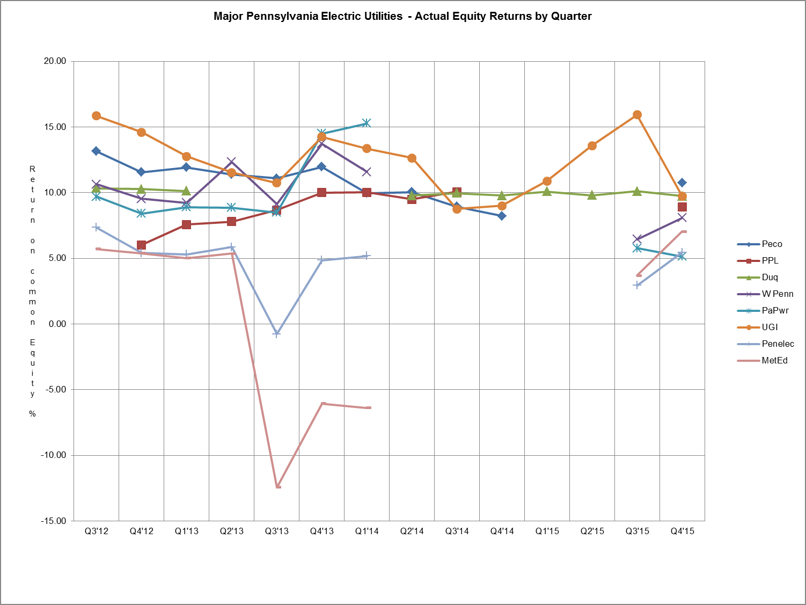

|  |  |  |  |  |  |  |  |  |  |  |  |  |  |  |  |  |  |  |
| --- | --- | --- | --- | --- | --- | --- | --- | --- | --- | --- | --- | --- | --- | --- | --- | --- | --- | --- |
|  |  | **GAS UTILITIES**  **EQUITY RETURNS BY QUARTER** | | | | | | | | | | | | | | | | |
| **QTR** |  | | **Columbia** | | **Peoples** | | **PECO** | | **UGI** | | **Peoples-Eqt** | | **NFG** | | **UGI Penn** | | **Peoples TWP** | |
| **END** |  | | ACT | ADJ | ACT | ADJ | ACT | ADJ | ACT | ADJ | ACT | ADJ | ACT | ADJ | ACT | ADJ | ACT | ADJ |
|  |  | |  |  |  |  |  |  |  |  |  |  |  |  |  |  |  |  |
| 2010 | 2 | |  |  | 9.65 | 5.25 |  |  | 15.97 | 11.48 | 9.47 | 8.99 | 19.13 | 10.33 | 8.86 | 7.95 |  |  |
|  | 3 | |  |  |  |  |  |  | 14.84 | 11.79 | 8.87 | 8.56 | 18.19 | 10.99 | 8.62 | 9.03 |  |  |
|  | 4 | | 12.50 | 7.67 |  |  | 10.21 | 9.94 | 16.52 | 11.88 | 8.78 | 8.67 | 18.97 | 11.29 | 9.57 | 10.12 | 3.27 | 9.57 |
|  | 1 | |  |  |  |  | 11.74 | 11.34 | 19.61 | 13.11 | 9.48 | 9.78 | 19.87 | 12.11 | 13.08 | 12.17 | 6.52 | 9.06 |
| 2011 | 2 | |  |  |  |  | 11.97 | 10.79 | 19.67 | 13.92 | 10.81 | 10.71 | 20.83 | 12.97 | 14.08 | 12.65 | 6.10 | 6.94 |
|  | 3 | |  |  | 5.67 | 8.47 | 12.56 | 11.15 | 18.24 | 11.98 | 10.40 | 9.93 | 21.16 | 13.05 | 14.32 | 11.48 | 5.78 | 6.67 |
|  | 4 | |  |  |  |  | 11.69 | 12.06 | 16.55 | 9.18 | 7.99 | 8.89 | 19.62 | 12.34 | 14.01 | 9.35 | 6.75 | 5.56 |
|  | 1 | | 8.65 | 11.24 |  |  | 8.98 | 12.09 | 15.71 | 8.95 | 2.29 | 8.05 | 15.76 | 10.51 | 13.22 | 9.63 | 5.24 | 3.39 |
| 2012 | 2 | | 9.00 | 10.17 |  |  | 8.72 | 12.03 | 13.60 | 9.90 | 5.51 | 7.51 | 14.10 | 10.06 | 13.63 | 10.40 | 4.57 | 6.43 |
|  | 3 | | 9.27 | 8.88 | 6.21 | 9.35 | 9.98 | 13.48 | 13.79 | 10.05 | 5.84 | 7.79 | 13.88 | 10.39 | 13.16 | 10.66 | 7.02 | 7.41 |
|  | 4 | |  |  | 11.24 | 9.57 | 12.42 | 15.10 | 13.68 | 9.44 | 7.27 | 8.05 | 15.11 | 10.17 | 13.31 | 10.63 | 5.05 | 6.94 |
|  | 1 | |  |  | 12.49 | 9.89 | 14.63 | 15.13 | 14.65 | 10.27 | 12.42 | 8.40 | 19.33 | 10.25 | 13.28 | 10.58 |  |  |
| 2013 | 2 | | 10.85 | 7.15 | 16.59 | 8.35 | 14.43 | 14.40 | 13.02 | 10.21 | 10.40 | 8.92 | 20.18 | 10.25 | 10.98 | 10.27 |  |  |
|  | 3 | | 9.36 | 9.86 | 17.39 | 8.72 | 14.14 | 14.01 | 12.60 | 9.38 | 9.84 | 9.48 | 19.61 | 10.72 | 10.59 | 10.76 |  |  |
|  | 4 | | 10.60 | 10.78 | 16.33 | 10.02 | 14.35 | 13.97 | 16.08 | 9.20 | 10.52 | 9.76 | 20.51 | 10.07 | 13.41 | 10.49 | 7.21 | 12.23 |
|  | 1 | |  |  | 14.68 | 9.94 | 15.23 | 13.52 | 16.81 | 8.35 | 12.00 | 8.73 | 23.11 | 9.78 | 16.67 | 10.06 | 12.19 | 11.87 |
| 2014 | 2 | |  |  | 13.05 | 9.78 | 15.32 | 13.24 | 16.71 | 8.39 | 13.54 | 8.49 | 22.97 | 12.00 | 15.30 | 10.90 | 14.06 | 12.32 |
|  | 3 | |  |  | 13.43 | 9.16 | 15.45 | 13.21 | 16.63 | 8.64 | 14.41 | 9.15 | 21.36 | 11.03 | 13.77 | 10.15 | 15.07 | 12.62 |
|  | 4 | | 9.71 | 9.97 | 11.85 | 7.89 | 13.86 | 12.59 | 15.00 | 7.93 | 14.52 | 12.46 | 20.40 | 10.79 | 15.64 | 9.82 | 16.91 | 11.83 |
|  | 1 | |  |  | 14.22 | 7.90 | 14.60 | 13.01 | 15.76 | 7.87 | 15.36 | 12.14 | 20.17 | 10.31 | 15.57 | 9.52 | 16.36 | 11.23 |
| 2015 | 2 | |  |  | 14.37 | 8.88 | 13.89 | 12.32 | 14.07 | 7.62 | 14.08 | 11.26 | 18.82 | 10.39 | 13.76 | 8.90 | 16.15 | 12.90 |
|  | 3 | |  |  | 13.55 | 8.14 | 13.29 | 11.77 | 15.67 | 6.51 | 11.30 | 10.87 | 16.41 | 10.27 | 13.16 | 8.32 | 15.69 | 12.58 |
|  | 4 | | 9.75 | 9.73 | 8.80 | 9.83 | 12.50 | 12.70 |  |  | 10.60 | 10.00 | 15.01 | 10.59 | 9.17 | 7.25 | 12.71 | 12.14 |
|  |  | |  |  |  |  |  |  |  |  |  |  |  |  |  |  |  |  |

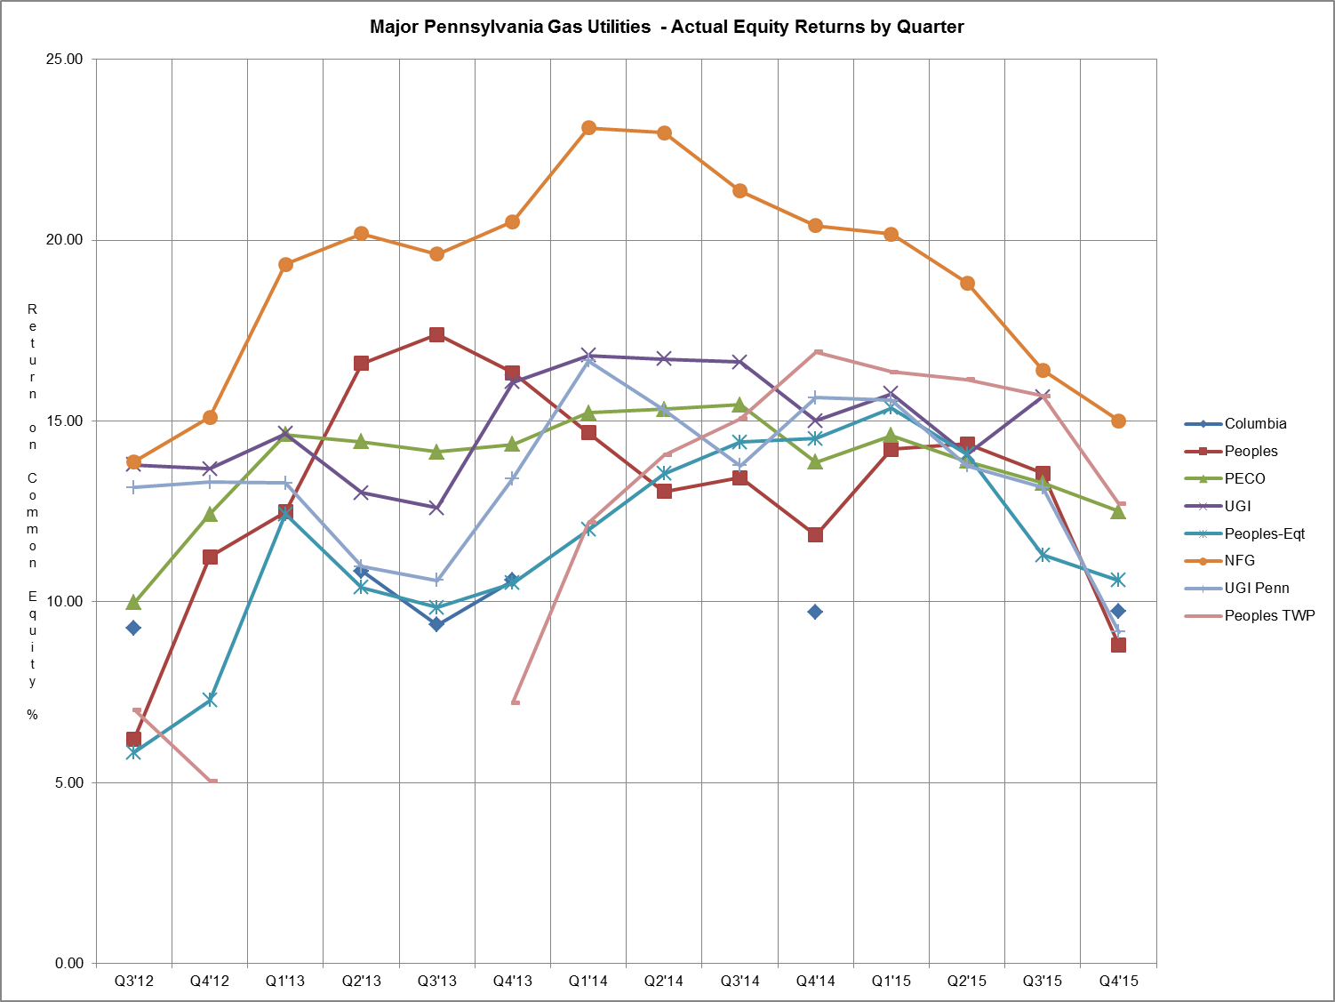

|  |  |  |  |  |  |  |  |  |  |  |  |
| --- | --- | --- | --- | --- | --- | --- | --- | --- | --- | --- | --- |
| **WATER UTILITIES** | | | | | | | | | | | |
| **EQUITY RETURNS BY QUARTER** | | | | | | | | | | | | | |
|  |  |  |  |  |  |  |  |  |  |
|  |  |  |  |  |  |  |  |  |  |
| **QTR** |  | **PAWC** | | **AQUA** | | **SUEZ** | | **York** | | **Superior** | | |
| **END** |  | ACT | ADJ | ACT | ADJ | ACT | ADJ | ACT | ADJ | ACT | ADJ | |
|  |  |  |  |  |  |  |  |  |  |  |  | |
| 2010 | 2 | 9.30 | 9.30 |  |  | 6.59 | 7.54 |  |  |  |  | |
|  | 3 | 9.58 | 9.58 | 10.19 | 10.35 | 7.15 | 8.34 |  |  |  |  | |
|  | 4 | 9.18 | 8.52 | 10.10 | 8.94 | 4.66 | 8.69 | 10.4 | 11.2 |  |  | |
|  | 1 |  |  | 10.68 | 8.32 | 5.02 | 8.81 | 10.8 | 11.1 |  |  | |
| 2011 | 2 |  |  | 10.92 | 7.93 | 4.72 | 8.61 | 11.1 | 10.2 |  |  | |
|  | 3 |  |  |  |  | 3.92 | 7.69 | 10.9 | 10.2 |  |  | |
|  | 4 |  |  |  |  | 7.69 | 8.00 | 10.8 | 10.0 |  |  | |
|  | 1 | 8.98 | 8.98 |  |  | 7.38 | 7.84 | 10.7 | 9.5 |  |  | |
| 2012 | 2 | 9.06 | 9.06 |  |  | 7.30 | 7.65 | 10.4 | 9.4 |  |  | |
|  | 3 | 9.17 | 9.17 | 9.50 | 7.77 | 7.96 | 8.38 | 10.5 | 9.1 |  |  | |
|  | 4 | 9.54 | 9.04 | 12.41 | 12.56 | 8.33 | 8.49 | 10.4 | 9.1 |  |  | |
|  | 1 |  |  | 13.24 | 11.96 | 8.53 | 8.71 |  |  |  |  | |
| 2013 | 2 |  |  | 14.26 | 12.52 | 8.99 | 9.15 |  |  | 8.57 | 7.85 | |
|  | 3 |  |  | 15.49 | 12.21 | 8.83 | 9.01 |  |  | 7.46 | 6.85 | |
|  | 4 |  |  | 13.77 | 11.97 | 8.43 | 9.05 | 10.2 | 10.8 | 10.71 | 10.01 | |
|  | 1 | 10.52 | 9.98 | 13.29 | 11.56 | 8.45 | 9.02 | 10.2 | 10.2 | 13.12 | 9.97 | |
| 2014 | 2 | 10.51 | 10.02 | 13.01 | 11.42 | 8.81 | 9.32 | 10.7 | 10.7 | 17.09 | 9.61 | |
|  | 3 | 11.11 | 10.57 | 12.82 | 11.29 | 8.57 | 9.06 | 10.9 | 10.9 | 34.68 | 9.88 | |
|  | 4 | 10.49 | 9.38 | 12.62 | 11.49 | 8.90 | 9.44 | 12.3 | 11.6 | 16.74 | 7.96 | |
|  | 1 | 10.33 | 9.14 | 12.46 | 11.11 | 9.11 | 9.83 | 12.7 | 12.7 | 15.92 | 8.37 | |
| 2015 | 2 | 10.51 | 9.31 | 12.66 | 11.62 | 8.36 | 9.25 | 12.7 | 12.7 | 14.65 | 8.93 | |
|  | 3 | 10.06 | 8.81 | 12.41 | 11.95 | 8.39 | 9.37 | 13.6 | 13.6 | 12.54 | 9.37 | |
|  | 4 | 9.80 | 8.48 | 12.61 | 12.16 | 8.54 | 8.77 | 12.50 | 11.10 | 12.73 | 9.50 | |
|  |  |  |  |  |  |  |  |  |  |
|  |  |  |  |  |  |  |  |  |  |

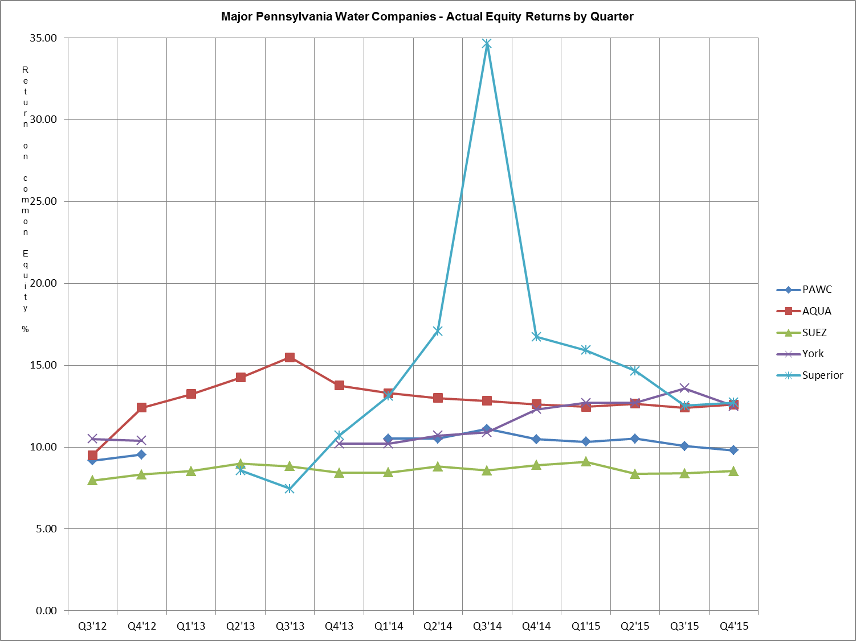

Attachment B includes:

A. Overall Returns on rate base

1. Actual

2. Company proposed pro forma and ratemaking adjustments

and

B. Equity Returns

1. Actual

2. Company proposed pro forma and ratemaking adjustments

Summary of Returns

For the Year Ended December 31, 2015

|  |  |  |  |  |  |  |
| --- | --- | --- | --- | --- | --- | --- |
|  | **OVERALL RETURN** | | **EQUITY RETURN** | | ROE | YEAR |
| COMPANY NAME | ACTUAL | ADJ | ACTUAL | ADJ | AUTH | AUTH |
| **ELECTRIC** |  |  |  |  |  |  |
| **$10,000,000 Revenues** |  |  |  |  |  |  |
| PECO Energy | 7.87 | 6.83 | 10.74 | 8.84 | Settled | 2010 |
| PPL Electric Utilities Corp. | 6.91 | 6.70 | 8.89 | 8.48 | 10.40 | 2012 |
| Duquesne Light Company | 7.64 | 7.42 | 9.73 | 9.36 | Settled | 2014 |
| West Penn Power Company | 6.61 | 6.61 | 8.09 | 8.09 | Settled | 2015 |
| Pennsylvania Power Company | 5.28 | 5.28 | 5.13 | 5.13 | Settled | 2015 |
| UGI Utilities, Inc. | 7.52 | 7.26 | 9.74 | 9.21 | Settled | 1996 |
| Pennsylvania Electric Company | 6.17 | 6.17 | 5.45 | 5.45 | Settled | 2015 |
| Metropolitan Edison Company | 6.30 | 6.30 | 7.04 | 7.04 | Settled | 2015 |
| **$1,000,000 to $10,000,000** |  |  |  |  |  |  |
| **Revenues** |  |  |  |  |  |  |
| Citizens Electric Company | 6.69 | 6.69 | 6.76 | 6.76 |  |  |
| Pike County Light & Power Co. | 7.07 | 7.40 | 9.70 | 9.24 |  |  |
| Wellsboro Electric Company | 8.46 | 8.46 | 21.46 | 21.46 |  |  |
| **GAS** |  |  |  |  |  |  |
| **$10,000,000 Revenues** |  |  |  |  |  |  |
| Columbia Gas of PA, Inc. | 7.63 | 7.71 | 9.75 | 9.73 | Settled | 2013 |
| Peoples Natl Gas LLC | 6.85 | 7.04 | 8.80 | 9.83 | Settled | 2012 |
| PECO Energy | 8.88 | 8.99 | 12.50 | 12.70 | Settled | 2010 |
| UGI Utilities, Inc.* |  |  |  |  | Settled | 1995 |
| Peoples-Equitable Division | 7.56 | 7.07 | 10.60 | 10.00 | Settled | 2008 |
| National Fuel Gas Distribution Co. | 10.16 | 7.81 | 15.01 | 10.59 | Settled | 2006 |
| UGI Penn Natural Gas, Inc. | 7.40 | 6.19 | 9.17 | 7.25 | Settled | 2009 |
| Peoples TWP, LLC | 8.16 | 7.83 | 12.71 | 12.14 | Settled | 2013 |
| UGI Central Penn Gas, Inc. | 9.94 | 7.50 | 12.69 | 9.67 | Settled | 2009 |
| **$1,000,000 to $10,000,000** |  |  |  |  |  |  |
| **Revenues** |  |  |  |  |  |  |
| North East Heat & Light Co. | 8.40 | 8.40 | 11.58 | 11.57 |  |  |
| Valley Energy | 8.10 | 8.10 | 11.80 | 11.80 |  |  |
| Pike County Light & Power Co. | 3.45 | 3.34 | 2.57 | 1.23 |  |  |
| **WATER** |  |  |  |  |  |  |
| **$10,000,000 Revenues** |  |  |  |  |  |  |
| PA American Water Company | 7.90 | 7.21 | 9.80 | 8.48 | Settled | 2013 |
| AQUA Pennsylvania | 8.86 | 8.65 | 12.61 | 12.16 | Settled | 2012 |
| York Water Company | 9.70 | 8.90 | 12.5 | 11.10 | Settled | 2014 |
| SUEZ Water Pennsylvania, Inc. | 6.98 | 7.10 | 8.54 | 8.77 | Settled | 2009 |
| Superior Water Company, Inc. | 9.16 | 7.46 | 12.73 | 9.50 | Settled | 2011 |
| **$1,000,000 to $10,000,000** |  |  |  |  |  |  |
| **Revenues** |  |  |  |  |  |  |
| Newtown Artesian Water Co. | 6.79 | 5.42 | 9.62 | 6.69 |  |  |
| Columbia Water Company | 4.94 | 4.94 | 5.04 | 5.04 |  |  |
|  |  |  |  |  |  |  |
|  |  |  |  |  |  |  |
|  |  |  |  |  |  |  |
|  |  |  |  |  |  |  |

* UGI Utilities, Inc. – Gas Division has a pending rate filing at Docket No. R-2015-2518438, and filed a letter with the Secretary in place of a report in accordance with 52 Pa. Code § 71.4.

**ALLOWED RATES OF RETURN ON COMMON EQUITY**

This is a historical chart that shows the most recent fully litigated rate cases for select companies in electric, gas, and water. A docket number followed by their final return on equity and year is also given.

**ELECTRIC** **Docket Number ROE (%) Year**

Recent PA PUC Allowed

PPL Electric Utilities Corp. R-2012-2290597 10.40 2012

PECO Energy Company R-2010-2161575 Settled 2010

UGI - Electric R-00953524 Settled 1996

Pennsylvania Electric Company R‑2014‑2428743 Settled 2015

Metropolitan Edison Company R‑2014‑2428745 Settled 2015

Pennsylvania Power Company R‑2014‑2428744 Settled 2015

West Penn Power Company R‑2014‑2428742 Settled 2015

Current Market Indicated ROE as calculated by the **7.71-10.01**

Bureau of Technical Utility Services.

**GAS**

Recent PA PUC Allowed

Columbia Gas of Pa. R-2014-2406274 Settled 2014

UGI Utilities, Inc. – Gas R-00953297 Settled 1995

Peoples Natural Gas R-2012-2285985 Settled 2012

UGI Penn Natural Gas R-2008-2079660 Settled 2009

UGI Central Penn Gas R-2008-2079675 Settled 2009

PECO Energy R-2010-2161592 Settled 2010

Peoples TWP R-2013-2355886 Settled 2013

Current Market Indicated ROE as calculated by the **8.09-10.12**

Bureau of Technical Utility Services.

**WATER**

Recent PA PUC Allowed

Aqua Pennsylvania R-2011-2267958 Settled 2012

PA American Water R-2013-2355276 Settled 2013

Columbia Water R-2013-2360798 9.75 2014

York Water R-2012-2336379 Settled 2014

Current Market Indicated ROE as calculated by the **6.14-9.44**

Bureau of Technical Utility Services.

**Distribution System Improvement Charge (DSIC) Eligible Utilities**

**Return on Equity (ROE) Summary**

|  |  |  |  |  |  |
| --- | --- | --- | --- | --- | --- |
|  | | | **Utility Adjusted**  **ROE[2] (%)** | | **Commission Approved**  **ROE[3] (%)** |
| **ELECTRIC** | | |  | |  |
| PECO Energy | | | 8.84 | | 9.80 |
| PPL Electric Utilities Corp. | | | 8.48 | | 9.80 |
| **GAS** | | |  | |  |
| Columbia Gas of PA, Inc. | | | 9.73 | | 9.90 |
| Peoples Natural Gas LLC | | | 9.83 | | 9.90 |
| PECO Energy | | | 12.70 | | 9.90 |
| UGI Utilities, Inc.* | | |  | | 9.90 |
| Peoples-Equitable Division | | | 10.00 | | 9.90 |
| UGI Penn Natural Gas, Inc. | | | 7.25 | | 9.90 |
| Peoples TWP LLC | | | 12.14 | | 9.90 |
| UGI Central Penn Gas, Inc. | | | 9.67 | | 9.90 |
| **WATER** | | |  | |  |
| PA American Water Company | | | 8.48 | | 9.80 |
| PA American - Wastewater | | | 8.48 | | 9.80 |
| AQUA Pennsylvania | | | 12.16 | | 9.80 |
| AQUA Pennsylvania - Wastewater | | | 1.84 | | 9.80 |
| York Water Company | | | 11.10 | | 9.80 |
| SUEZ Water Pennsylvania Inc. | | | 8.77 | | 9.80 |
| Columbia Water+ | | | 5.04 | | 9.80 |
| Newtown Artesian Water+ | | | 6.69 | | 9.80 |
| Superior Water | | | 9.50 | | 9.80 |
| * UGI Utilities, Inc. – Gas Division has a pending rate filing at Docket No. R-2015-2518438, and filed a letter with the Secretary in place of a report in accordance with 52 Pa. Code § 71.4. | | | | | |
| + These utilities have annual revenue less than $10 million and only file a year end, 4th quarter report. | | | | | |
|  | | |  | |  |
|  |  |  | |

Explanation of Discounted Cash Flow (DCF) and Capital Asset Pricing Model (CAPM)

**Barometer Group Criteria**

The criteria used for determining the industry barometer groups used to calculate ROEs in this report are as follows:

* 50% or more of the company’s assets must be related to the jurisdictional utility industry;
* The company’s stock must be publically traded;
* Companies involved in merger & acquisition activity will be excluded;
* Investment information for the company must be available to the Commission from more than one source; and
* Geographic Regions:

EDCs: Value Line East Group Electric Utility companies;

NGDCs: Value Line Investment Survey’s Natural Gas Utility industry group companies;

Water/Waste water: Value Line Investment Survey’s Water Utility industry group companies.

The barometer group companies are reviewed by staff on a quarterly basis and make any changes to these companies based upon the criteria above.

**ROE Calculations**

The Commission consistently uses the DCF model to determine the appropriate cost of equity for utilities. In this report, the DSIC ROE is calculated using two DCF models.

TUS uses the following formula to calculate the current dividend DCF: K = D1/P0 + G

TUS uses the following formula to calculate the 52-week average dividend DCF: K = D1/Pa + G

Definitions:

K = Cost of equity

D1 = Dividend expected during the year

= D0 + ½g

D0 = Latest indicated dividend, obtained from Yahoo! Finance

g = Expected 5-year dividend growth rate of barometer group obtained from Value Line Investment Survey.

P0 = Current price of the stock, obtained from Yahoo! Finance

Pa = Average of high and low stock price over the latest 52-week period, obtained from Yahoo! Finance

G = Average of 5-year expected earnings growth rate forecasts obtained from Value Line Investment Survey, Zacks Investment Survey, Yahoo! Finance, Morningstar and/or Reuters.

The CAPM uses the yield of a risk-free interest bearing obligation plus a rate of return premium that is proportional to the systematic risk of an investment.

TUS uses the following formula to calculate CAPM: K = β(Rm-Rf)

Three components are necessary to calculate the CAPM cost of equity:

β = Beta, a measure of systematic risk for each stock

Rf = The risk-free rate of return, 10-year U.S. Treasury yields are used for Rf .

Yields are taken from the previous two quarters and forecasted next four quarters.

Rm = Total return of the equity market as determined by the SBBI Yearbook

*The Commission determines the ROE used for DSIC purposes* based on the range of reasonableness from the DCF barometer group data, CAPM data, recent ROEs adjudicated by the Commission, and informed judgment.

The market indicated common equity cost rate range consists of data used from the barometer groups and is based on a series of calculations to average the DCF methods.



**Historic Electric Industry Barometer Group DCF and CAPM Average ROEs**



**Linear Trend Line Chart of Historic Electric Industry DCF and CAPM Average ROEs**

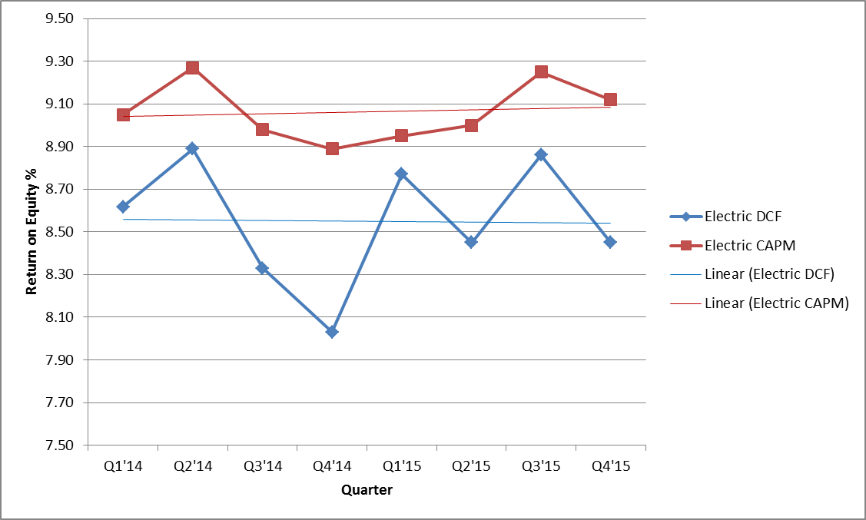

Barometer electric companies are used to calculate a current DCF in the first chart. The second chart demonstrates the companies 52 week average DCF. A final average of the two calculations is also shown at the bottom.



Multiple sources of the Barometer companies projected 5 year Earnings Per Share are used to calculate the Group Average Dividend Growth Estimate.



The market indicated common equity cost rate range consists of data used from the barometer groups and is based on a series of calculations to average the DCF methods.



**Historic Gas Industry DCF and CAPM Average ROEs**



**Linear Trend Line Graph of Historic Gas Industry DCF and CAPM Average ROEs**

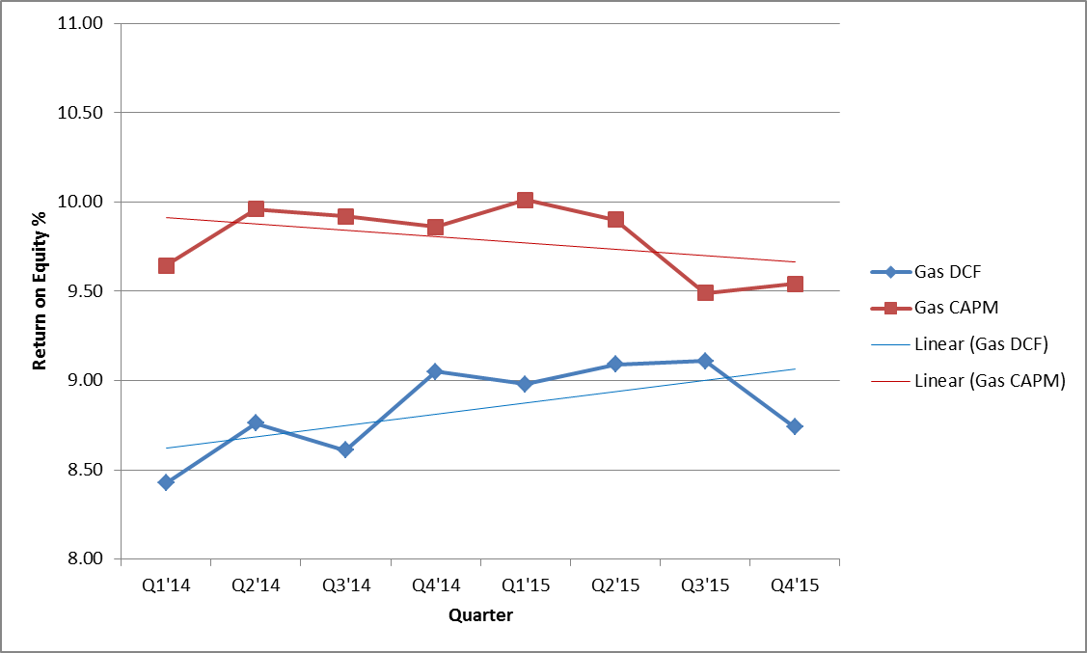

Barometer gas companies are used to calculate a current DCF in the first chart. The second chart demonstrates the companies 52 week average DCF. A final average of the two calculations is also shown at the bottom.



Multiple sources of the Barometer companies projected 5 year Earnings Per Share are used to calculate the Group Average Dividend Growth Estimate.



The market indicated common equity cost rate range consists of data used from the barometer groups and is based on a series of calculations to average the DCF methods.



**Historic Water Industry DCF and CAPM Average ROEs**



**Linear Trend Line Chart of Historic Water Industry DCF and CAPM Average ROEs**

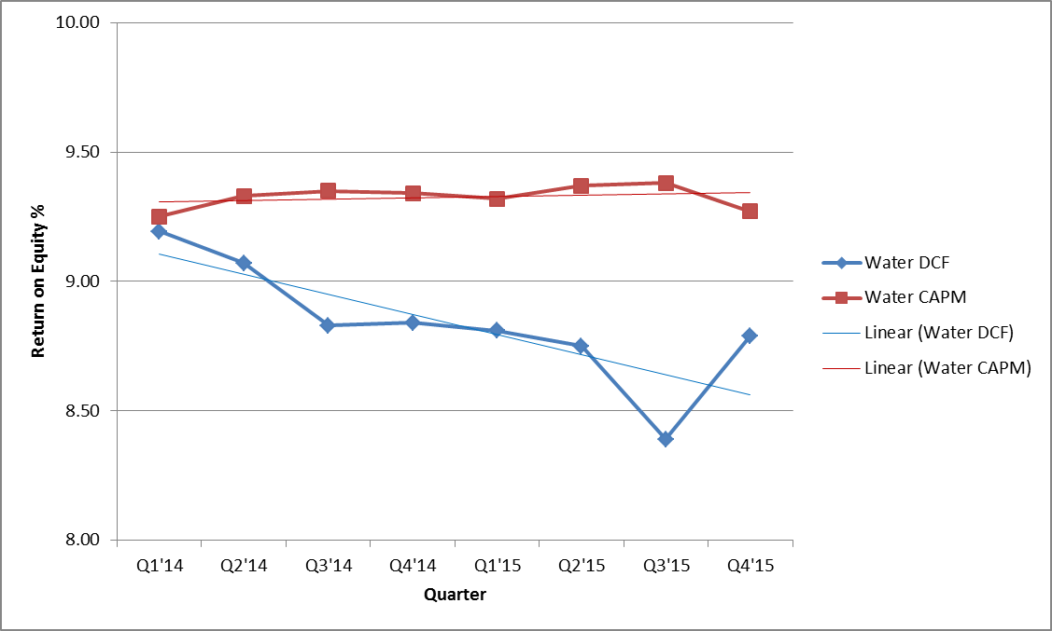

Barometer water companies are used to calculate a current DCF in the first chart. The second chart demonstrates the companies 52 week average DCF. A final average of the two calculations is also shown at the bottom.



Multiple sources of the Barometer companies projected 5 year Earnings Per Share are used to calculate the Group Average Dividend Growth Estimate.



1. UGI Utilities, Inc. – Gas Division has a pending rate filing at Docket No. R-2015-2518438, and filed a letter with the Secretary in place of a report in accordance with 52 Pa. Code § 71.4.
2. Each utility lists adjustments on Schedule B of their quarterly financial report.
3. The ROE is approved in a utility's most recent fully litigated base rate proceeding for which a final order was entered not more than two years prior to the effective date of the DSIC. If more than two years have elapsed between the entry of a final order and the DSIC effective date, the ROE is from this report. If the base rate proceeding is settled, without a stipulated ROE, the ROE is from this report.