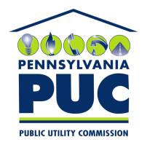 | COMMONWEALTH OF PENNSYLVANIA  PENNSYLVANIA PUBLIC UTILITY COMMISSION  P.O. BOX 3265, HARRISBURG, PA 17105-3265 | IN REPLY PLEASE REFER TO OUR FILE
June 14, 2017
A-2017-2606103
Utility Code: 230073
David P. Zambito, Esquire
Cozen O’Connor
17 North Second Street
Suite 1410
Harrisburg, P A 17101

Dear Attorney Zambito:

Receipt is acknowledged of the Application of Pennsylvania-American Water Company - Wastewater under Section 1329 of the Pennsylvania Public Utility Code, 66 Pa. C.S. §1329, for approval of the use for ratemaking purposes of the lesser of the fair market value or the negotiated purchase price of The Municipal Authority of the City of McKeesport's assets related to its wastewater collection and treatment system and other related transactions, which has been docketed to the above number.

It will be necessary for you to serve copies of the Application upon the following parties, then file proof of such service with this Commission, pursuant to 52 Pa. Code, §1.57 and §1.58:

Each city, borough, town, township, county and related planning office which is included, in whole or in part, in the proposed service area;

A water or wastewater utility, municipal corporation or authority which provides water or wastewater collection, treatment and disposal service to the public and whose service area abuts the service area proposed in the application;

And the Department of Environmental Protection’s appropriate regional office.

You are directed upon receipt of this letter to publish the enclosed notice once a week for two consecutive weeks in a newspaper having a general circulation in the area involved and file proof of publication with the Commission on or before July 10, 2017.

Pursuant to 52 Pa. Code §5.14, the Commission will proceed with publishing the attached notice in the Pennsylvania Bulletin. This notice will appear in the Saturday, June 24, 2017 issue.

This matter will receive the attention of the Commission and you will be advised of any further necessary procedure.

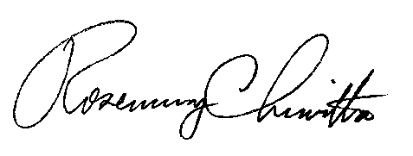
Sincerely,

Rosemary Chiavetta
Secretary
Enclosure

PENNSYLVANIA PUBLIC UTILITY COMMISSION
NOTICE TO BE PUBLISHED

Application of Pennsylvania-American Water Company-Wastewater under Section 1329 of the Pennsylvania Public Utility Code, 66 Pa. C.S. § 1329, for approval of the use for ratemaking purposes of the lesser of the fair market value or the negotiated purchase price of The Municipal Authority of the City of McKeesport's assets related to its wastewater collection and treatment system and other related transactions. Docket Number: A-2017-2606103.
________________________________________________

Formal protests and petitions to intervene must be filed in accordance with Title 52 of the Pennsylvania Code, on or before July 10, 2017. All filings must be made with the Secretary of the Pennsylvania Public Utility Commission, P. O. Box 3265, Harrisburg, PA 17105-3265, with a copy served on the Applicant. The documents filed in support of the Application are available for inspection and copying at the Office of the Secretary between the hours of 8:00 a.m. and 4:30 p.m., Monday through Friday, on the Commission's website at www.puc.pa.gov, and at the Applicant's business address.

Applicant:

Pennsylvania American Water Company - Wastewater

Through and By Counsel for:

David P. Zambito, Esquire
Cozen O’Connor
17 North Second Street
Suite 1410
Harrisburg, P A 17101

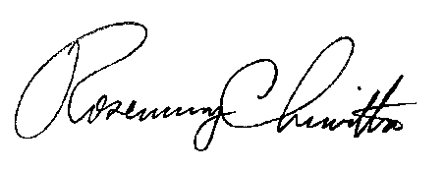
BY THE COMMISSION

Rosemary Chiavetta
Secretary

