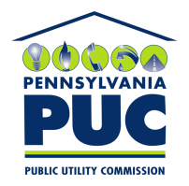 | COMMONWEALTH OF PENNSYLVANIA  PENNSYLVANIA PUBLIC UTILITY COMMISSION  400 NORTH STREET, KEYSTONE BUILDING, SECOND FLOOR  HARRISBURG, PENNSYLVANIA 17120 | IN REPLY PLEASE REFER TO OUR FILE

December 29, 2017

Via Certified Mail

Anne Elisa McDonnell
Avalon Energy Services LLC
PO Box 220
Galena MD 21635

RE: Continuation Certificate
Avalon Energy Services LLC
A-2010-2150814

Dear Ms. McDonnell:

Please find under cover of this letter the updated financial instrument filed with the Commission on behalf of Avalon Energy Services LLC because it is a copy and not acceptable.

The Commission requires a supplier to file an original bond, letter of credit, continuation certificate, amendment, or other financial instrument as part of a supplier’s licensing requirements under Section 2809(c) of the Pennsylvania Public Utility Code.

The enclosed financial instrument does not have a "wet ink" original signature or raised seal for the surety company. Please file the corrected, originally signed and sealed security instrument with my office within 20 days of the date of this letter, preferably by overnight delivery.

Sincerely,

Rosemary Chiavetta
Secretary of the Commission

RC: alw
Enclosures

