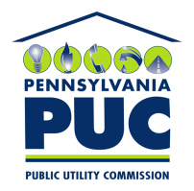 | COMMONWEALTH OF PENNSYLVANIA  PENNSYLVANIA PUBLIC UTILITY COMMISSION  400 NORTH STREET, HARRISBURG, PA 17120 | IN REPLY PLEASE REFER TO OUR FILE  DOCKET NO. A-110158

January 23, 2019

Geraldine B Hailes
WGL Energy
Office of General counsel
1000 main avenue sw 6th floor
Washington, dc 20024

RE: Return of Parental Guarantee filed November 20, 2017
WGL Holdings Inc.
Docket No. A-110158

Dear Sir or Madam:

Per the December 6, 2018 request of Attorney Michael Gruinn at Steven’s and Lee Lawyers and Consultants, we are hereby returning the Parental Guarantee filed on November 20, 2017.

Sincerely,

Rosemary Chiavetta
Secretary of the Commission

mjr
Enclosure

