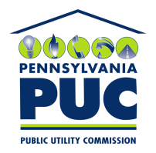 | COMMONWEALTH OF PENNSYLVANIA  PENNSYLVANIA PUBLIC UTILITY COMMISSION  400 NORTH STREET, KEYSTONE BUILDING, SECOND FLOOR  HARRISBURG, PENNSYLVANIA 17120 | IN REPLY PLEASE REFER TO OUR FILE

June 11, 2019

Via Certified Mail

Washington International Insurance Co
1450 American Lane Suite 1100
Schaumburg, IL 60173

RE: Cancellation Notice
Unitil Resources, Inc
A-110131

Dear Sir/Madam:

Please find under cover of this letter Cancellation Notice filed with the Commission on behalf of Unitil Resources. Inc because it is not acceptable.

In all locations where the name of the Principal appears, please note that this must match exactly with the license issued by the Commission. Please correct the Principal’s Name to Unitil Resources, Inc. d/b/a Usource

Please return the Cancellation Notice with my office within 20 days of the date of this letter, preferably by overnight delivery to my office address listed above.

Sincerely,

Rosemary Chiavetta
Secretary of the Commission

rc:jbs
cc: Unitil Resources Inc. 6 Liberty Lane West Hampton NH 03842( letter only )

