 | COMMONWEALTH OF PENNSYLVANIA  PENNSYLVANIA PUBLIC UTILITY COMMISSION  400 NORTH STREET, HARRISBURG, PENNSYLVANIA 17120 | IN REPLY PLEASE REFER TO OUR FILE

June 28, 2019

A-2019-3008589
A-2019-3008652
C-2019-3010963

EMILY M. FARAH, ESQUIRE
DUQUESNE LIGHT COMPANY
411 SEVENTH AVENUE
PITTSBURGH, PA 15219

Application of Duquesne Light Company Filed Pursuant to 52 Pa. Code Chapter 57, Subchapter G, for Approval of the Siting and Construction of the 138 kV Transmission Lines Associated with the Brunot Island – Crescent Project in the City of Pittsburgh, McKees Rocks Borough, Kennedy Township, Robinson Township, Moon Township, and Crescent Township, Allegheny County, Pennsylvania

Dear Ms. Farah:

Please be advised that the formal complaint filed against you at the above captioned Application will be considered a Protest to the Application, attached to the Application’s docket, and assigned to the Administrative Law Judge now presiding over this matter.

You will receive further information regarding your Protest from the presiding Judge.

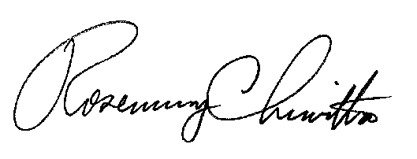
Sincerely,

Rosemary Chiavetta
Secretary

RC: AEL

