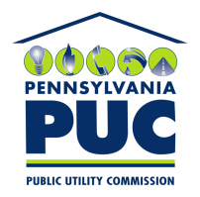 | Commonwealth of Pennsylvania  Pennsylvania Public Utility Commission  400 North Street, Harrisburg, PA 17120 | IN REPLY PLEASE REFER TO OUR FILE
January 7, 2020

DAVID OGDEN
DUQUESNE LIGHT COMPANY R-2019-3015083
411 SEVENTH AVE. Mail Drop 15-7
PITTSBURGH, PA 15219

Re: State Tax Adjustment Surcharge
Duquesne Light Company

Dear Mr. Ogden:

On December 20, 2019, Duquesne Light filed a State Tax Adjustment Surcharge tariff in response to changes to Pennsylvania corporate tax rates. The Commission hereby accepts these tariff changes, and we are therefore allowing the tariff changes to go into effect by operation of law. However, this notification shall not preclude this Commission from investigating the financial affairs of your company and, in appropriate cases, ordering refunds or other remedies, which it deems proper.

Very truly yours,

Rosemary Chiavetta
Secretary

cc: Marissa Boyle, TUS

