 | COMMONWEALTH OF PENNSYLVANIA  PENNSYLVANIA PUBLIC UTILITY COMMISSION  P.O. BOX 3265, HARRISBURG, PA 17105-3265 | IN REPLY PLEASE REFER TO OUR FILES  M-2020-3015229

March 20, 2020

TO ALL INTERESTED PARTIES:

Re: Cancellation Notice for the Act 129 Statewide Evaluator Energy Efficiency and Peak Demand Reduction Market Potential & Demand Response Potential Studies Stakeholder Meeting

With this Secretarial Letter, the Commission, in response to the Coronavirus (COVID-19), announces the cancellation of its Act 129 Statewide Evaluator Energy Efficiency and Peak Demand Reduction Market Potential and Demand Response Potential Studies Stakeholder Meeting.

The meeting was initially scheduled for Wednesday, March 25, 2020, from 10:00 A.M. to 2:30 P.M. in Hearing Room 1 of the Commonwealth Keystone Building, 400 North Street, Harrisburg, Pennsylvania, 17120.

Please note that the Commission has solicited formal comments on the studies through its Phase IV Tentative Implementation Order at Docket No. M-2020-3015228. Comments are due 30 days from the date the notice of the Tentative Order is published in the Pennsylvania Bulletin, which is anticipated to be March 28, 2020. Reply Comments are due 15 days after that.

Any questions regarding legal and process issues related to the Tentative Order should be directed to Adam Young at adyoung@pa.gov. Any questions regarding this Letter and technical issues related to the Tentative Order should be directed to Joseph Sherrick at josherrick@pa.gov.

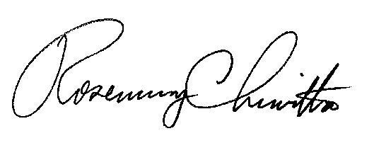
Sincerely,

Rosemary Chiavetta
Secretary

cc: Chairman’s Office
Vice Chairman’s Office
Commissioners’ Offices
Darren Gill, Deputy Director, TUS
Joseph Sherrick, Supervisor, TUS
Kriss Brown, Attorney, LAW
Adam Young, Attorney, LAW

