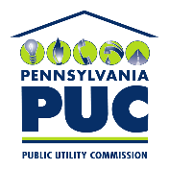 | COMMONWEALTH OF PENNSYLVANIA  PENNSYLVANIA PUBLIC UTILITY COMMISSION  400 North Street, Harrisburg, Pennsylvania 17120 | IN REPLY PLEASE REFER TO OUR FILE  M-2020-3019775

June 5, 2020

Re: COVID-19 Customer Service, Billing, and Public Outreach Provisions Request for Utility Information
Docket No. M-2020-3020055

In response to requests for extensions to file responses to the Commission’s Secretarial Letter issued on May 29, 2020 at the above docket number, the extensions are granted. Due to the Commission’s limited access to mail delivery, this extension is being served on the parties by email only but will also be placed on the docket and published on the Commission’s website.

Therefore, all jurisdictional fixed utilities will now have until the close of business (4:30 p.m. EST) on Monday, June 15, 2020 to file its responses to the Secretarial Letter. Please efile your response through the Commission’s efiling system using your efiling account. If your response contains confidential or proprietary material, you may email the response directly to me. Courtesy copies of responses should be sent by email to Sarah Dewey of BCS sdewey@pa.gov and/or Tom Charles, Director of Communications thcharles@pa.gov respectively.

Sincerely
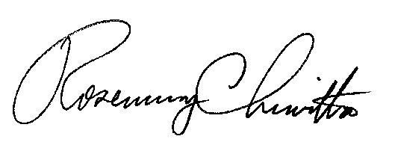

Rosemary Chiavetta
Secretary

cc: All Jurisdictional Fixed Utilities (by email only)

