 | COMMONWEALTH OF PENNSYLVANIA  PENNSYLVANIA PUBLIC UTILITY COMMISSION  400 NORTH STREET, HARRISBURG, PA 17120 | IN REPLY PLEASE REFER TO OUR FILE
July 1, 2020
Docket Nos.: P-2018-3005037
P-2018-3005039

Utility Codes: 2220554
2320555
DEANNE O’DELL
ECKERT SEAMANS CHERIN & MELLOTT, LLC
213 MARKET STREET, 8TH FLOOR
HARRISBURG, PA 17101
dodell@eckertseamans.com

RE: Petition of The Pittsburgh Water and Sewer Authority for its Amended Long-Term Infrastructure Improvement Plan (LTIIP)

Dear Ms. O’Dell:

The Pittsburgh Water and Sewer Authority (PWSA) filed a Petition seeking approval of its Amended LTIIP on April 27, 2020. To assist the Commission in conducting the review of PWSA’s LTIIP, please respond with the information requested in Attachment 1. Please forward the information to the Secretary of the Commission as directed below within ten (10) business days from the date of this letter. Make sure to reference the Docket Numbers listed above when filing your response.

During the pendency of the current Proclamation of Disaster Emergency, the Commission shall only accept e-filings in lieu of paper filings for all documents. Please e-file your responses at http://www.puc.pa.gov/efiling/default.aspx. A list of allowable e-filing document types is available at http://www.puc.pa.gov/efiling/DocTypes.aspx. All filings containing confidential or proprietary information shall be filed with the Commission by emailing the Secretary at rchiavetta@pa.gov. Use of encryption with the prior consent of the Secretary is permitted. All documents requiring notary stamps must have original signatures.

Your answers should be verified per 52 Pa Code § 1.36. Accordingly, you must provide the following statement with your responses:

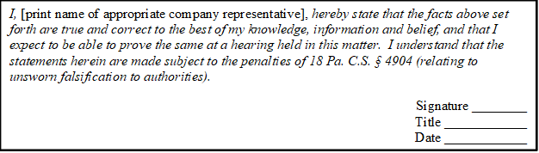

In order to expedite review of the data request responses, please also email a copy to Kenneth Shaffer, Bureau of Technical Utility Services, at kennshaffe@pa.gov. Please also direct any questions to Mr. Shaffer at his email, or (717)-787-2359.

Sincerely,

Rosemary Chiavetta
Secretary

Enclosure: Attachment 1

cc: Daniel Searfoorce, TUS
John Van Zant, TUS
Patricia Wiedt, LAW
Kenneth Shaffer, TUS

Attachment 1
Technical Utility Service (TUS) Data Request 1
The Pittsburgh Water and Sewer Authority (PWSA) Amended LTIIP
Docket Nos. P-2018-3005037 and P-2018-3005039

Please provide the following information regarding PWSA’s Amended LTIIP:

- On April 28, 2020, Kristine Marsilio emailed Ken Shaffer in TUS with Excel versions of Amended tables 2-6 and 5-1 in PWSA’s Amended LTIIP Filing. Please formally file these tables with the Commission.

- In the Amended filing an Appendix B is referenced, but not included. Is it to be understood that the unamended tables in Appendix B of PWSA’s original LTIIP stand as filed and will not be updated?

  - If answering in the negative to question 2 above, please provide all amended and updated tables for Appendix B.

- In the Amended filing, updated table 2-6 included projected expenditures for year 2024. Is this a projection merely for reference purposes, or does PWSA intend to include 2024 in its LTIIP?

  - If answering in the affirmative to question 3, above, please provide all necessary amended and updated tables.

