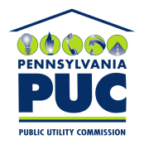 | COMMONWEALTH OF PENNSYLVANIA  PENNSYLVANIA PUBLIC UTILITY COMMISSION  400 NORTH STREET, HARRISBURG, PA 17120 | IN REPLY PLEASE REFER TO OUR FILE  M-2018-2640802  M-2018-2640803
September 10, 2020

Sarah C. Stoner
Eckert Seamans Cherin & Mellott, LLC
213 Market Street, 8th Floor
Harrisburg, PA 17101

Re: Implementation of Chapter 32 of the Public Utility Code for
Pittsburgh Water and Sewer Authority
(Docket Nos. M-2018-2640802 and M-2018-2640803)

Petition of Pittsburgh Water and Sewer Authority for Approval
Of its Long-Term Infrastructure Improvement Plan
(Docket Nos. P-2018-3005037 and P-2018-3005039)

Dear Ms. Stoner:

On September 3, 2020, the Pittsburgh Water and Sewer Authority (the Authority) filed a request for a 14-day extension, pursuant to 52 Pa. Code § 1.15, to file the compliance proposal as directed in Ordering Paragraph No. 4 of the Commission’s Opinion and Order entered on June 18, 2020, in the above referenced matter. The Order directed that the Authority file a compliance proposal to address various issues by September 16, 2020.

Commission Staff has reviewed the request for the extension of time. Based on what has been represented, it appears that all the parties have been in communication to confer on the issues. Specifically, the letter stated another conference is scheduled for September 11, 2020 with the parties. The Commission will grant the Authority’s request for submitting its compliance proposal no later than September 30, 2020.

Should you have any questions, you may contact the Office of Special Assistants, Kathryn G. Sophy, Director. Please direct your inquiry to (717) 787-1827 or RA-OSA@pa.gov.

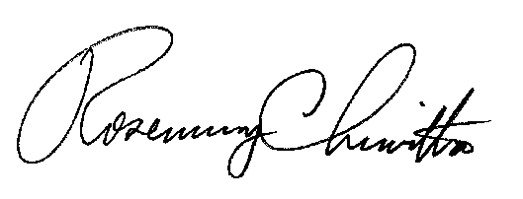
Very truly yours,

Rosemary Chiavetta
Secretary

