 | COMMONWEALTH OF PENNSYLVANIA  PENNSYLVANIA PUBLIC UTILITY COMMISSION  400 North Street, Harrisburg, Pennsylvania 17120 | IN REPLY PLEASE REFER TO OUR FILE  M-2020-3019244

October 1, 2020

Service by Email ONLY

Re: Temporary Reporting Requirements: At-Risk Accounts
Docket No: M-2020-3019244

To: All Jurisdictional Fixed Utilities

Pursuant to the Commission’s authority under Section 504 of the Public Utility Code, 66 Pa. C.S. § 504, the Commission directs all electric, natural gas, water, wastewater, and telecommunications utilities to comply with a temporary reporting requirement listed herein. This requirement is intended to inform this Commission of the specific situation for each of these utilities as it relates to customers at-risk of termination.

Specifically, each electric distribution company, natural gas distribution company, water utility, wastewater utility, and telecommunications utility shall file the following information as applicable to the month of September, 2020 by the close of business (4:30 p.m. EST) on October 15, 2020.

- Total number of a Residential and Non-Residential accounts at risk of termination at the end of the month and for the same month the year prior.
- Total aggregate dollars of arrears, broken down by the same account categories, at the end of the month and for the same month the year prior.

If you have any questions in this matter, please contact Sarah Dewey in the Commission’s Bureau of Consumer Services at sdewey@pa.gov .

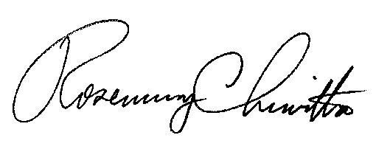
Sincerely

Rosemary Chiavetta
Secretary

cc: Renardo L. Hicks, Chief Counsel
Paul Diskin, Director Technical Utility Services
Alexis Becthel, Director Bureau of Consumer Services

