|  |  |  |
| --- | --- | --- |
|  | COMMONWEALTH OF PENNSYLVANIA  PENNSYLVANIA PUBLIC UTILITY COMMISSION  400 NORTH STREET 2ND FLOOR, HARRISBURG PA 17120  <http://www.puc.pa.gov>  *E-filing and E-service only per Emergency Order M-2020-3019262* | **IN REPLY PLEASE REFER TO OUR FILE** |

|  |  |  |
| --- | --- | --- |
|  |  |  |

September 16, 2021

A-2015-2470544



Application of Salsgiver Telecom for approval of the alteration of the crossing where Somerset Avenue (SR 1033) crosses, at grade, the tracks of Norfolk Southern Railway Company (DOT # 529 146 J), located in Borough of Windber, Somerset County.

To Whom it May Concern:

This matter is before the Commission by reason of a Petition for the transfer of maintenance of the communications line from Salsgiver Telecom to PEG Bandwidth PA, LLC. This petition was filed by PEG Bandwidth PA, LLC on April 7, 2021.

Proof of service of a copy of PEG Bandwidth PA, LLC’s petition on each party in interest has been received. None of the parties have advised that they object to the issuance of a of a Secretarial Letter granting the request to transfer utility maintenance.

Upon full consideration of the matters involved in this proceeding, we find that the petition can be granted.

The Commission issues this Secretarial Letter in accordance with Section 2702 of the Public Utility Code and finds that:

1. Upon completion of the alteration of the crossing, PEG Bandwidth PA, LLC, at its sole cost and expense, furnish all material and perform all work necessary thereafter to maintain the new aerial line and any ancillary facilities installed in accordance with the approved plan and this Secretarial Letter.

2. The case be “CLOSED.”

The Parties are reminded that failure to comply with this or any Order or Secretarial Letter in this proceeding may result in an enforcement action seeking civil penalties and/or other sanctions pursuant to 66 Pa. C.S. § 3301.

All parties are being served via email due to the COVID-19 Emergency Closure. Please note that during this period of Disaster Emergency, the Commission shall only accept e-filings in lieu of paper filings, for all documents. Thus, all parties are to open and use e-filing accounts to file documents and accept service during the pandemic emergency in accordance with the Commission’s Emergency Order at M-2020-3019262.

If you are dissatisfied with the resolution of this matter, you may, as set forth in 52 Pa. Code §§ 1.31 and 5.44, file a Petition for Reconsideration from Staff Action (Petition) with the Commission within twenty (20) days of the date of this letter. The Petition shall be submitted by e-filing said petition within twenty (20) days, or if no timely request is made, the action will be deemed to be a final action of the Commission.

The Petition for Reconsideration must include: (1) a written statement (divided into numbered paragraphs) outlining the reasons for the request; (2) the case docket number (it is provided for you at the top right-hand corner of this letter); (3) the party on whose behalf the petition is made; (4) a Certificate of Service on the other parties of record; and (5) a Verification with original signature in accordance with 52 Pa. Code § 1.36.

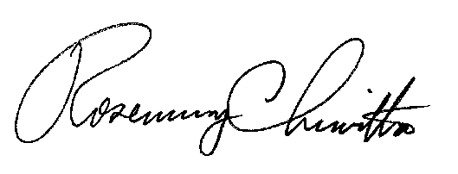 Very truly yours,

Rosemary Chiavetta

Secretary